

**GeeLogic**

*by CHNZ2*

*Supervised by Prof Graham Roberts*

MSc Computer Science

August 8, 2023

This report is submitted as part requirement for the MSc Computer Science at

UCL. It is substantially the result of my own work except where explicitly

indicated in the text. This report may be freely copied and distributed provided the

source is explicitly acknowledged.

Department of Computer Science

University College London

**Abstract**

The field of Earth observation is a rapidly developing industry. Space applications see more and more adoption within the non-space economy, and new startups are experiencing rapid growth. However despite this incredible advancement, there is a notable lack of space for scientists and developers to find common ground and explore each other’s ideas in orbital imagery analysis. GeeLogic aims to bridge this gap, and create such a space.

By the end of the project fully functional internet platform for researchers and developers to post and discuss their Earth-observation oriented work was successfully developed. The aim of the project was to design a proof-of-concept application and experiment with technologies and approaches that could be used to develop such a platform. The deliverable was to create a working prototype which could facilitate information about algorithms working on Google Earth Engine submitted by the users. Both were successfully achieved.

The resultant product uses Flutter Web framework for its frontend and three APIs using Python and Node.JS along with Firebase for its backend. It is successfully deployed and can be access through [this link](https://gee-gis-project-393016.firebaseapp.com/), and is hosted by an array of services including Firebase for frontend, Render for backend APIs and Clever Cloud for SQL database.

Use the following hyperlinks to access GitHub repositories containing the source code for the project:

* [GeeLogic frontend](https://github.com/fedorSulitskiy/GIS-GEE-Project.git) (code which was written for this project is within the “lib” folder)
* [Node API](https://github.com/fedorSulitskiy/geelogic_node_api.git) (every file is of interest)
* [Python API](https://github.com/fedorSulitskiy/geelogic_python_api) (code of interest is in the main.py file)
* [Thumbnail API](https://github.com/fedorSulitskiy/geelogic_thumbnail_api.git) (code of interest is in the main.py file)

Contents

1 Introduction 1

1.1 Aims and Goals 1

1.2 Development Approach 2

1.3 Content Overview 2

2 Context 3

2.1 Importance of Earth Observation Research 3

2.1.1 Applications 3

2.1.2 Commercial Value 4

2.2 What is Google Earth Engine? 5

2.3 What is geemap? 6

2.4 Technologies used 7

2.4.1 Flutter 7

2.4.2 ipywidgets 7

2.4.3 Flask 1

2.4.4 geemap 1

2.4.5 Selenium 2

2.4.6 Node.JS and Express 2

2.4.7 MySQL 2

2.4.8 Firebase 3

2.4.9 Render 3

2.4.10 Docker 3

2.4.11 Clever cloud 3

3 Requirements and Targets 5

3.1 Problem Statement 5

3.2 MoSCoW Requirements 5

3.3 User Stories and Use Cases 6

3.4 Prototypes and Sketches 8

4 Design and Implementation 11

4.1 Architecture 13

4.2 Frontend 15

4.2.1 Flutter Widgets 15

4.2.2 State Management 16

4.2.3 Responsive Design 21

4.2.4 Navigation 21

4.3 Backend 22

4.3.1 Node API 22

4.3.2 Python API 22

4.3.3 Thumbnail API 24

4.3.4 Database 25

5 Testing 29

5.1 Main Testing Sequence 29

5.2 Miscellaneous Testing 40

5.2.1 Test is one can choose a custom image upon registration 40

5.2.2 Testing if the Feedback Screen is functional 41

5.2.3 Create new algorithm using JavaScript API 42

5.2.4 Cumulative votes and votes visibility 44

5.2.5 Undoing deletion of the algorithm 44

6 Discussion and Conclusion 45

6.1 Summary of Achievements 46

6.2 Future Work 46

References 48

Appendix 49

I. User Manual 49

a. Login Screen and Signup Screen 49

b. Catalogue Screen 50

c. Details Screen 54

d. User Screen 55

e. Input Screen 55

f. Edit Screen and Delete 56

g. About Screen 58

h. Tutorial Screen 58

i. Feedback Screen 59

j. Additional Side Menu Buttons 59

II. API Documentation 60

# Introduction

This project aims to develop a proof-of-concept service for researchers and developers to easily share their algorithms in the area of Earth Observation. GeeLogic, as it was named, utilises Google Earth Engine API to rapidly access the results of these algorithms, allowing for immediate user intractability.

Ever since the first images of Earth were taken from outer space in 1947 researchers and scientists have found ways to extract useful information from them and apply it. Space technologies and orbital imagery applications have become integral tools for supporting the lifestyle of hundreds of millions of people, from climate forecasting to state security. However, despite developing for the last 76 years this industry’s growth is only accelerating due to increasing accessibility of space to private companies and greater amount of better and more easily accessible data.

For instance, ESA’s (European Space Agency) Copernicus (Copernicus, n.d.) programme has the explicit goal of providing free data to anyone from its Sentinel, among other, satellites. In fact, they are currently the greatest provider of free data in the world, generating 16 terabytes of imagery data per day.

Earth observation industry along with the rest of the Space Industry is going through a quiet renaissance. Hence this project aims to contribute to this incredible development.

Google Earth Engine (GEE) is a powerful cloud computing service that aims to gather most freely available sources of Earth observation imagery such as the data from the aforementioned Sentinel satellites. It allows real time analysis and extraction of data, driving innovation trough making access to relevant data very easy. Many professional researchers use GEE for their studies, however there is a notable absence of a dedicated platform to accessibly share their findings. This is where GeeLogic (Google Earth Engine Logic) serves to fill this demand.

## Aims and Goals

The key aim of this project is to explore how various technologies can be used together to design this platform. Since it is uncommon that GEE API is ever used in third party software, save for jupyter notebooks, it was an interesting challenge to integrate it with Flutter frontend framework. Furthermore, a secondary goal is to create a sophisticated service utilising Flutter Web, a young but rapidly developing framework that is focused on mobile app development, but recently sees greater use for web applications. So, to summarise, the aims are:

* Explore various technologies’ feasibility in supporting this project.
* Integrate GEE API with Flutter in the form of an application.
* Explore the potential of Flutter Web for developing web applications.

This project was completed under UCL’s IXN (Industry Exchange Network) programme under Dr Joseph Connor’s supervision. The key deliverable is a public service, which facilitates hosting of code by professionals in the field of Earth Observation that uses GEE’s resources to solve particular problems. Problems can include any conceivable issue that users deem appropriate or useful, as long as orbital imagery from GEE is used. Furthermore, said service must also facilitate room for discussion and feedback, as the goal is to create a space where ideas can be shared and improved upon. So, to summarise, the deliverables are:

* A public service which hosts information about GIS algorithms submitted by users.
* It must host information including description and source code.
* It must provide a way for users to discuss each other’s research.

## Development Approach

The project was completed using Agile Approach, inspired by Lean Startup and Kanban methodologies. This is the first major project attempted by the author using Flutter, hence every step required a degree of learning, building, and assessing the success of the approach. At the very beginning of the project, key requirements were outlined, which served as a guide for every subsequent decision. Hence the general approach was the following:

* **Build**. Begin designing a certain screen that would serve to satisfy a certain requirement, and experiment with various techniques Flutter has to offer to complete said screen.
* **Measure.** The success of the technique would be assessed, judging it by such metrics as aesthetics, performance, speed of coding and ease in navigating the code itself.
* **Learn**. There is more than one way of achieving the same result. Hence after assessing the recent approach, already completed screens would be assessed if they could accommodate the new approach, allowing for a better overall product. Finally, using the accumulated knowledge, decision on what screen should be worked on next would be made, cycling the whole process.

Kanban agile development methodology inspired the liberal choice of next work item to pursue and limiting each sprint time by available production capacity rather than time deadlines. Furthermore, every attempt was made to visualise remaining workload through graphics and notes, which resembled a Kanban board approach, alas with only one worker.

## Content Overview

The rest of the report contains the following chapters:

* **Context** **–** This chapters explores the context of Earth observation industry landscape, applications of Google Earth Engine, as well as introduces the technologies used in the final deliverable.
* **Requirements and Targets –** This chapter defines problem statement and the requirements of the final deliverable that could satisfy said problem.
* **Design and Implementation –** This chapter focuses on the details of how GeeLogic was developed and what technical exploits were used in its development.
* **Testing –** This chapter outlines what tests and how manual testing was performed to test key features of GeeLogic. Additionally, it provides a detailed example of intended user flow.
* Error! Reference source not found. **–** This chapter assesses the results of the project; how well the final deliverable was able to satisfy the requirements, as well as it explores the potential improvements and further development path.
* **Appendix –** The appendix contains two major sections: User Manual and API documentation. User Manual outlines every screen; how to use and navigate them. API documentation provides a link to the documentation of the APIs used by GeeLogic, as well as provides an example.

# Context

## Importance of Earth Observation Research

Earth observation offers us a unique perspective on the world around us; from above. Being able to look at the larger picture allows one to make better calculated decisions and learn about the environment at a macro scale. Satellites are tools that can help solve various problems, from optimising food production to disaster mitigation to national security. In fact, 22% of all satellites in orbit are observation satellites, which is second to communication satellites 63% (Primož Rome, 2022).

It is predominantly a peaceful industry with civilian applications, despite the stereotypical images of spy satellites that come to mind when one thinks of cameras in space. The first observational satellite was Vanguard 2, a metrological satellite for cloud observation, launched in 1959 (Vanguard 2, n.d.). Today meteorological satellites are essential for modern weather forecasting as well as early spotting of Tornados and other dangerous environmental phenomena.

McKinsey has posted a Technology Trends Outlook in June of this year where among other technologies such as generative AI or Quantum computing they discussed space tech’s potential. In the past 5-10 years this industry experienced large growth due to decreasing technology costs and increasing accessibility. Furthermore, more and more companies, unrelated to space, are looking to adopt space tech into their business models. Prime example being Hitachi Energy leveraging remote sensing to better respond to the impact of storms and other weather events on managing vegetation around train tracks of their clients (Vegetation manager for rail: Limit downtime by managing vegetation around tracks, n.d.). Space market is growing, and it has already grown to approximately $447 billion—up from $280 billion in 2010—and could grow to $1 trillion by 2030 (Chui, Issler, Roberts, & Yee, 2023).

### Applications

Applications of remote sensing satellites include the following (Surrey Satellite Technology Ltd., 2019):

* **Agriculture** - Satellite observation transforms agriculture, enabling precision farming through real-time data on soil, crops, and weather conditions, optimizing resource use and increasing yields. Continuous monitoring detects crop stress and diseases early, conserving resources and improving quality. It aids in efficient irrigation and nutrient management while providing essential weather forecasting for timely interventions. Additionally, satellites contribute to sustainable land use planning and enhance crop insurance by ensuring accurate assessments and fair compensation.
* **Forestry -** Satellite observation provides a bird's-eye view of forests, helping monitor deforestation, assess forest health, and plan sustainable practices. Satellites detect changes in forest cover, identify illegal logging activities, and offer data on tree density and species distribution. This information guides forest conservation efforts, supports fire risk assessments, and aids in carbon sequestration monitoring.
* **Risk management** - By providing accurate and up-to-date data on weather patterns, natural disasters, and property conditions, satellites help insurers assess and mitigate risks effectively. This technology enables the creation of risk models that improve underwriting accuracy and enable the tailoring of insurance policies to individual clients. In the event of a claim, satellite imagery assists in verifying damages quickly, reducing fraud, and expediting claims processing. Ultimately, satellite observation enhances the overall efficiency and fairness of the insurance industry.
* **Disaster monitoring** - In disaster response, satellites provide real-time data on natural disasters such as hurricanes, floods, and wildfires, allowing for early warnings and effective evacuation plans. In agriculture, they assist in assessing crop and weather-related risks, helping farmers prepare for adverse conditions. In urban planning, satellites identify vulnerable areas prone to hazards like flooding or landslides.
* **Maritime** **Activities** - Satellites equipped with radar and AIS (Automatic Identification System) receivers monitor vessel movements, enhancing maritime security and preventing illegal activities like piracy and smuggling. They also provide critical data for safe navigation, tracking shipping routes, and optimizing logistics. Moreover, satellites assist in monitoring ocean health by observing factors like sea surface temperature, sea level rise, and marine pollution, aiding in sustainable fisheries management and environmental protection. In emergencies, satellite communication ensures connectivity at sea, allowing distress signals and location tracking for timely search and rescue operations.
* **Defence and security** -Satellites equipped with advanced imaging technology provide real-time surveillance, tracking military movements, potential threats, and border security. They aid in disaster response, facilitating rapid deployment of resources during emergencies. Communication satellites ensure secure, global connectivity for military and intelligence agencies. Additionally, satellites offer navigation and targeting support, enhancing precision-guided weaponry and missile defence systems. These capabilities strengthen national security and deter potential adversaries, while also enabling rapid response to crises worldwide. (No space lasers just yet).
* **Natural resource management** - Satellite provides a comprehensive view of Earth's surface, enabling efficient monitoring of forests, water bodies, agriculture, and mineral resources. This data aids in sustainable land use planning, deforestation detection, and water resource management. Satellites also help track environmental changes and assess the impact of climate change on ecosystems. In mining and energy sectors, satellite data assists in resource exploration and monitoring extraction activities.

Overall, satellite observation empowers governments and organizations to make informed decisions and promote responsible environmental stewardship for a more sustainable future.

### Commercial Value

As mentioned above the satellite industry is expected to grow to $1 trillion by 2030, with plenty of potential for expansion, such as asteroid mining, in-orbit manufacturing, or lunar economy. Earth observation in particular sees wider adoption within non-space industry which stimulates growth and offers room for greater commercial gain.

To illustrate the exciting opportunities offered by remote sensing industry two case studies are explored below: recent launch of Satellite Vue’s first satellite and acquisition of Irriwatch by Hydrosat.

Satellite Vue is unique in that it takes up a very specific niche: high resolution thermal imaging. They employ cameras with 3.5m resolution looking at infrared end of the spectrum. Their clients come from sustainability and climate industries as well as from defence and state security. Recently they became one of the few startups that has their own satellite in orbit, appropriately named HOTSAT-1 (Satellite Vue, 2023). This is an exciting development since it demonstrates availability of funds for newcomers to the field of space tech, as well as it opens greater possibilities and novel approaches in developing solutions based on thermal imaging from space. HOTSAT-1 offers to provide some of the best thermal resolution available, going from 100s of meters per pixel to only 3.5! Granted, the data is not open source, but it’s an advancement in remote sensing technology as well as it is an advancement in environmental sustainability. Better information leads to better decisions.

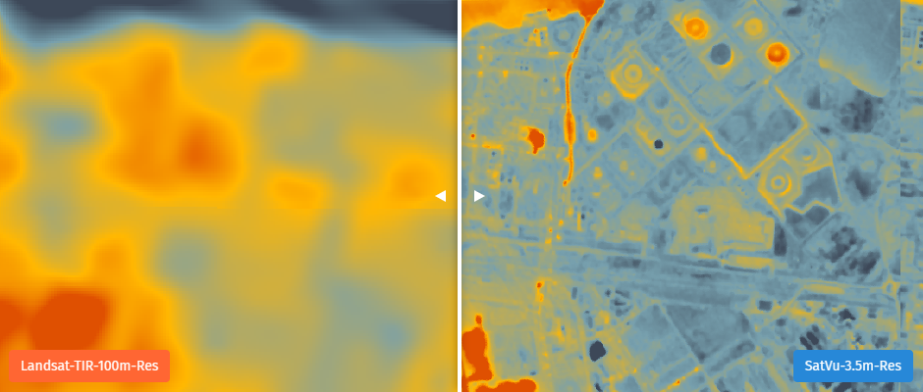

Figure 1 This figure illustrates the difference in resolution between Satellite Vue’s solution and freely available data from Landsat satellite. (Satellite Vue, 2023)

Hydrosat and Irriwatch are very similar to each other, and similar to Satellite Vue in a way that they all deal with thermal imagery (albeit Satellite Vue specialises in different optical bands). However, they are concerned with agriculture, both leveraging data gathered by NASA satellites (Landsat and MODIS (Erwin, 2023)), and then funnelling it into their analytics platforms to optimise agricultural practices. This development is curious since it demonstrates commercial power of Hydrosat to acquire their European competitors. Furthermore, Hydrosat and Irriwatch exemplify excellent practices of the remote sensing industry; developing sophisticated algorithms that help farmers use less water and produce greater yield. Sometimes their efforts result in water use reduction as high as 25% with yield increase as high as 50% (Werner, 2023).

These case studies highlight the vastness of opportunities offered by remote sensing industry. All companies mentioned above work with similar data and solve similar problems, but still devise different approaches and yield effective results. Inevitably they will enter a synergy, and their developments will ultimately lead to more sustainable world, that has cooler cities, less water waste and more efficient agriculture.

## What is Google Earth Engine?

Earth Engine is a platform facilitating the scientific exploration and visualization of geospatial datasets across academic, non-profit, business, and governmental spheres. At its core, Earth Engine is an expansive repository of satellite imagery, accumulating a historical archive spanning over forty years. These images, continuously incorporated into the database, are subsequently offered for global-scale data mining endeavours. Beyond this data reservoir, Earth Engine equips users with the APIs and integrated tools to facilitate the analysis of its vast datasets.

Google Earth Engine distinguishes itself from Google Earth as a specialized instrument tailored for geospatial analysis. While Google Earth primarily enables users to engage with satellite imagery, maps, terrain, and 3D structures, Earth Engine pivots towards the comprehensive dissection of geospatial information. Users harness its potential to explore a multitude of areas, ranging from forest and water coverage to tracking land use transitions or evaluating agricultural field health. While the two tools rely on some of the same data, only some of Google Earth's imagery and data is available for analysis in the Earth Engine.

Notably, Earth Engine has gained traction among researchers, non-profit organizations, educators, and government agencies, all of whom employ the platform to exploit and analyse large-scale geospatial data. Real-world applications of Earth Engine can be explored from the platform's Case Studies, which exhibit its transformative potential in action.[1]

To conclude, Earth Engine is a powerful instrument for geospatial analysis and visualization, catering to diverse user base while facilitating access to a treasure trove of geospatial data. Its fusion of satellite imagery, computational power, and flexible APIs creates a dynamic environment where users can discover valuable insights and contribute to a multitude of scientific, humanitarian, and environmental initiatives. (Gorelick, et al., 2017)

## What is geemap?

In recent years, the Google Earth Engine (GEE) has gained significant popularity within the geospatial community, revolutionizing environmental applications across local, regional, and global scales. Earth Engine offers both JavaScript and Python APIs to interact with Earth Engine servers, facilitating computational requests. While the JavaScript API boasts comprehensive documentation and an interactive Integrated Development Environment (IDE) known as the GEE JavaScript Code Editor, the Python API has traditionally suffered from limited documentation and interactive visualization capabilities. Addressing this gap, the geemap Python library has emerged as a valuable addition to the geospatial toolkit.

Geemap is built upon ipyleaflet and ipywidgets python visualisation libraries. This allows users to analyse and visualize Earth Engine datasets interactively within the familiar Jupyter-based environment. This versatile tool primarily targets students and researchers seeking to use Python for their exploration of Google Earth Engine. Moreover, it serves as a bridge for existing GEE users aiming to transition from the JavaScript API to the Python API. A standout feature of geemap is its automated JavaScript-to-Python conversion module, significantly reducing the effort required to migrate existing GEE JavaScript code to Python scripts and Jupyter notebooks. Further on in the report, it will be explored how this feature was used to implement submission of both JavaScript and Python API based algorithms.

## Technologies used

GeeLogic is first and foremost a proof-of-concept demonstration work, one of the key requirements of which is to create a scalable and modern web-based application. Hence many technologies were chosen on the basis of exploring new possibilities rather than seeking a trial and tested tech-stack. Prime example of this approach is Flutter for the frontend, a relatively novel framework for developing cross-platform application for mobile, web and desktop platforms. Nevertheless, for less open-ended problems such developing a versatile and scalable RESTful API Node JS combined with Express were chosen.

Subsequent sub-sections will explore each key technology used in development of GeeLogic and reasoning behind their use. A summary of which technology was used for which purpose can be found on Figure 2.

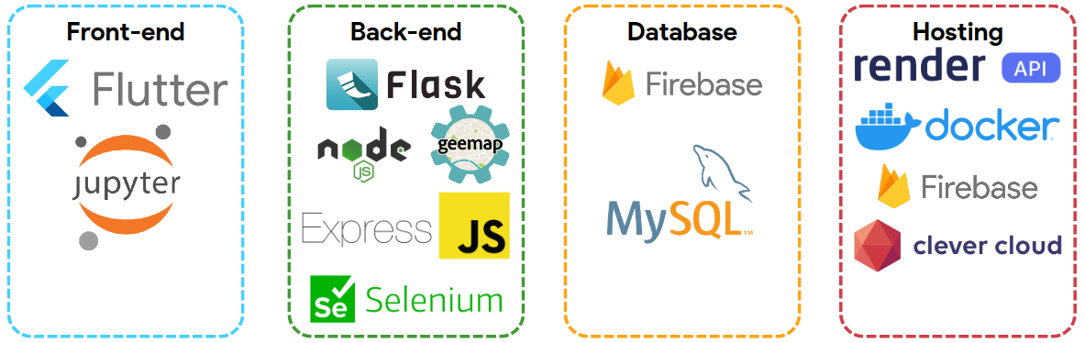

Figure 2 Key services, frameworks and technologies used in developmnent of GeeLogic.

### Flutter

The great inspiration for using Flutter was from Google I/O 2023 conference’s announced commitment to improving Flutter’s development experience, graphics handling improvements, further integration for web, desktop, and mobile platforms and emergence of Flutter for new and emerging architectures. Flutter framework is rapidly gaining popularity and threatens to overtake React as the main development toolkit for applications across all key platforms.

Furthermore, Flutter team announced arrival of Flutter 3.10 which greatly enhanced flutter capabilities for rendering web-applications, speeding up loading times and improving performance. Dart itself, the Google developed language that Flutter framework runs on also received the largest update to date, improving development experience. Google puts a lot of effort into developing Flutter, industry developers employ Flutter more often, and the there is a plethora of positive feedback about scalability, speed of development and versatility of the framework. Hence the combination of these factors has inspired the author of this project to choose flutter as the primary front-end framework.

### ipywidgets

Ipywidgets, also known as jupyter-widgets, are interactive HTML components designed for Jupyter notebooks and the IPython kernel. These widgets enable users to interact with and visualize data dynamically. This interactivity enhances learning experiences, allowing users to observe data changes in real-time and gain a deeper understanding of their models.

They were essential for rendering an interactive map based on users’ submitted algorithms for other users to interact with. geemap can generate ipywidgets, which were then extracted as html code to embed them into the Flutter front-end. The exact workflow of this system is further explored in the

Problem statement, and project’s requirements were described according to functionality and priority. It is stressed that GeeLogic doesn’t aim to deliver a fully functional service ready to be used by professionals, but to explore the feasibility of realising its key idea: to create a space for professionals to interchange ideas about GIS analysis. Hence, intended stakeholders’ and ideal users’ profiles were explored along with their user stories to further align the deliverable’s features with the users’ interests.

Finally, some prototypes and sketches were demonstrated, which were used to formulate the design philosophy of the UI. It was decided that since most crucial services were derived from Google’s projects, the general design should be reminiscent to that of Google.

section.

### Flask

Flask, a Python web application library, serves as a lightweight and versatile framework for building web applications and, notably, REST APIs. Due to the need to use geemap for accessing Google Earth Engine resources, it was necessary to execute python scripts from the frontend. Flask was used as a mechanism to do just that. Hence despite Node.JS and Express being the primary framework for the main API, in fact GeeLogic employs three custom REST APIs two of which use Flask.

Flask is a minimalistic and simple framework which is also quite fast. Since the Python based APIs for this project won’t need to be big or require much expansion, it was decided that the simplest framework would be the best.

### geemap

geemap was explored previously in the What is geemap? sub-section. Google Earth Engine has two primary APIs; JavaScript based, and python based. However, JavaScript API is almost exclusively used for the internal Code Editor, which is shown on Figure 3. Meanwhile Python based API was adapted for use in Jupyter notebooks, but as mentioned above it was not as well documented and usable as the JavaScript API.

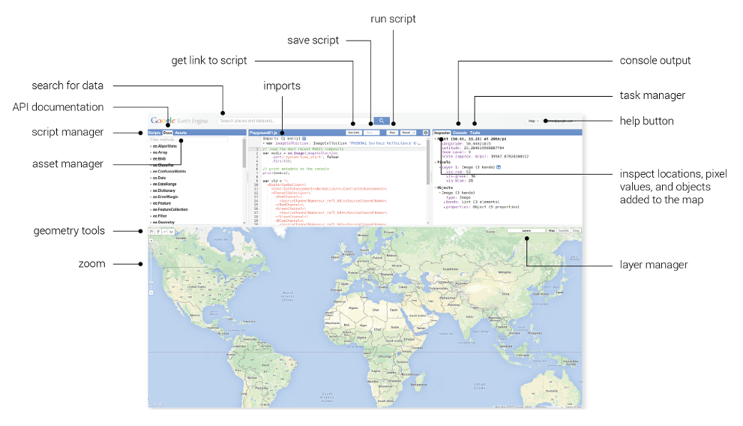

Figure 3 Screenshot of GEE online code editor, courtesy of (Google Earth Engine). This demonstrates what researchers tend to encounter first when they decide to use JavaScript API with Google Earth Engine Code Editor.

Luckily Prof. Wu from University of Tennessee developed geemap library which enhances and simplifies the use of GEE’s Python API, due to its exhaustive documentation and extensive collection of tutorials online. Another advantage of using geemap is its use of ipywidgets that allow one to export the interactive maps linked to GEE and embed them in the frontend.

### Selenium

GeeLogic automatically generates thumbnails from algorithms submitted by users. However, there is no native functionality within geemap or GEE Python API to generate an image from input algorithm. Furthermore, the widget generated by the geemap is dynamic as it accesses the GEE resources directly which made it hard-to-impossible to convert the html to an image or convert html to pdf and then to image.

To solve these problems a non-ideal solution was developed; using selenium to render the html widget in a headless browser and screenshot it as an image to generate a thumbnail image. This approach takes a long time, but it is functional and free, hence it was considered satisfactory in the context of developing a proof-of-concept project.

Selenium was chosen due to its ability to work in a headless browser (opening a browser window that doesn’t render on the screen), significance of which will be explored in the Docker subsection, as well as dure to its simplicity. Nevertheless, it is a measure that should not be adopted for production version of the service due to its slowness.

### Node.JS

Node is very fast, it allows for asynchronous request calls and has wide support from the community, making it ideal for developing a REST API quickly. Indeed Node.JS is very scalable allowing for sophisticated error handling, middleware functions integration for more complex authentication and its widely popular, meaning a new developer looking to work on GeeLogic would find it easy to understand the backend code and improve on it.

In the context of putting experimental nature of this project at the forefront of the development approach, Node is ideal since the author is already familiar with it, and it allows for a quick and versatile API to be developed in a short space of time.

### MySQL

Initial requirements of the project have necessitated a relatively simple database. However, in perspective the idea of the project has a large potential for expansion across numerous functionalities, and potentially acting as a specialised social network. Therefore, it was decided that a relational database would offer the perfect combination of a simple start and potential for further expansion for the features not currently apparent. SQL based relational databases offer advantages of structured data organization, data integrity, and support for complex relationships between data entities, making them a solid choice for applications where data accuracy, consistency, and intricate data connections are paramount. Their ACID compliance ensures reliable transactions, while standardized SQL querying simplifies data retrieval and reporting. Relational databases also excel in security and scalability. Hence to lay a foundation of a greater project SQL seemed to be the perfect choice.

While the choice of an SQL relational database was guided by project requirements the choice of MySQL type of database was guided by previous experiences of the author in creating and managing a database of the same type using Node.JS based REST API.

### Firebase

Firebase is a convenient app development platform, also developed by Google, that offers a multitude of functionalities, including authentication and authorisation, data storage and hosting of one’s application. Furthermore, it is well suited to integrate with Flutter applications, which was the main reason for choosing it as secondary backend managing system and host for the frontend.

Firebase is an industry grade platform created by Google, so all user specific information is stored on it, to provide additional security. Furthermore, since it provides a wide range of services it makes it more convenient to outsource multiple requirements including storing thumbnail images, authentication and authorisation and hosting to a single service, Firebase.

### Render

This is a unified cloud to build and run web services or websites. It is a rising competitor to Heroku, a popular host for Node.JS based REST APIs, however in the context of this project Render’s key advantage was in the fact that it is free to use. Since this is a proof-of-concept, costs were kept to a minimum and Render, unlike Heroku, offered a free hosting of GeeLogic’s API, albeit with certain downsides such as having to wait for a relatively large period of time, first time a request is sent after a period of inactivity as well as access to low performing virtual hardware. Nonetheless, practice showed that Render’s services proved satisfactory even for free tier use.

Second advantage of Render is it can host Node.JS apps without any additional adjustment as well as it can host Docker containers which was essential in hosting Python based APIs for GeeLogic. In fact, the process is as simple as providing Render with access to the relevant GitHub repository, and set secret variables to avoid compromising security, to launch a web application.

### Docker

Render is capable of hosting both Node.JS and Flask based web apps, however since the Python based APIs used unique code with exotic packages such as geemap, directly uploading them to Render proved impossible. To solve this problem, it was decided to containerise the Python based REST APIs and upload them in this form.

Furthermore, since Docker was used to containerise the API that generates thumbnails, it became essential to be able run Selenium in headless mode, since Docker containers are not optimal for graphical applications.

### Clever cloud

Although Render can host SQL databases, it is limited to only hosting PostgreSQL, which necessitated a search for a host of the MySQL database used in development. Clever Cloud is a cloud platform-as-a-service which offers to host practically every kind of web application and service including REST APIs and databases. It is similar to Render and Heroku, however it was decided to leave the APIs hosted on Render due to its better offered performance for free tier use.

To conclude, it is apparent that the field of space industry and Earth observation in particular are experiencing rapid growth, amplifying their influence on the rest of the economic ecosystem. Furthermore, these technologies are pivotal in recording, and therefore managing climate change which is becoming an increasingly pressing issue. The aforementioned Copernicus programme’s climate service reported that August of this year has been the second hottest month on record, with the first being July 2023 (Copernicus, 2023).

In spite of this, there is no dedicated platform for sharing researchers’ various work on their Earth observation-oriented solutions. Hence GeeLogic aims to bridge this gap.

Furthermore, each technology supporting GeeLogic in its current state was overviewed as well as Google Earth Engine and geemap were described. Current technology stack allows for rapid prototyping and proof-of-concept work at minimal cost; however, a production version would need more advanced solutions.

# Requirements and Targets

It is important to reiterate that GeeLogic is an experiment and a test platform. It was developed with experimentation and trail-test approach in mind. Knowledge gathered in developing this platform would primarily be used to develop better applications and potentially a production version of GeeLogic.

Sub-sections below explore technical requirements, dissecting them according to functionality / non-functionality and priority followed by use cases and use stories.

## Problem Statement

Research in the domain of Earth observation is extensive, however despite computers taking up the dominant role in this field, results of said research are most commonly released as conventional scientific papers. This is brilliant since it’s a working method which helped science progress for the last 200 years, at least. However, this approach deprives the reader from acquiring the source code quickly, which slows down the process of adopting the researched technique to test it on one’s own use cases.

Scientific community tends to keep their work inside their private jupyter notebooks and publish their results in a paper. Few people tend to post their code. Hence, GeeLogic aims to fill this niche, providing a specialised space where researchers and developers can quickly post their code as well as discuss their results. Stakeholders would be able to quickly explore different ideas, interact with them and immediately prototype their own work!

## MoSCoW Requirements

This section explores MoSCoW requirements of this project. Table 1 outlines functional requirements, and Table 2 outlines non-functional requirements. Since the aim of the project is not to create a production product the non-functional requirements are less strict in scope than one would expect for a social platform.

Table 1 MoSCoW functional requirements for this project. The id follows the following format: **F**(functional requirement)-**M**(must)**1**(id number).

|  |  |
| --- | --- |
| Id | Requirement |
| MUST-M | |
| F-M1 | Host various information relevant to the various geospatial observation algorithms, including title, description, and code |
| F-M2 | Use Google Earth Engine API to have an interactive access to the algorithms |
| F-M3 | Allow users to create details page about their algorithms |
| F-M4 | Authenticate users to allow them to use social functions and post algorithms |
| F-M5 | Allow users to search for an algorithm on the service |
| F-M6 | Contain feedback page connected to the developer’s mailbox |
| SHOULD-S | |
| F-S1 | Have multiple sections in the webapp corresponding to different major categories |
| F-S2 | Have short guides on how to use the website/service |
| F-S3 | Have the details page have rigid structure to be filled in by the user |
| F-S4 | Allow users to leave comments |
| F-S5 | Allow users to upvote and downvote algorithms |
| COULD-C | |
| F-C1 | Have detailed tutorials on how to use GEE and / or this service |
| F-C2 | Allow users to upload their own earth observational data |
| F-C3 | Allow users to upload their own code in the form of files |
| F-C4 | Have limited example data filled in to start with |
| F-C5 | Special page with direct access to normal GEE Code Editor (playground) |
| F-c6 | Have an option to upload machine learning models |
| F-c7 | Contain link to geemap documentation page, to help users write correct syntax when inputting their code using python API |
| F-c8 | Contain link to GEE website, for users to quickly switch to it, in case they wish to prototype |
| WON’t-W | |
| F-W1 | Use providers of satellite data other than GEE |
| F-W2 | Have a large array of starting algorithms filled in |
| F-W3 | Have internal code IDE |

Table 2 MoSCoW non-functional requirements. The id follows the following format: **NF**(non-functional requirement)-**M**(must)**1**(id number).

|  |  |
| --- | --- |
| Id | Requirement |
| MUST-M | |
| NF-M1 | Have visually appealing interface, reminiscent of Google’s style |
| NF-M2 | Have user information stored in a secure location |
| NF-M3 | Have an understandable tutorial, allowing a new user to easily start using the service |
| SHOULD-S | |
| NF-S1 | Take no more than 30 seconds to load any given widget or information about algorithm, with average internet speed |
| COULD-C | |
| NF-C1 | Minimise loading times of main page and map widget to 5 seconds at most, with average internet speed |
| NF-C2 | Minimise uploading time of an algorithm to 5 seconds at most, with average internet speed |
| WON’t-W | |
| NF-W1 | Run on mobile or desktop platforms |
| NF-W2 | Employ additional security measures regarding the integrity of the main body of data |

Requirements were revised multiple times during development to adjust for newly occurring challenges, however the main body of the requirements has always remained the same. It was always the aim to develop a space where users can post and then review each other algorithms, participate in discussion and learn new techniques.

## User Stories and Use Cases

Below four key stakeholders were identified: researchers, developers, businessmen and entrepreneurs and Google itself. Each stakeholder’s profile was described, and below that a list of bullet points in italics outlines user stories in the format of:

*“As a [persona], I [want to], [so that].”*

* *Researchers* – either beginners or experienced professionals would be potentially interested. Beginners would have a playground where they could learn and explore approaches towards geospatial analysis of varying complexity; some people use indices and others train machine learning models. A place where their research is interactive allows for more effective learning environment. Experienced professionals would benefit by having a centralised database for novel research allowing for quicker conceptualisation, discovery, and research of existing material.
  + *As a researcher, I want to be able to share my work with the rest of the GEE community, so that my work gains wider reach.*
  + *As a researcher, I want to be able to access other people’s work, so that I can expand my own knowledge.*
  + *As a junior researcher, I want to see the code used to generate the response I see on GEE, so I can play with it, learning how the code editor works.*
  + *As a junior researcher, I want to read the detailed description of the approaches used in developing an algorithm, so that I can replicate it.*
  + *As an experienced researcher, I want to be able to interact with other researchers’ work, so that I can improve on their work with mine.*
  + *As a researcher, I want to sort the algorithms according to tags or criteria, so that it would be easier to navigate the website.*
  + *As a researcher, I would like to have a voting system, so that I would be able to find the algorithms best approved by the community and ignore bad takes.*
  + *As a researcher, I would like to be able to participate in discussion around certain algorithms, to leave my feedback after a peer review.*
* *Developers* – people working in existing companies / enthusiasts building geospatial applications may find a code-centric forum useful for their purposes. Once again it would allow for quicker conceptualisation and discovery. Techniques that would have been more obscure due to being solely represented in a scientific paper would be more accessible in an interactive environment and as such more attractive towards people who wish to apply them.
  + *As a developer, I would like to be able to participate in discussion around certain algorithms, to learn more about them.*
  + *As a developer, I would like to have access to source code of certain algorithms, so it would be easier for me to replicate it.*
  + *As a developer, I would like a rating system, so that I can see which algorithms work best according to the community.*
  + *As a developer, I would like to be able to interact with GEE API and existing projects, so that I can improve my own knowledge of the API.*
* *Entrepreneurs and Businessmen* – people who already have or wish to start a company will have a place to investigate new approaches. Geospatial algorithmics is a rapidly developing field with few established or conservative approaches; it is simply too young for those to have formed. Hence if academic work is more accessible it will encourage these people to monetise it and then apply it on a larger scale.
  + *As a businessman, I would like to have a rating system, so that I can see which algorithms seem to be working best.*
  + *As a businessman, I would like to have a comprehensive and sophisticated search and navigation system on the website to be able to find exactly what I need.*
  + *As a businessman, I would like to have detailed descriptions and spaces for images and graphs on the details page, so that I can understand the research easier.*
* *Google* – ultimately GEE is Google’s framework that is also being rapidly developed and constantly changed. Google insists that GEE is not used by unauthorised users, which isn’t a large barrier since getting authorised is very easy, but Google’s interests and licences must be respected*.*
  + *As Google, I would like to have my licencing agreements to not be violated.*

## Prototypes and Sketches

During initial stages of development the general design philosophy was established using Figma software. First prototypes of the most important page, the Catalogue page, were created which guided the rest of the development. However, at later stages of development prior to starting to design a new page it was sufficient to draw a sketch to outline of the general orientation of its components, since Flutter made it quite easy to replicate the established design style.

Since most key technologies used for this project were developed by Google, including Earth Engine, Flutter and Firebase it was decided that it would be appropriate to keep the design of GeeLogic inspired by Google. Hence, relevant fonts and colours were used. Implementation is further discussed in the Frontend sub-section.

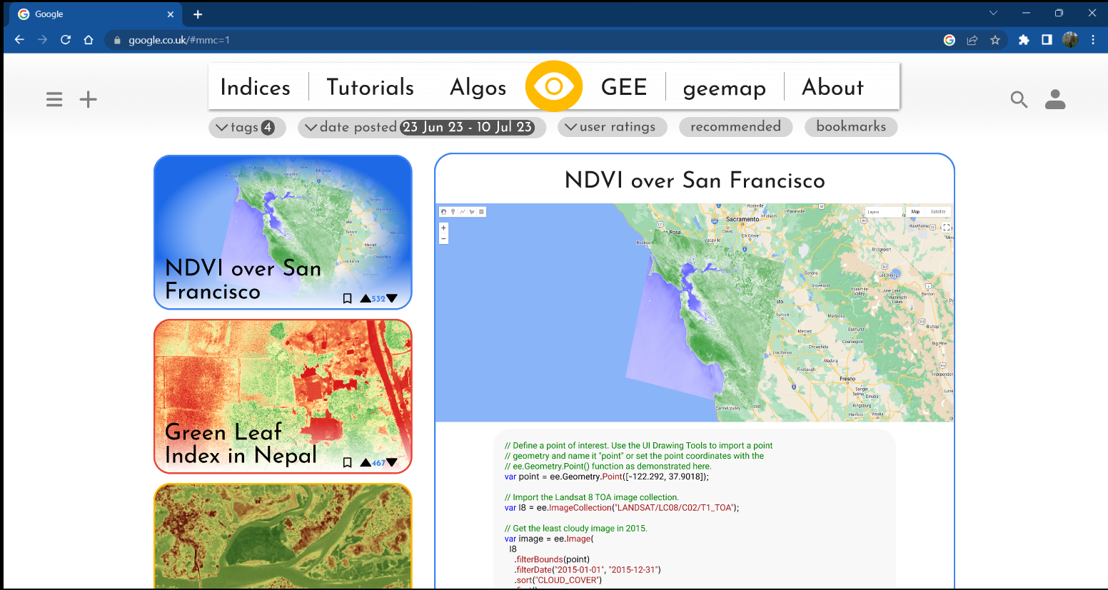

Figure 4 Initial prototype of the catalogue page. Top of the page.

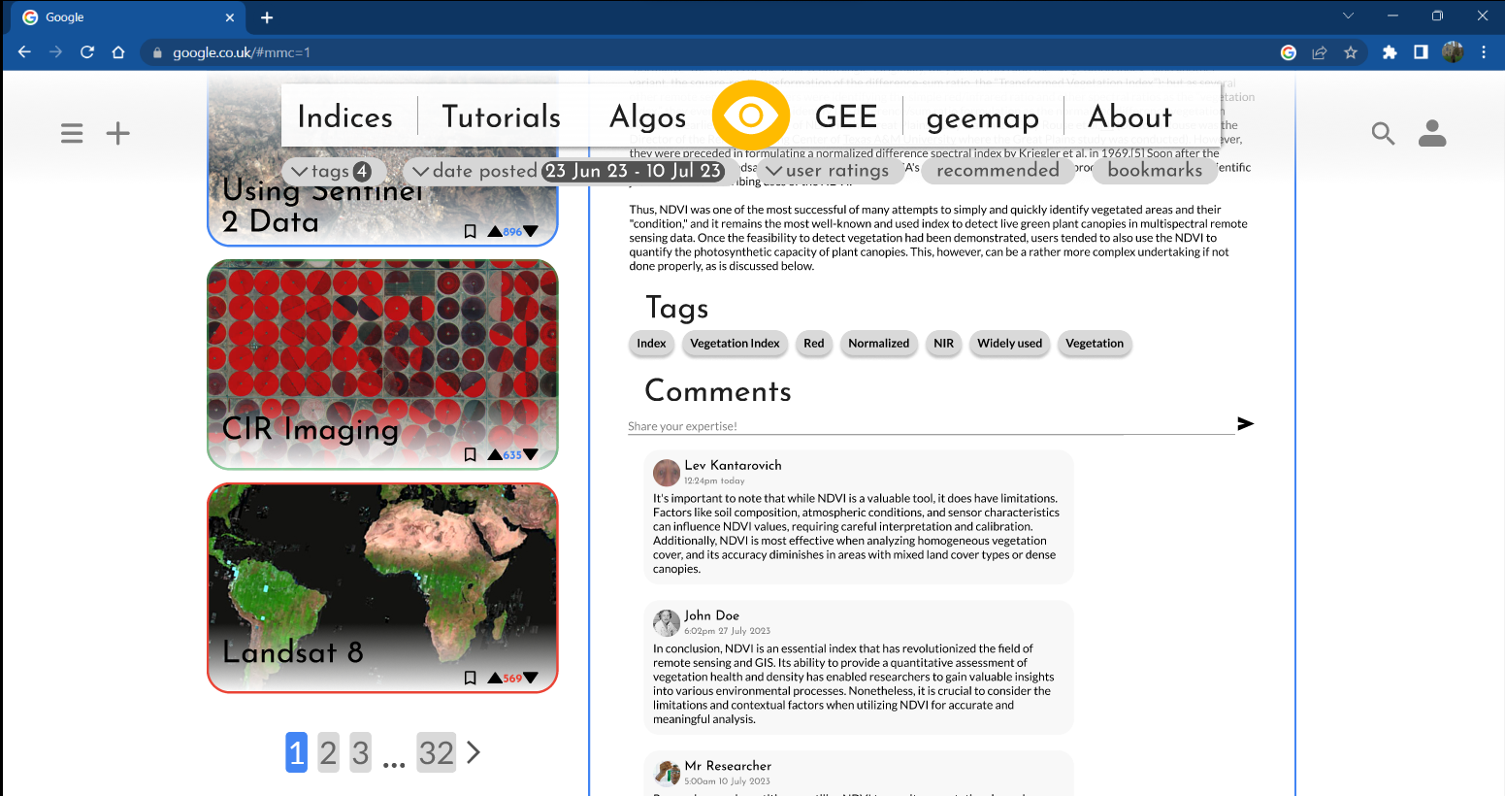

Figure 5 Initial prototype of the catalogue page. Scrolled down.

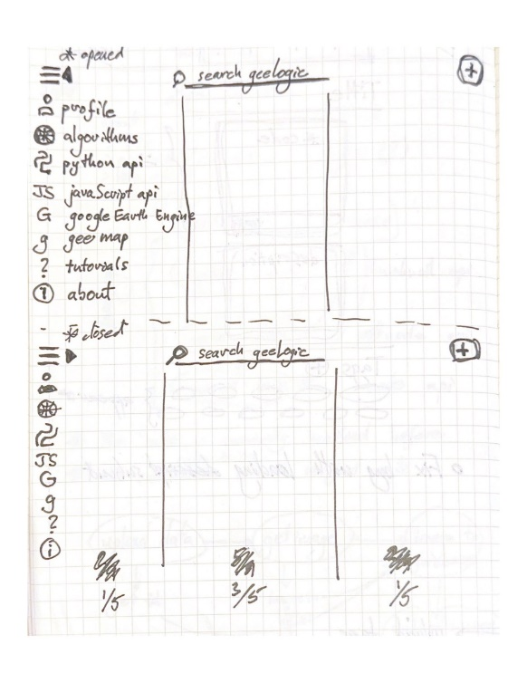

Figure 6 Sketch of the new design for the app bar. It was decided that the old app bar was less adaptable for responsive design and less elegant. Hence new navigation controls were created, with side menu instead of the app bar, persistent search bar at the top and a highlighted add algorithm button at the top right corner.

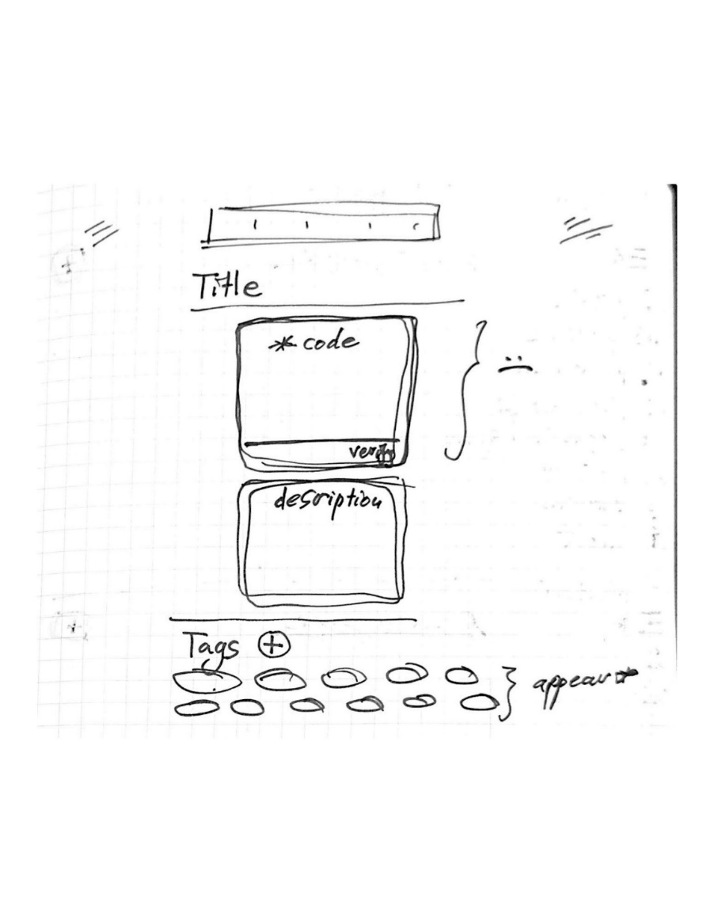

Figure 7 Sketch of the input page. This sketch represents the initial conceptualisation on how the input page would look like. Input page is where users would input information about their algorithms.

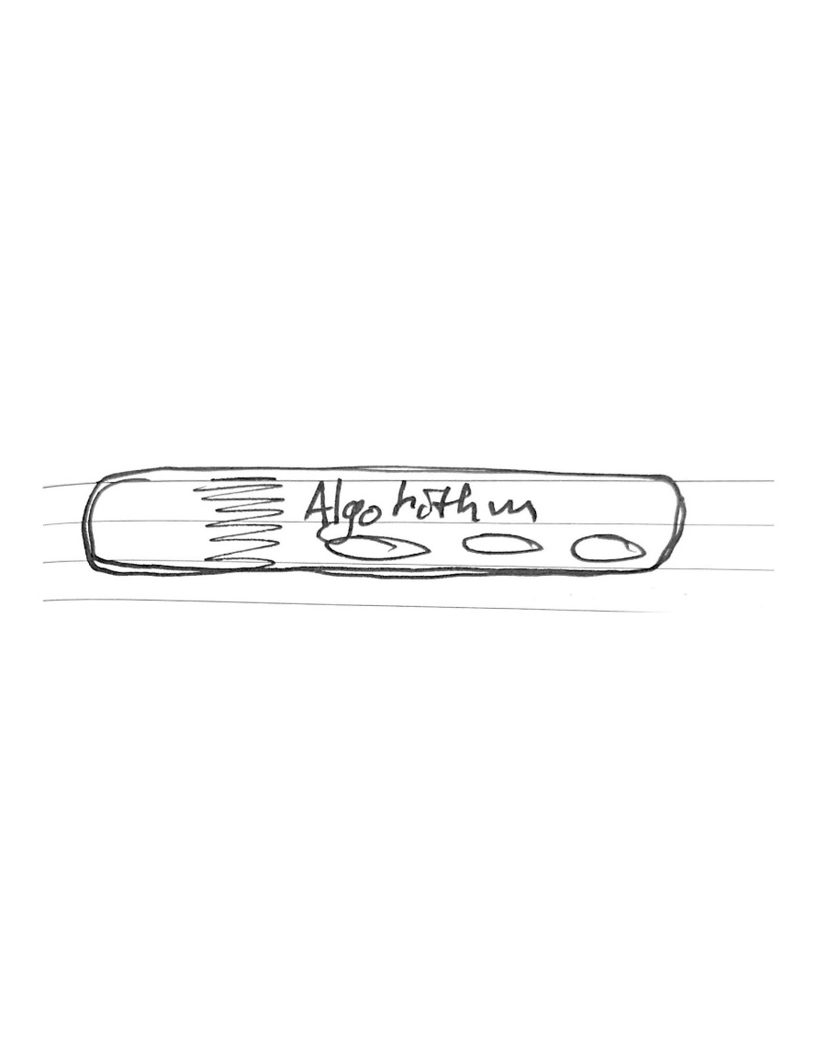

Figure 8 Sketch of the User Algorithm widget. This is a compact thumbnail used on the user’s profile page. Since the focus on said page is on the user's profile a new thumbnail was required to subtly list algorithms contributed by the user, as well as their bookmarks. This sketch was the solution to this problem.

Problem statement, and project’s requirements were described according to functionality and priority. It is stressed that GeeLogic doesn’t aim to deliver a fully functional service ready to be used by professionals, but to explore the feasibility of realising its key idea: to create a space for professionals to interchange ideas about GIS analysis. Hence, intended stakeholders’ and ideal users’ profiles were explored along with their user stories to further align the deliverable’s features with the users’ interests.

Finally, some prototypes and sketches were demonstrated, which were used to formulate the design philosophy of the UI. It was decided that since most crucial services were derived from Google’s projects, the general design should be reminiscent to that of Google.

# Design and Implementation

A Flutter web application was created and successfully deployed, albeit not SEO optimised making it hard to find through a search engine, but accessible to anyone with the right URL. It is fully functional and satisfies all must-have and should-have requirements outlined in Table 1 and Table 2.

This section will discuss the most technically interesting elements of development without going into the intimacies of the source code. Figure *9* and Figure *10* show the screenshots of the Catalogue Screen, which when compared with Figure *4* and Figure *5* are quite similar. Furthermore Figure *11* outlines the site map with icons at each bubble’s corner representing the icon used in the frontend as button to navigate to each one of those screens (except GL, which stands for GeeLogic, since Login Screen and Signup Screen cannot be navigated to using buttons). Figure *12* and Figure *13* show user flows of two of the most important activities: adding an algorithm and editing/viewing one’s bookmarks.

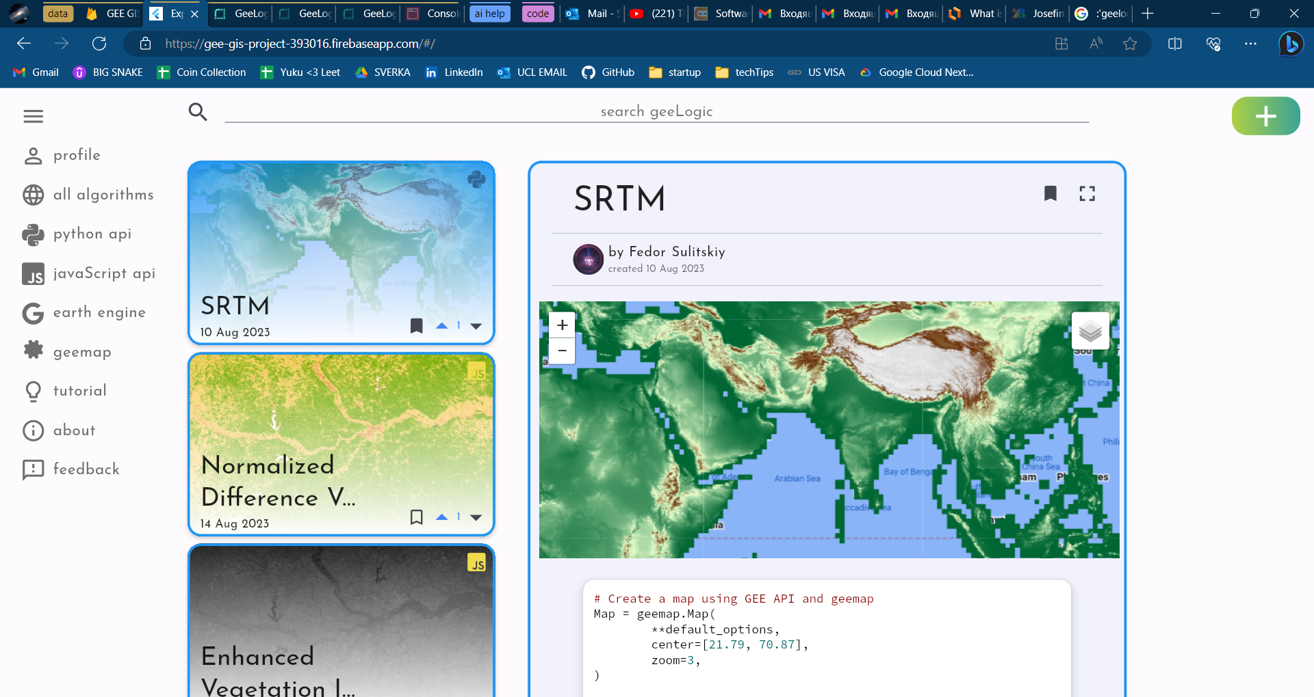

Figure 9 Screenshot of the deployed application's Catalogue Screen.

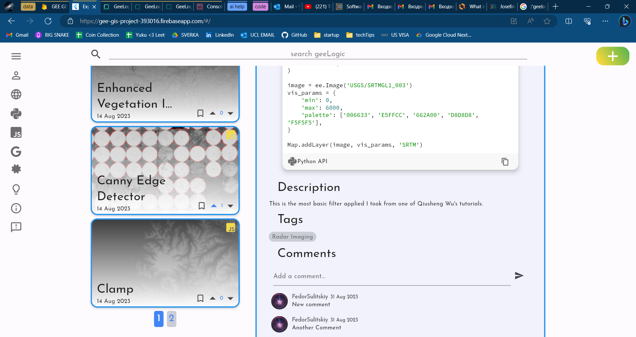

Figure 10 Screenshot of the application’s Catalogue Screen, scrolled down to better compare it with Figure 5 Initial prototype of the catalogue page. Scrolled down.

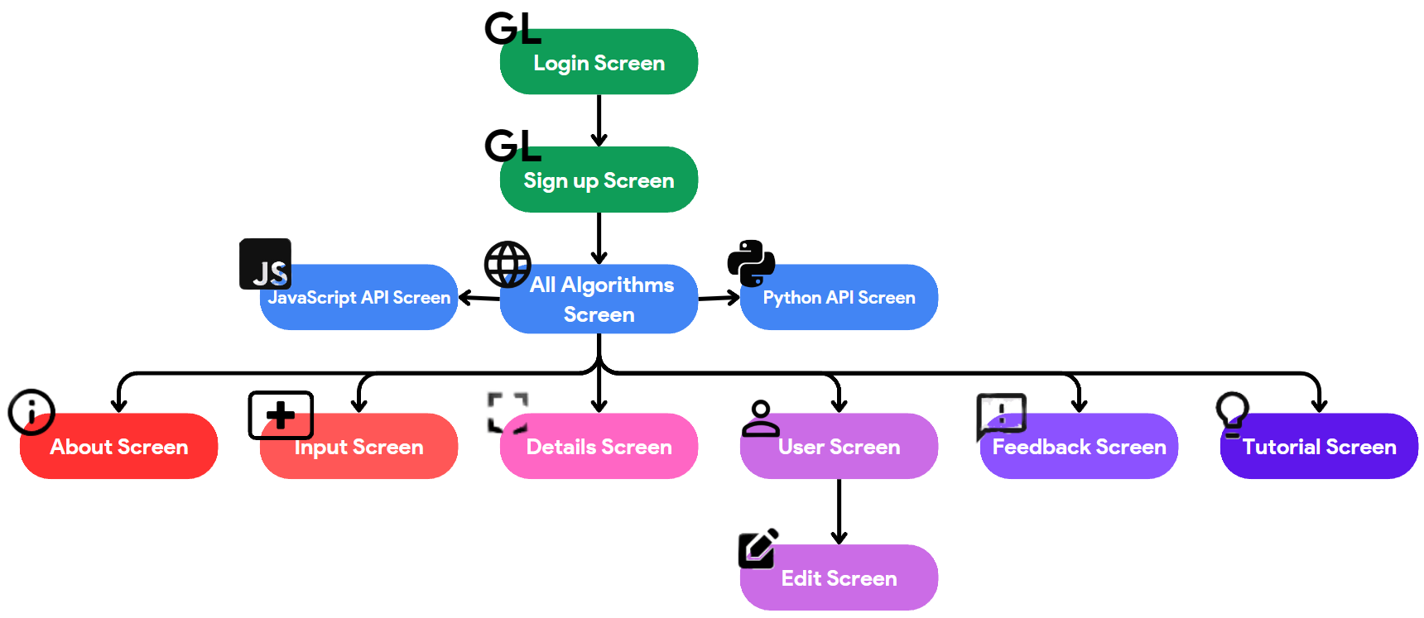

Figure 11 Site map diagram including every apparent screen of the application. However, it is important to note than not all screens are unique, and some are heavily recycled, such as the blue Catalogue-type screens, where their only difference is filtering by which language of the API was used to write returned algorithms: Python, JavaScript, or both.

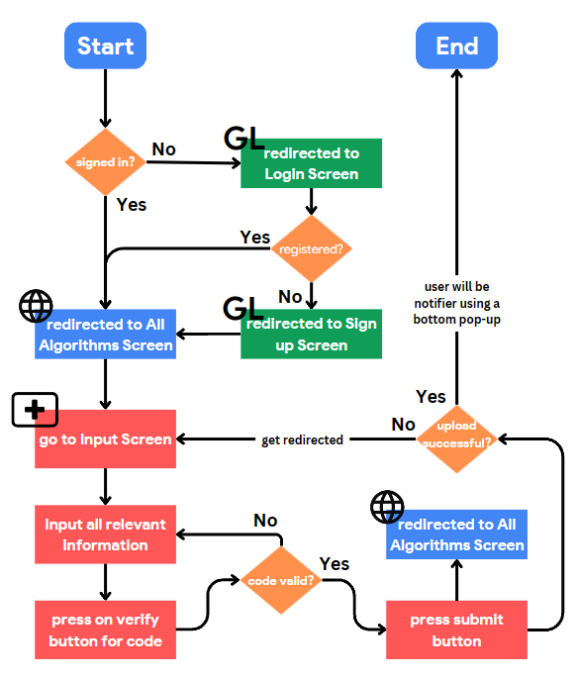

Figure 12 User flow diagram for the process of contributing a new algorithm. The upload sequence takes a relatively long time due to inefficient thumbnail generation, so to optimise user experience the user is automatically redirected to the All Algorithms Catalogue Screen so as they can occupy themselves with browsing the website while they wait. They have the option to return to the Input Screen if they wish, and the fact that their algorithm is being uploaded is reflected in the activated loading animation on the Add Algorithm button.

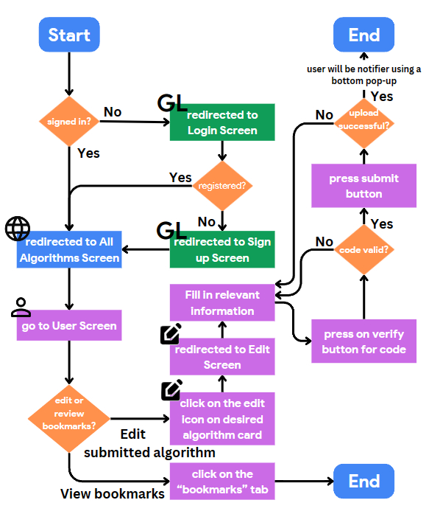

Figure 13 User Flow Diagram for the processes of either editing an algorithm already contributed by user or accessing bookmarks. Since access to either objective is very close, it made sense to include both on a single diagram.

## Architecture

GeeLogic operates via three APIs in the backend with additional support from Firebase. The three REST APIs: Node API, Python API and Thumbnail API are hosted on a service called Render, each dealing with its specialised areas of responsibility further explored in the Backend sub-section. Python API and Thumbnail API were dockerised prior to deployment, whilst Node API is directly deployed from Render.

Main body of data, about algorithms submitted by users is stored in a MySQL database hosted on Clever Cloud. Whereas more sensitive data, such as user data and user comments are stored on Firebase Firestore database. Images, such as user profile image and thumbnail images for the algorithms are stored on Firebase Storage database. The Flutter based frontend is hosted on Firebase also.

GeeLogic’s system architecture is represented on Figure 14 below.

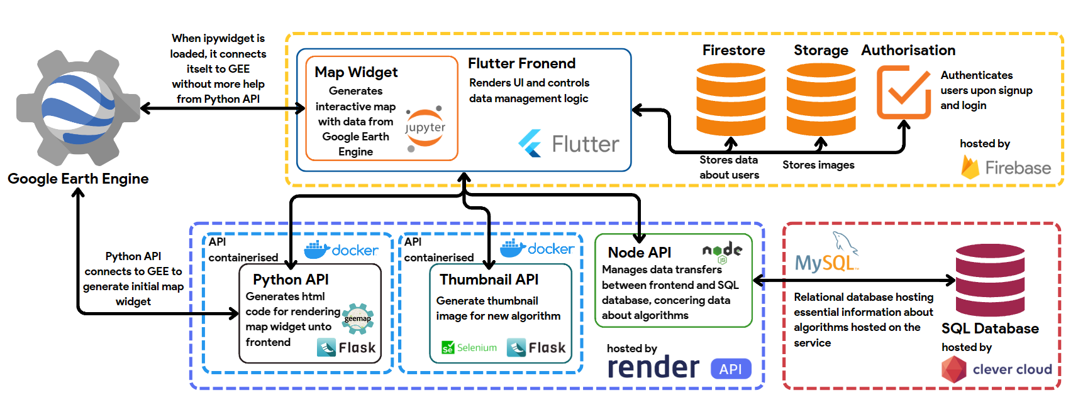Figure 14 System Architecture Diagram of GeeLogic. Each container symbolises a supporting system, where dotted borders indicate a hosting/formatting service, and solid lines are working software, developed for this project. Double arrows indicate two-sided transfer of data between various components of GeeLogic.

For example, the container at the centre bottom, shows that Render hosts the three APIs, two of which are inside Docker containers. Node API communicates both with SQL database hosted inside Clever Cloud and the frontend, while Thumbnail API is only linked to the frontend logic, with Python API talking to both the frontend and GEE servers.

## Frontend

Flutter proved to be a versatile and capable platform. Indeed, its features of hot reload and uniquely detailed support in Visual Studio Code assisted greatly in rapidly prototyping different solutions to a problem. Furthermore, it integrated very well with Firebase which made the whole workflow very smooth.

However, a few issues were encountered such as the difficulty in implementing a navigation system where each screen would be associated with a URL. In general, during development there were times when an ideal package to solve a particular problem was available for Flutter Android and iOS but not Flutter Web, which required lengthy trial and testing, adaptation, or invention of new, less optimised ways to solve said problem. This consumed a large amount of development time.

Nonetheless a sophisticated and functional application was developed. All the business logic is managed by the frontend, which meant most of the development time was spent using Flutter. There were a lot of unique techniques employed to build GeeLogic, however covering all of them would not fit in the scope of this report. However, a few concepts were deemed to be especially interesting from technical point of view. Namely: Flutter state management, responsive design, and navigation. However, prior to moving to those it is important to establish context about Flutter.

### Flutter Widgets

Developing with Flutter requires one to follow a unique design approach; every object rendered on the screen is a widget. Flutter creates a widget tree which relates many inherited widgets embedded in the parent-child relationship to render a graphical interface. For example, if one wished to create an application with a simple button at the centre, one would have a Screen widget that is simply a white background container, with a child of Center widget, that creates an invisible empty container centred inside its parent widget, that has a Button widget as its child. This is a simplified three widget tree which exemplifies what every Flutter app looks behind the code. In a real application these widget trees can have dozens of widgets embedded in one another.

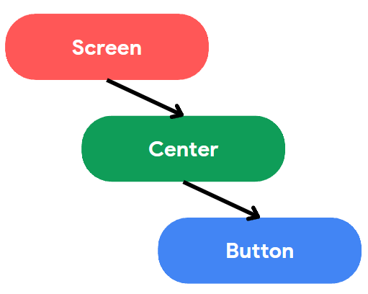

Figure 15 Simplified Flutter widget tree example

There are two key types of widgets: stateful and stateless. Stateful widgets can rebuild themselves if there is an internal state change. Stateless widgets are static and remain constant after a screen is rendered. For example, if one wanted the Button widget from the example above to change colour when tapped on, they would make it a stateful widget with an internal variable that controls the colour upon a button press. This is very useful since it allows for more efficient use of rendering resources. If one has a very large Stateful widget that has a lot of child widgets but only one element changes inside it, to avoid rebuilding all the static elements one can export the changing element into a Stateful widget and reformat the original giant widget into a Stateless widget. Hence, now only the small relevant part is rebuilt on change instead of the whole large thing.

Finally, a widget that is embedded inside a Scaffold widget, can be called a screen. It is still a widget, but the Scaffold is special as it allows its child widgets to be rendered on the screen in an organised manner.

This background information is essential to understanding this work in the subsequent chapters where elements making up the objects on each screen will be referred to as widgets. However certain widgets will be addressed to as Screens, this is due to them having a Scaffold widget as their first parent widget, being a root of the widget tree. They are no different to other widgets in terms of how they are written or how they behave otherwise, however it is more understandable to call them screens since they serve as origin for each screen or page of the application.

From hereon the different elements on the screen will be called by their widget names from the source code. Every element and its name have been documented under the Appendix User Manual, hence in case there is any confusion it is recommended to refer to it.

### State Management

State management is an essential concept to understand in Flutter development. It is also a relatively complex concept as is apparent from glancing at Figure 16**Error! Reference source not found.** and Figure 17, however efficient state management is the cornerstone of a functional Flutter application. In Flutter state means information, meaning state management is how information is passed across the widget tree. Normally information flows down, from parent to children, but not the other way round. For example, the colour of the Button widget from the example above can be read by a widget that is a child of the button but not by the Screen widget. This pattern is severely limiting for complex apps, but it’s solved through the use of providers.

Provider in Flutter can take state from a widget and transfer it to anywhere inside the widget tree. It is an outside mechanism that disregards the widget tree structure.

For this project the Riverpod package was used to manage state. It is not unique and there are a few Flutter packages that provide state management capabilities, but Riverpod was chosen due to it being one of the most modern and popular ones. It contains some specific providers, four of which were used in the development of this project:

* *State Notifier Provider* – most used, and recommended provider. It is used to listen to any changes in the state of immutable objects. If the listened-to object changes state upon user interaction will cause the provider to rebuild the widgets which listen to its changes. For example, when widget from code_input file receives new code from the user (when they input information about their algorithm) the codeProvider notifies listening variables inside submit_button (in the Edit Screen), submit_button (in the Input Screen) and verify_button files. These listening variables are then using this information to communicate with the backend to verify if the submitted code is valid for GeeLogic, or to post said code along with the rest of input data to the database.
* *Change Notifier Provider* – second most used since it is very similar to State Notifier Provider. However, the key difference is that this provider concerns itself with mutable objects. This makes it excellent for updating visible state of two separate widgets simultaneously. For example, DataMangerProvider has a purpose of providing data duplicate of that from the backend to allow for changes in the backend to be reflected immediately in the frontend without having to reload all the data from the database. An example of it being used is when one presses the bookmark button on the catalogue screen to bookmark an algorithm. The issue is there exist two separate bookmark buttons on the Catalogue Screen; one on the Algo Card (refer to Appendix I, part b. Catalogue Screen) and one at the top right corner of the Details Card, as can be observed on Figure 9. When user presses on one of these buttons it would be good user experience to have both change simultaneously, to avoid confusion. Hence, DataMangerProvider serves to rebuild one of the two immediately upon a change in either’s bookmark state.
* *Provider* – simplest provider. It creates a value. It is used by the singleAlgorithmProvider where it provides a Future object (pending object, which promises to resolve to some other data object upon resolution of an asynchronous operation). In this case the asynchronous operation was receiving information on a particular algorithm from the backend. In other words, it simply makes a request to the backend and provides the returned data.
* *Future Provider* – this is a specialised provider for asynchronous calls. It is practically the same as Provider above, but specifically for asynchronous calls. Example of a Future Provider would be mapWidgetProvider. It makes a request to the Python API to get a string of html code for rendering an interactive map widget.

Below on Figure 16 and Figure 17 the State Management Diagram (SMD) has been outlined. It is appropriately spread between two different figures since the two figures refer to files belonging to different pages of the application. This diagram would be essential for future development and navigating existing code for someone new as it shows intricate and complex relationships between widgets.

The SMD tracks every state management relationship between widgets, excluding internal state management, when state is changed but contained within a single widget. To read it one must follow the following bullet points:

* Focus on an individual node of interest and track where do its arrows lead to, as if they were train tracks.
* Sometimes lines cross or join but unless there is a gentle bend, that doesn’t mean that those cross-roads share state.
* Arrow pointing away from a node means that widget/provider passes data from itself to the receiving widget/provider.
* Arrow pointing into a node, naturally means it receives that information from the other node.
* There are also some double arrows; they indicate that a widget both reads and writes state to a provider.
* Black arrows indicate state movement via the providers and red arrows indicate state movement of state from one widget to another.
* Hollow nodes indicate widgets or helper functions; everything that uses state. The names of these nodes correspond with files where said widgets or helpers are stored.
* Filled nodes indicate different types of providers. The names of these nodes correspond to the name of each provider, not its file name, since some provider files contain multiple providers, whereas as a rule of thumb each widget file contains a single large widget.
* To determine the type of the widget, or type of provider one must look at the pattern of each node and compare it with the Legend on Figure 16.
* To determine the screen to which each widget file belongs one must look at the colour of the border. They are already grouped into bands according to their corresponding screen where the colour of the title corresponds to the screen for the nodes. An exception is the widgets from the “common” folder in the file directory. Their colour is dark blue.

For example, to interpret state management of catalogue_content (at the top left corner of Figure 16) one must follow three arrows which upon closer examination turn into seven due to some of them joining together. Four arrow lead into the node, meaning catalogue_content receives data from four providers:

1. allAlgorithmsProvider
2. selectedAlgoIndexProvider
3. selectedPageProvider
4. catalogueSelectedApiProvider

For context, catalogue_content is a widget that organises which widgets are present on the screen at the Catalogue Screen. It is responsible for rendering the elements related to different algorithms, on Figure 9 and Figure 10. Therefore, it makes sense that it requires to get an array of data to render these algorithms from allAlgorithmsProvider.

It must know which algorithm is currently selected to render one of the thumbnail cards with blue hue signifying that its selected, like with SRTM algorithm on Figure 9, meaning it needs data from selectedAlgoIndexProvider.

To avoid loading every algorithm in the database GeeLogic loads 5 algorithms per page, hence catalogue_content requires to know what page is currently being displayed so it can request a series of data with a different offset. This makes it necessary to read from selectedPageProvider.

Finally, catalogue_content is recycled for showing algorithms written using different GEE APIs; Python or JavaScript or all. On the side menu one can select which major category by API type does user wish to view, as per requirement F-S1. Therefore catalogue_content requires to know for which type of API it needs the database to provide information.

Next, catalogue_content provides state to its three child widgets:

1. algo_card
2. details_card
3. page_selection

Both algo_card and details_card display information about algorithms to the user, such as details about some particular information as well as generate an array of thumbnail cards for user to choose from. page_selection is a widget that allows user to click on which page to display at the Catalogue Screen, meaning it needs to know the range of pages required to contain all the data so user cannot click on a page without data. When catalogue_content requests data to render information on the screen from the backed, it requests data limited to only five algorithms with an offset to load one page at a time, as well as it requests the length of the total number of matching algorithms. That last parameter is passed into page_selection to let it know how many page buttons it needs to generate.

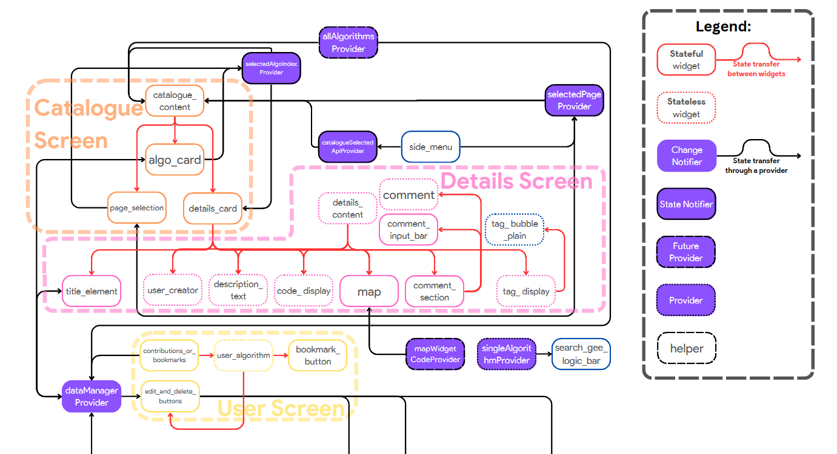

Figure 16 Top half of the State Management Diagram, with Legend.

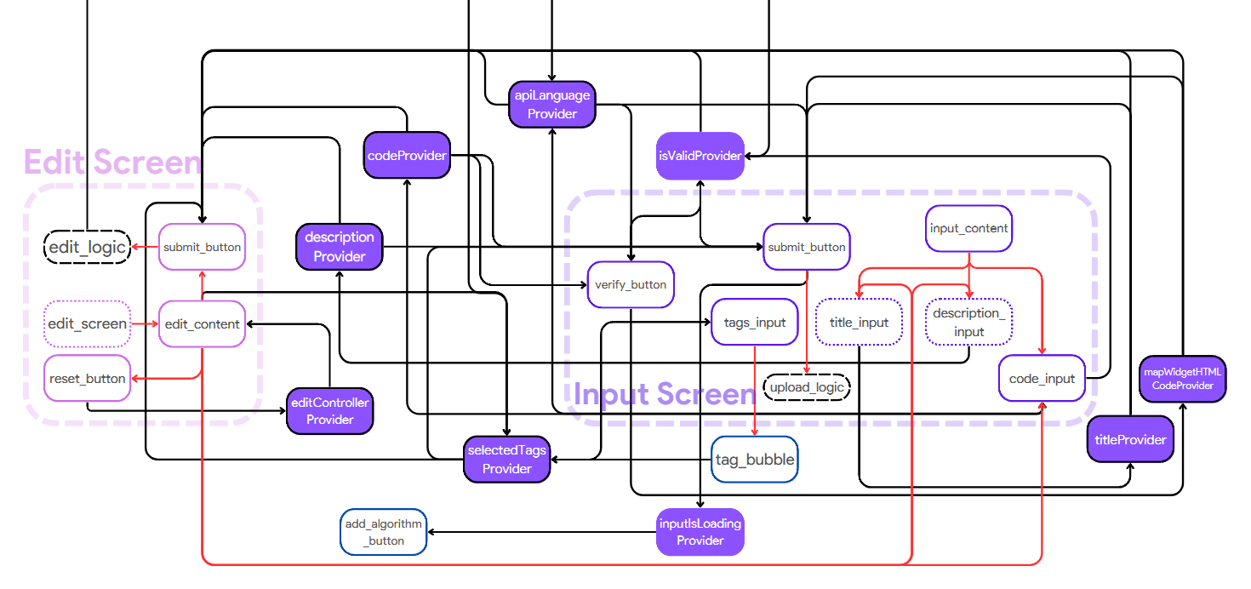

Figure 17 Bottom half of the State Management Diagram.

### Responsive Design

An essential component of any website or web application is its responsiveness to changes in window size. A good application will adjust its widget size or configuration to cater to the smaller screen. Hence it was important to introduce this element to GeeLogic.

The development approach for this project was the following: to design every layout to fit the screen of the development machine perfectly and then make it responsive as a finishing step. This proved a harder endeavour than originally anticipated, making this approach sub-optimal. Nonetheless responsiveness was mostly introduced successfully. Every screen adapts according to the size of its window and successfully retains its content even at the limits of the browser’s width, except Catalogue Screen which struggles at widths smaller than 800px.

The responsiveness was mostly introduced through tying the width of particular widgets to the width of the screen and multiplying their intended maximum size by the ratio of current width / height to the maximum width / height, with certain limits set. Furthermore, to fit more information on the screen under a certain width the Side Menu was converted to a drawer such as exemplified by Figure 18.

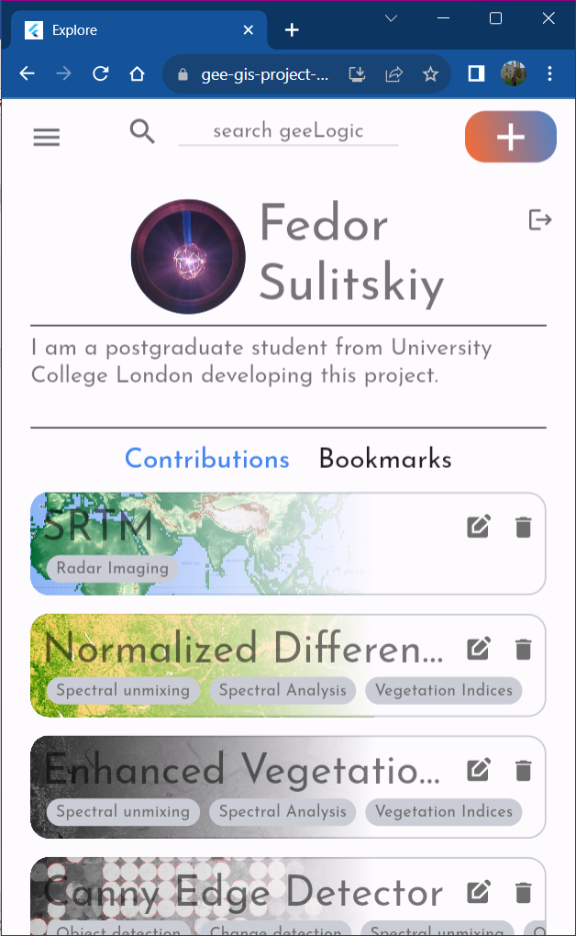 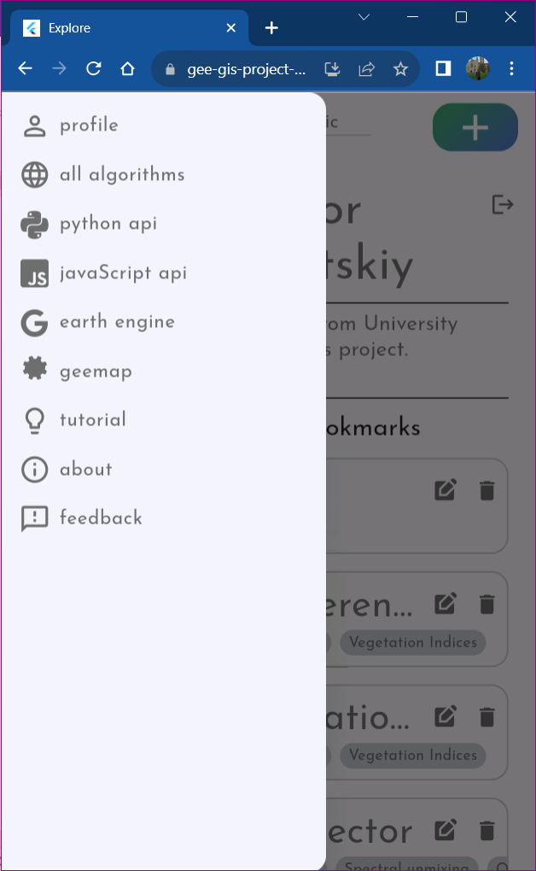

Figure 18 User Screen responsive design, with Side Menu drawer.

### Navigation

GeeLogic implements basic Flutter navigation. For the purpose of keeping the development fast it was decided to use basic navigation 1.0 for this application. This style of navigation is easy to implement and understand, however it is optimised for mobile use, not browsers. It is imperative, while navigation 2.0 is declarative; harder to implement but well optimised for using it in a browser.

For context, Navigator 2.0 is an upgrade of Flutter’s original navigation system and was introduced in the latter half of 2020, hence it is a technical term. Normal navigation works by calling the screens as widgets and then optionally associating a route with them; but, Navigation 2.0 uses a route to associate a widget with.

There exists a sole route in the application, with input_algorithm_details endpoint. During the uploading of a new algorithm, it allows the user to go back to the Input Screen as they left it when they pressed the submit button.

Normal navigation is an effective, but temporary solution since it comes with multiple downsides. The different screens visited by the user are not registered in internet history, meaning navigation around the app using URLs is also impossible. The back and forward buttons integral to any browser do not necessarily direct the user to previous screen, but occasionally quit the entire app. The aforementioned route is not directly associated with the Input Screen since it is possible to be looking at the Catalogue Screen with the input_algorithm_details endpoint in the URL bar. Finally, whenever the user logs out, they will be redirected to the Login Screen, but to login they will need to reload the page once; another side effect of using Navigator 1.0.

These problems however have a solution; employing Navigator 2.0. Despite this, it was not implemented in the current version of the project due to the associated complexities that come with using Navigator 2.0. Since navigation was not deemed to be one of the primary requirements it was decided to deprioritise it in favour of focusing on core features, which resulted in it not being implemented by the deadline.

## Backend

It was decided to implement three separate APIs called: Node API, Python API, and Thumbnail API. This decision was taken due to the necessity to write them in different computer languages and the potential redundancy of some functions provided. Node API and Python API received their names from the frameworks they were written in. Thumbnail API is considered less important and hence was not joined with Python API but kept separate. Its function is to provide each algorithm with a thumbnail image upon creation, which gave it its name.

For further reference, each API has comprehensive documentation associated with it, and can be accessed at Appendix II API Documentation.

### Node API

Node API’s role is to manage data transfers between the main SQL database and the frontend. The data contains information about each algorithm; its description, title, code, user who created it, when it was created, upvotes, etc. The only data that is not managed by this API is the personal data about each user, thumbnail images, and comments.

### Python API

Python API’s responsibility is to link to the code submitted by users, geemap functionality and the frontend. It receives the code submitted by user, formats it to work with geemap, generates an ipywidgets html widget and exports the html code as a string back to the frontend. The frontend can then render said html code as a widget.

This API contains two queries: for getting a map widget when using Python and when using JavaScript GEE APIs. Their workflows are very similar, and both leverage powerful functionality offered by geemap library.

The workflow of the query which generates map widget from Python code is the following:

1. Receive the string with code from the user and clean it from unwanted artifact such as new line identifiers “\\n” or excessive indentation identifiers “\\t”



1. Set default options of the Map geemap object which determines which elements are present on the ipywidgets widget later at the frontend. This must be universally set to ensure consistent user experience. The only controls permitted to remain are the zoom control to facilitate more convenient zoom into the map, for users who don’t have a computer mouse.



1. Establish a template with the first line of code always being the initialisation of Earth Engine command so that users wouldn’t have to authenticate to use GEE.[2]



1. Finally execute the string received by the API as a string using “exec()” command, extract the resultant map and export it as an html string.



The workflow for the query which generates map from JavaScript code is the following:

1. Steps 1 and 2 are identical to those above.
2. Initialize Earth Engine and convert the JavaScript to Python code. This step is problematic since geemap is imperfect at converting JavaScript to Python which means some valid Google Earth Engine code unfortunately cannot be hosted on GeeLogic in its current state.



1. Final step is also practically identical to that of the above query. It involves executing the string, now Python code, using “exec()” command, followed by export of the generated ipywidget map as html code.



### Thumbnail API

As mentioned above Thumbnail API is considered to be less important since it is not a permanent solution to the problem of generating a thumbnail for a new algorithm. It contains a single query, which received an html string, corresponding to that generated by the Python API. It proceeds to use the string to open a headless Chrome browser window, wait for the html ipywidgets to render and takes a virtual screenshot of the map generated with algorithm applied on it. Finally, it converts the image to base64 bytes array, and exports it as a string back to the frontend where it is modified appropriately and sent to the Firebase Storage.

Base64 is a binary-to-text encoding scheme which allows one to reliable transfer binary data, image, across an http channel.

### Database

MySQL, Firebase Firestore (from hereon to be referred to as Firestore) and Firebase Storage (from hereon to be referred to as Storage) are used to store user data and comments, and images, respectively. MySQL contains data describing each algorithm.

Furthermore, Firebase manages the registration and authentication of users through their Google accounts. It was convenient to also use it to store confidential information and images which can be problematic with an SQL database, due to lower security.

Firestore is a non-relational database with no schema meaning its very versatile in terms of the form of data it stores. However, there are some rules on how its set: Firestore database splits into collections which contain documents, which contain other collections, etc, until actual end information (alphanumeric, timestamp, null etc.) is stored as fields. Collections store documents as a list and documents store information in json format, containing other collections or fields. This is a versatile approach that is quite easy to navigate and understand but less straightforward to describe as a diagram in case the end documents all have different fields.

Fortunately, in this case each end document and collection have a rigid structure enforced by the logic of the frontend, allowing for easy navigation, and if necessary straightforward migration to a relational database.

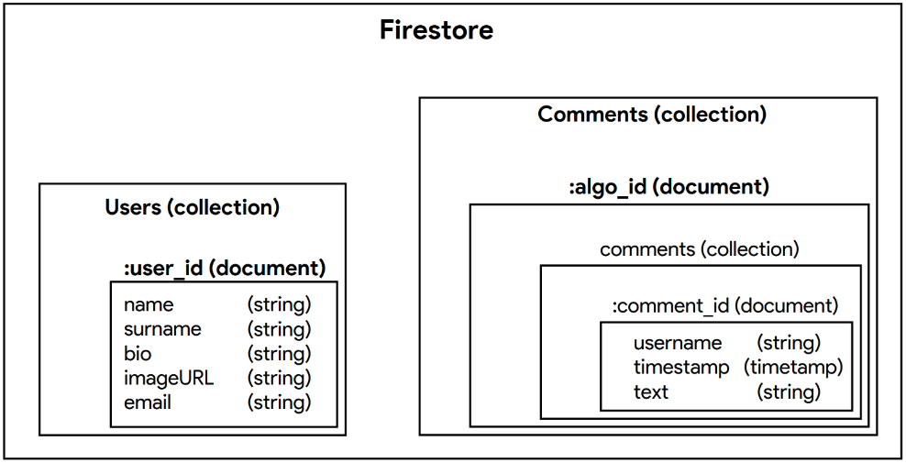

Figure 19 Relational diagram representing how data is stored inside Firestore. As mentioned before Firestore is a non-relational database which stores data in a series of fields inside documents, inside collections, inside other documents, inside other collections etc. For user data each user is stored as a document in a collection “Users” where each document has its id automatically generated by Firebase and contains five fields all containing a string: name, surname, bio (biography), image URL and email. For comments, the “Comments” collection contains a list of documents that correspond to each algorithm. Each document contains another collection “comments” which contains documents corresponding to each comment left by users. Each comment document contains three fields: username, timestamp, and text.

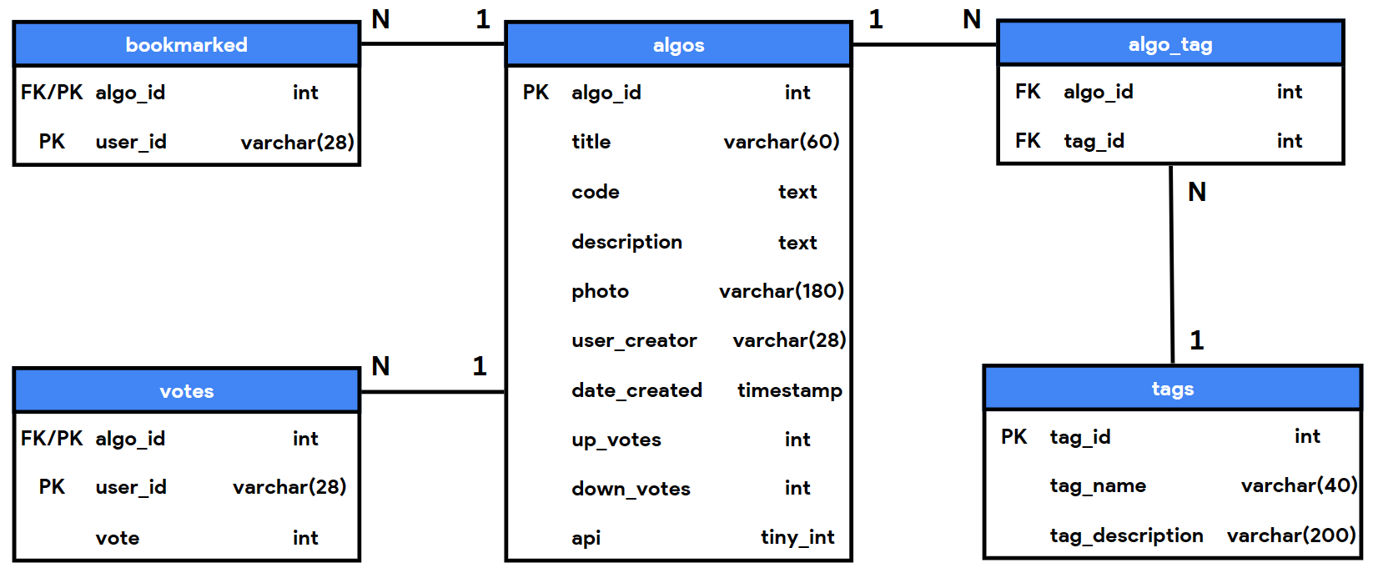

Figure 20 ER Diagram for SQL database

The SQL database is normalised to the 3rd Normal Form and contains five different tables which all eventually connect to the “algos” table containing core information about each algorithm. The database is quite straightforward since it is focused on managing data for a single type of entity; user submitted algorithm. Nonetheless Node.JS API requires a relatively complex query to access it to extract relevant information in a single request, where an example of such a query is present below:



This command is used in the “show” mechanism of the Node API, where mechanisms with endpoints “show_by_id”, “find_contributed_algos” and “find_bookmarked_algos” use very similar SQL commands. Initially multiple queries were used to separately extract the list of tags for each algorithm or determine if it was ever bookmarked by a specific user, but this approach was sub-optimal since it required a large number of requests being sent to the database which flooded the logfile needlessly and overwhelmed the free tier database.

Below is an example response from the “show_by_id” endpoint using id 42 and test account id as parameters of the request body (refer to Appendix II API Documentation for documentation on this request). Most notable is the value of the “tags” key. It is a string that contains a list of json objects corresponding to every tag related to this algorithm. SRTM only has “Radar Imaging” tag, hence there is only one json object in this list. When parsed to the frontend, this string is decoded into a list of json objects, which is then used to display tag bubbles as can be seen on Figure 10.

It is representative since when endpoints with multiple algorithms are called, the json objects containing information about the algorithms are of the same format.



It is also notable that data.api_condition and data.order_condition are parsed directly into the SQL command, however these values are not available to the be directly managed by the user, instead they are only managed by the front-end making them unsusceptible to SQL injection attacks. These variables were introduced to facilitate future developments, of adding an order-by and filter functionalities. Despite this being an experimental project, future improvement was always under consideration during development!

This chapter overviewed the technical implementation of the project. Separated into three sub sections, 4.1 Architecture, 4.2 Frontend and 4.3 Backend, this section described the general overview of GeeLogic, the way its frontend was developed and its backbend’s functionality including three REST APIs and storage management.

Most technically curious elements were highlighted in this section including state management for Flutter, culminating in Figure 16 and Figure 16 Top half of the State Management Diagram, with Legend.Figure 17, or means of converting user’s input into an interactive map connected to GEE’s services in sub-section 4.3.2 Python API.

# Testing

Flutter Web works by translating the original Dart code into html using its CanvasKit render engine which is then displayed by the browser. However, the end-product lacks familiar html structure which makes it very hard to use a tool like selenium to create automatic tests to test the functionality of the product. Hence, testing GeeLogic for this report was done using manual sequences. The representative user flow was identified which would trigger every backend query. It is documented in this section and results of its performance are recorded below. However, there is also a need to test certain miscellaneous functions, which are explored in subsequent sub-section.

## Main Testing Sequence

The sequence below will cover key features of GeeLogic, namely the functions associated with submitting, reviewing, and manipulating GIS algorithms.

1. Sign in with new account.
2. Post new algorithm. During uploading attempt to return to the Input Screen and back.
3. View the new algorithm on both the Catalogue and Details Screens.
4. Comment under the algorithm, observe changes.
5. Search for the new algorithm.
6. Upvote it / Downvote it.
7. Bookmark it.
8. Find in bookmarked tab under User Profile Screen and remove bookmark.
9. Edit the newly submitted algorithm.
10. Observe changes.
11. Delete the newly edited algorithm to leave the state of the website the same.

The tests were conducted twice, and response times were recorded, with wound down APIs and fully active APIs. As mentioned before, Render on free tier hosting winds down the API after 15 minutes of no use which means next query will take much longer to return since it will take some time to return the API back to full functionality. Where testing times are not stated, it is either because the time to load was negligible or because it was already stated in one of the previous steps.

1. Sign in with new account.

After being greeted with the Login Screen, user is redirected to the Signup Screen in case they are not already registered. During the test a secondary account was used to authorise the user using Google.

Default avatar image is chosen to demonstrate that this option is available for those users who lack images on their device. Subsequent testing will show that it is possible to select custom image as one’s avatar image.

It took approximately five seconds for the system to register the new account and another 25 seconds to load the first five algorithms. Upon reloading the page, the wound-up API managed to reduce that 25 seconds to only 5. With another 17 seconds to render in the map, where 10 seconds was just the rendering of the html, meaning the response time was around 5 seconds, on the wound-up API. If the Python API was given a “cold start” it takes around 20 seconds more to load in the interactive map.

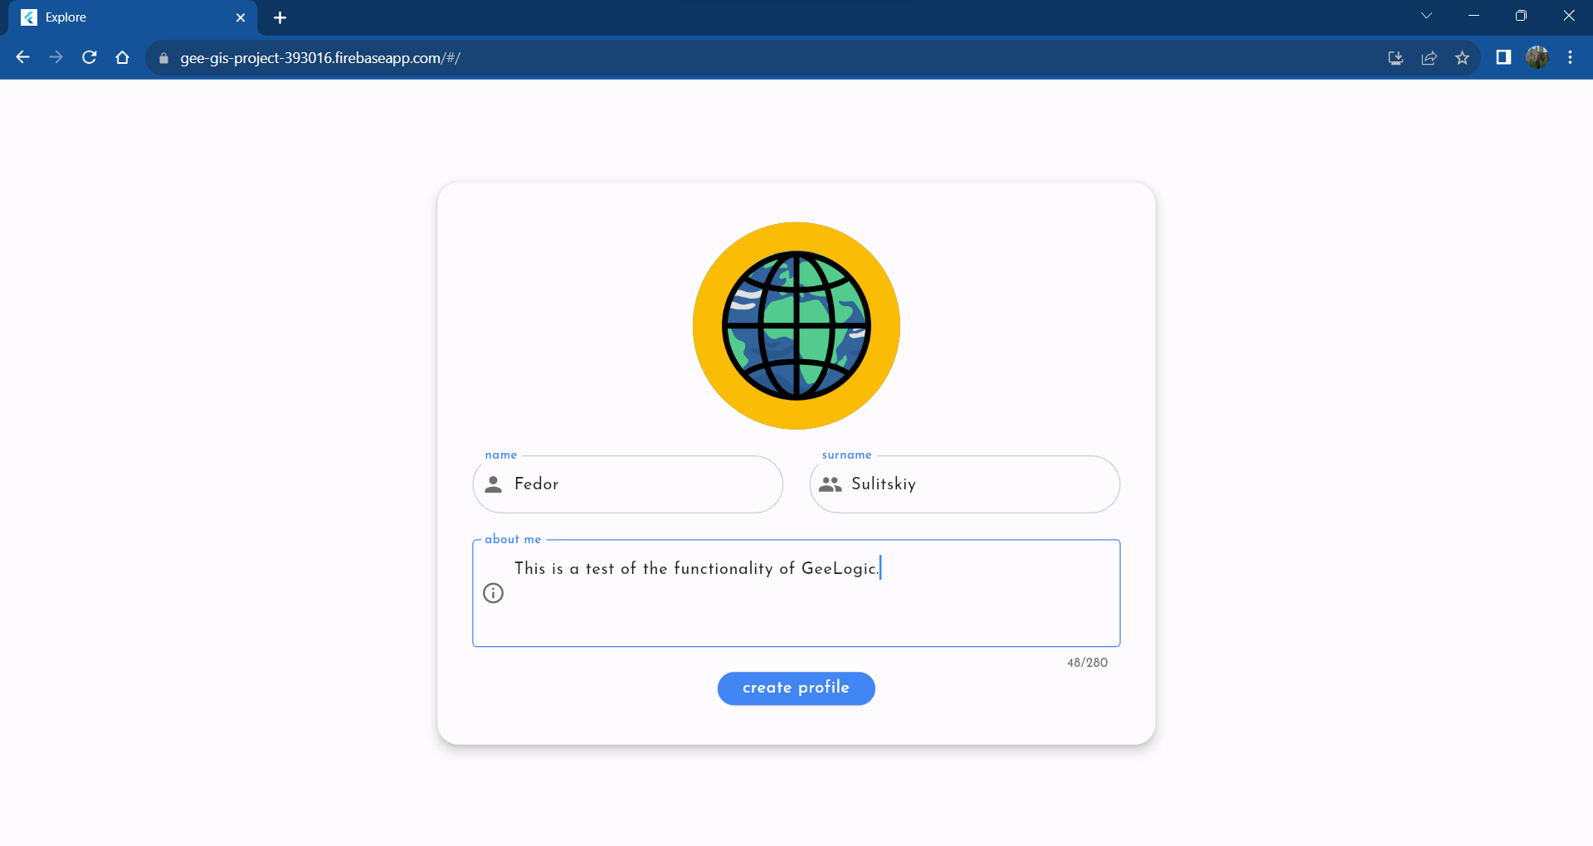

Figure 21 Screenshot of the Signup Screen.

1. Post new algorithm. During uploading attempt to return to the Input Screen and back.

A new “Test Algorithm’s” details were input, and the new code was verified.

It is notable that for Python API the Map object is created by default for the convenience of the users. Since it has no filters, it is a valid input. Therefore, for the purpose of testing simply leaving the code is sufficient to have it verified. It took 6 seconds to verify this code, warmed up, and around 22 seconds after waiting for the Python API to wind down.

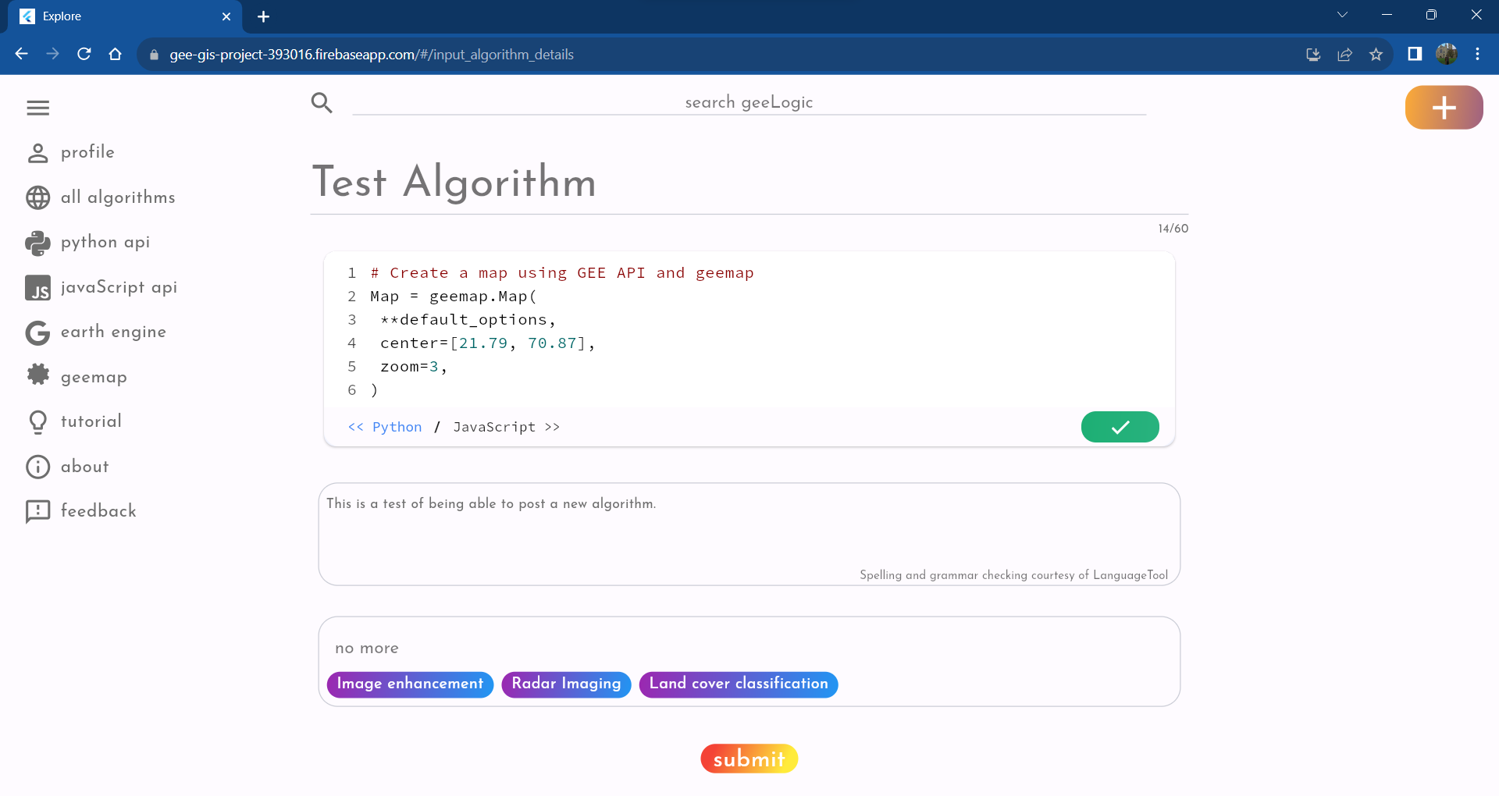

Figure 22 Screenshot of the Input Screen with code verified.

The waiting time for uploading the algorithm was the largest bottleneck; it took around 55 seconds to post when wound up and almost two minutes when all APIs were wound down. This large waiting time was the main reason for creating the user flow which redirected the user to the Catalogue Screen to occupy them with browsing while they wait for the upload to finish.

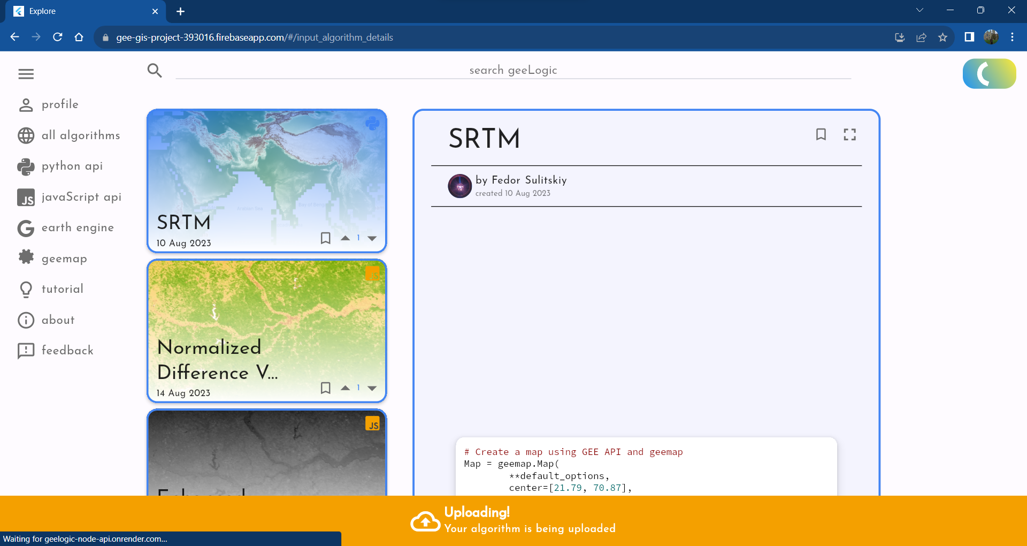

Figure 23 Screenshot of the Catalogue page, right after submitting the algorithm for upload. It will automatically redirect user here since the upload procedure takes a long while, so this user flow allows user to occupy themselves while they wait for the upload. To let the user know that uploading is taking place, the bottom pop-up will inform the user, as well as a loading animation will play on the “add algorithm button” instead of having a plus icon, at the top right corner.

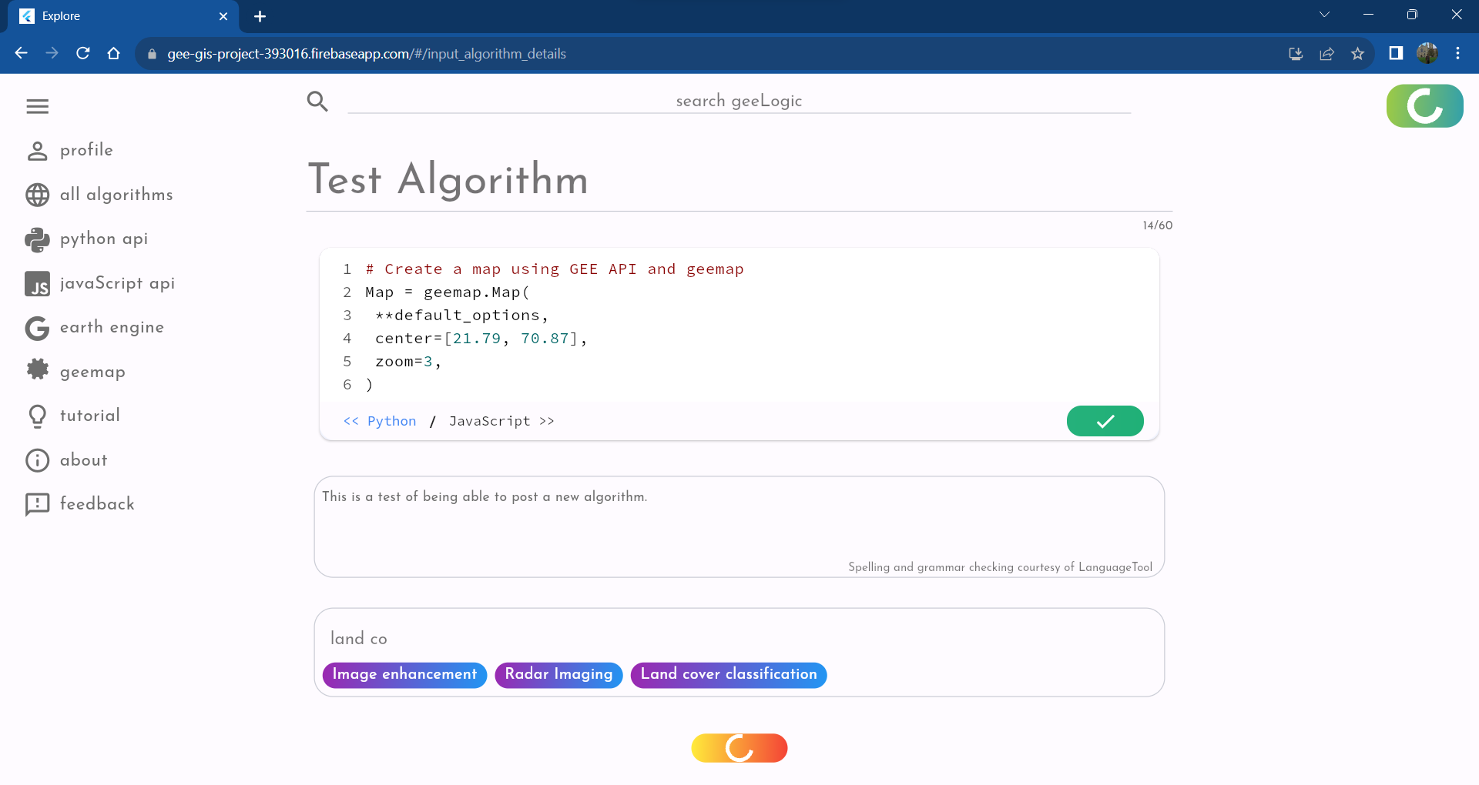

Figure 24 Screenshot of the Input Page. As can be seen by the loading animations both on the "add algorithm button" at the top right corner and at the "submit" button at the bottom of the screen the uploading is in progress, which means that users can return to their submission if they so choose in spite of being initially redirected to the Catalogue Screen.

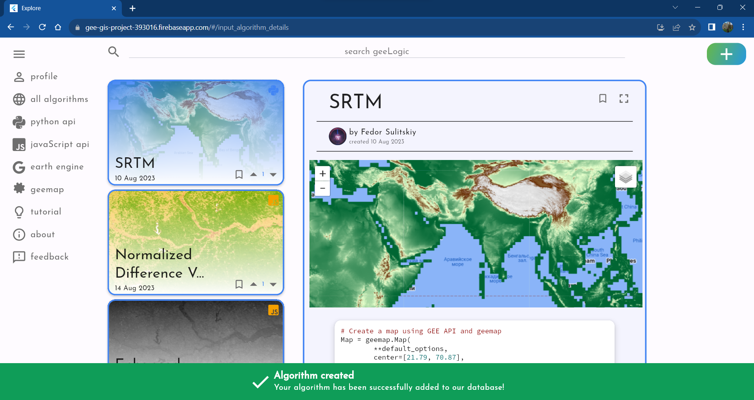

Figure 25 As part of testing this user flow, the user returned to the Catalogue Screen. When the upload is successful, they get informed by the green bottom pop up as shown on this screenshot. Since uploading is no longer taking place, the loading animation reverted to a plus icon at the “Add algorithm button”.

1. View the new algorithm on both the Catalogue and Details Screens.

Upon navigating to the Catalogue Screen for all algorithms, and then to page two, since algorithms are ordered in chronological order of submission, it is possible to discover the new “Test Algorithm”. As expected, it represents a blank Google Map. Furthermore, when going to the “python api” Catalogue Screen, the new algorithm can also be found there, since it was made using geemap and the Python API.

Finally, the new algorithm can be viewed on its Details Screen which is accessible when pressing the frame button at the top right corner of the details card of the algorithm on the Catalogue Screen.

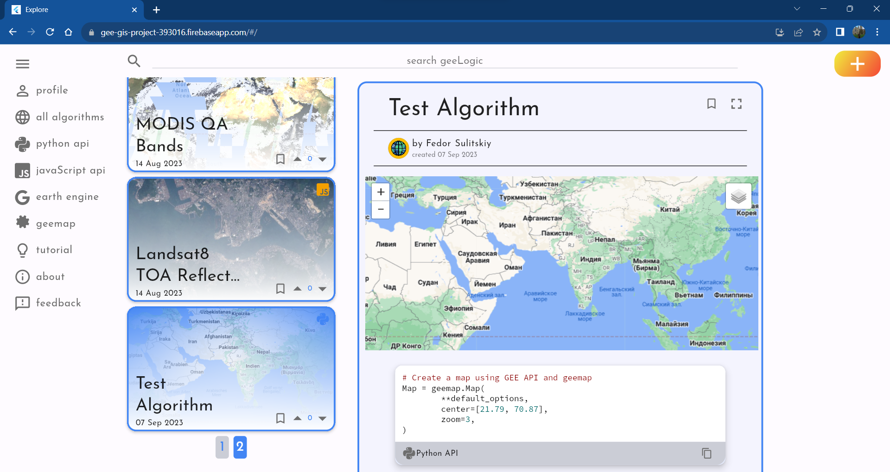

Figure 26 Screenshot of page two of "All algorithms" Catalogue Screen, with new test algorithm present.

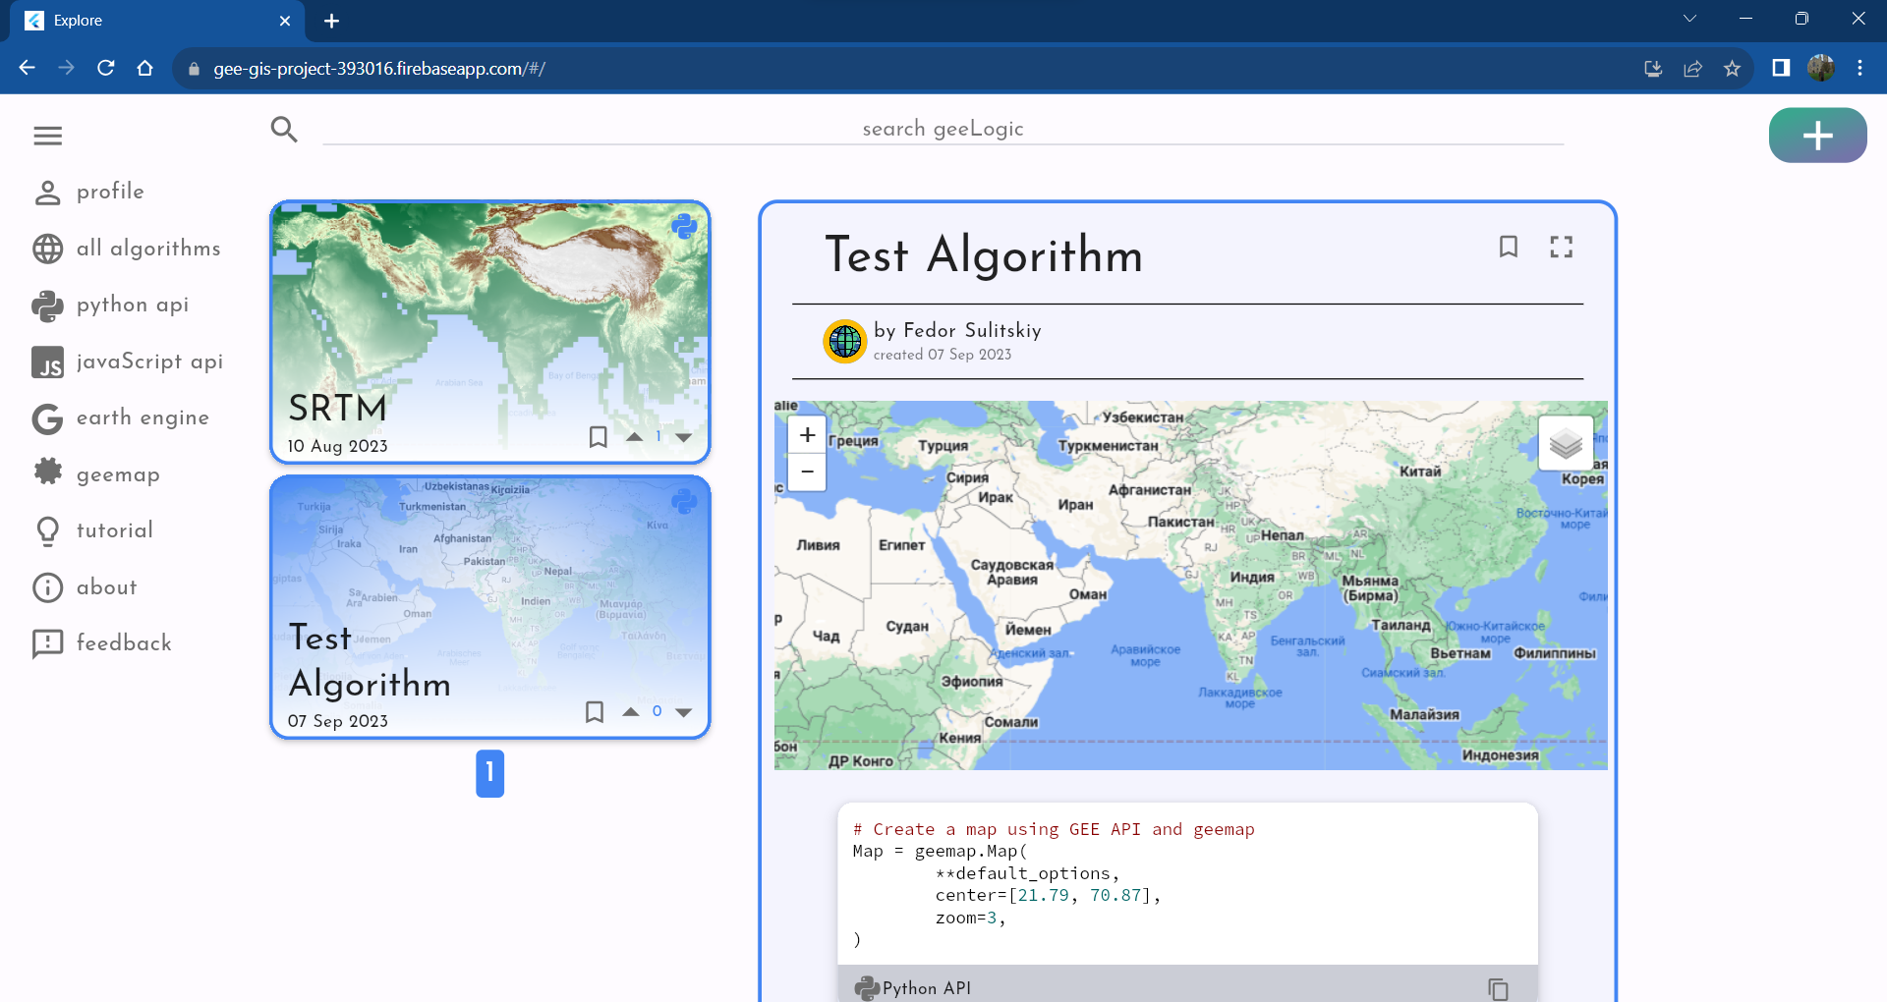

Figure 27 Newly created algorithm can also be found at the "python api" Catalogue Screen since Python API was used to create it.

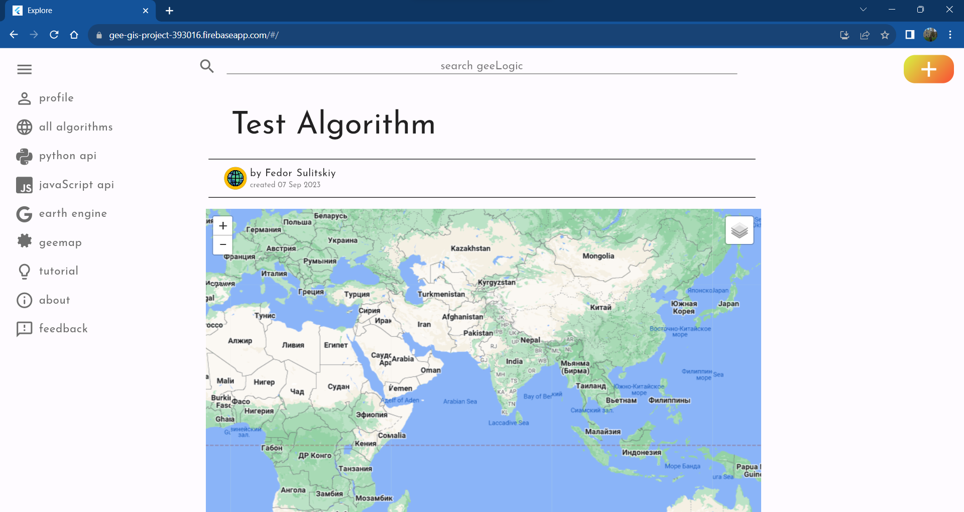

Figure 28 Screenshot of the Details Screen of the Test Algorithm, demonstrating that it is rendered on that page.

1. Comment under the algorithm, observe changes.

A comment was left, “This algorithm is amazing and eye-opening!” (Which is certainly true for Google Maps service). Upon reloading the page and navigating back to the “Test Algorithm” the comment remained there.

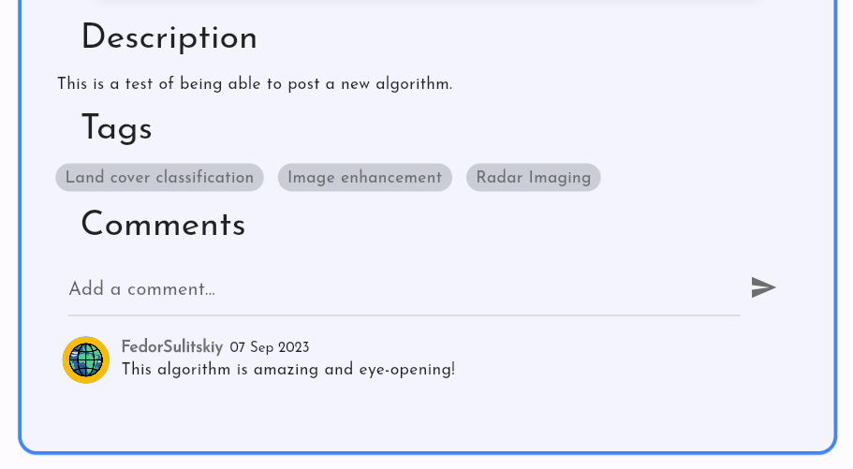

Figure 29 Partial Screenshot of the bottom of the Information card of the newly added test algorithm. It demonstrates the success of leaving a persistent comment.

1. Search for the new algorithm.

Upon writing “test” into the search bar it displays the clickable button with the new “Test Algorithm” showing the correct functionality of the search feature. This button, if clicked will lead to the Details Screen of the “Test Algorithm”, which also proved successful.

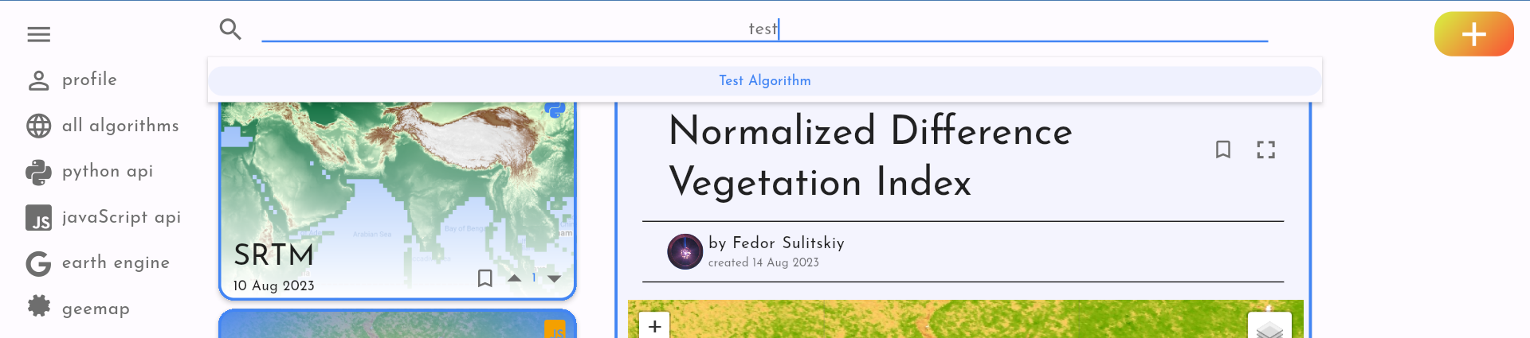

Figure 30 Partial screenshot of the top of the browser window with GeeLogic opened. Word "test" is typed into the search bar at the top of the screen, with "Test Algorithm" returned as an option for user to choose from. This is reasonable since no other algorithm in the database contains the string “test” in its name or tag.

1. Upvote it / Downvote it.

Upon clicking the upvote and downvote button the counter changes by positive or negative one. Furthermore, the arrow lights up blue or red, indicating the current user has voted for this algorithm.

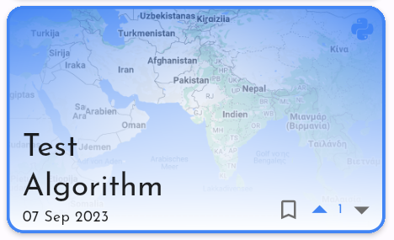 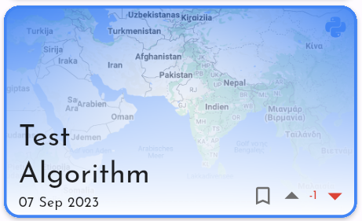

Figure 31 Demonstrates two screenshots of the "Test Algorithm's" thumbnail window, one with a single upvote, and one with a single downvote. This shows that feature is functional both ways.

1. Bookmark it.

Upon clicking either bookmark button the other one is also changed, notifying the user if the algorithm in question is bookmarked or not. There are two bookmark buttons: on the Algo Card and at the top of the Details Card.

Clicking on a bookmark button the second time will make it empty, signifying it has been removed from one’s bookmarked algorithms.

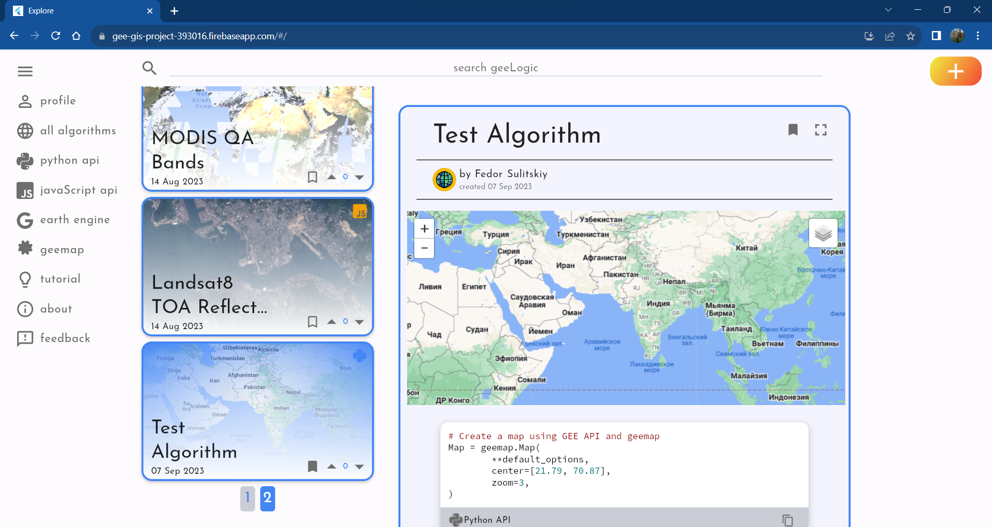

Figure 32 Screenshot of the Catalogue screen, demonstrating how "Test Algorithm" has been bookmarked by the user.

1. Find it under bookmarked tab in User Profile Screen and remove bookmark.

When the user navigates to their profile page, they will be able to observe their profile, which has their name, surname, biography, and user avatar as registered. Upon clicking the “Bookmarks” tab, “Test Algorithm” is the only algorithm listed, which is expected since only it has been bookmarked.

In the top right corner of the User Algorithm, there is the bookmark icon. When clicked user will be notified that they are removing the bookmark, however the list doesn’t instantly update giving the user an opportunity to return the bookmark in case the click was accidental.

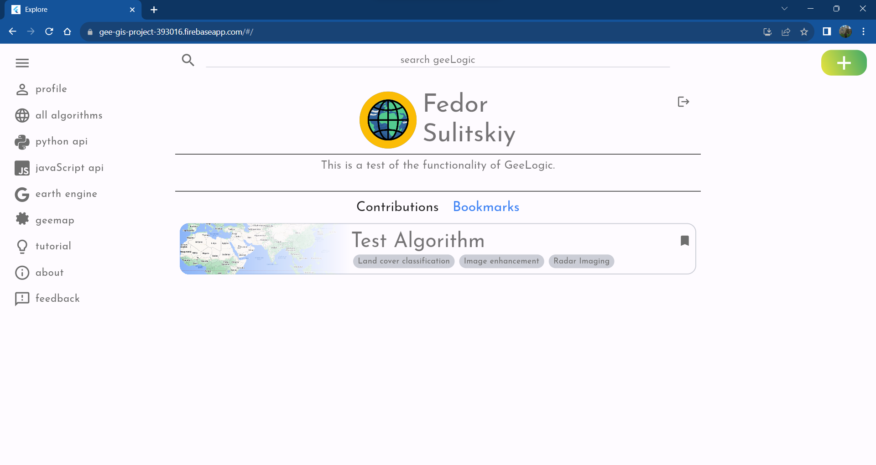

Figure 33 Screenshot of the User Screen when clicked on the "Bookmarked" tab. This demonstrated that there is a single bookmarked algorithm: "Test Algorithm".

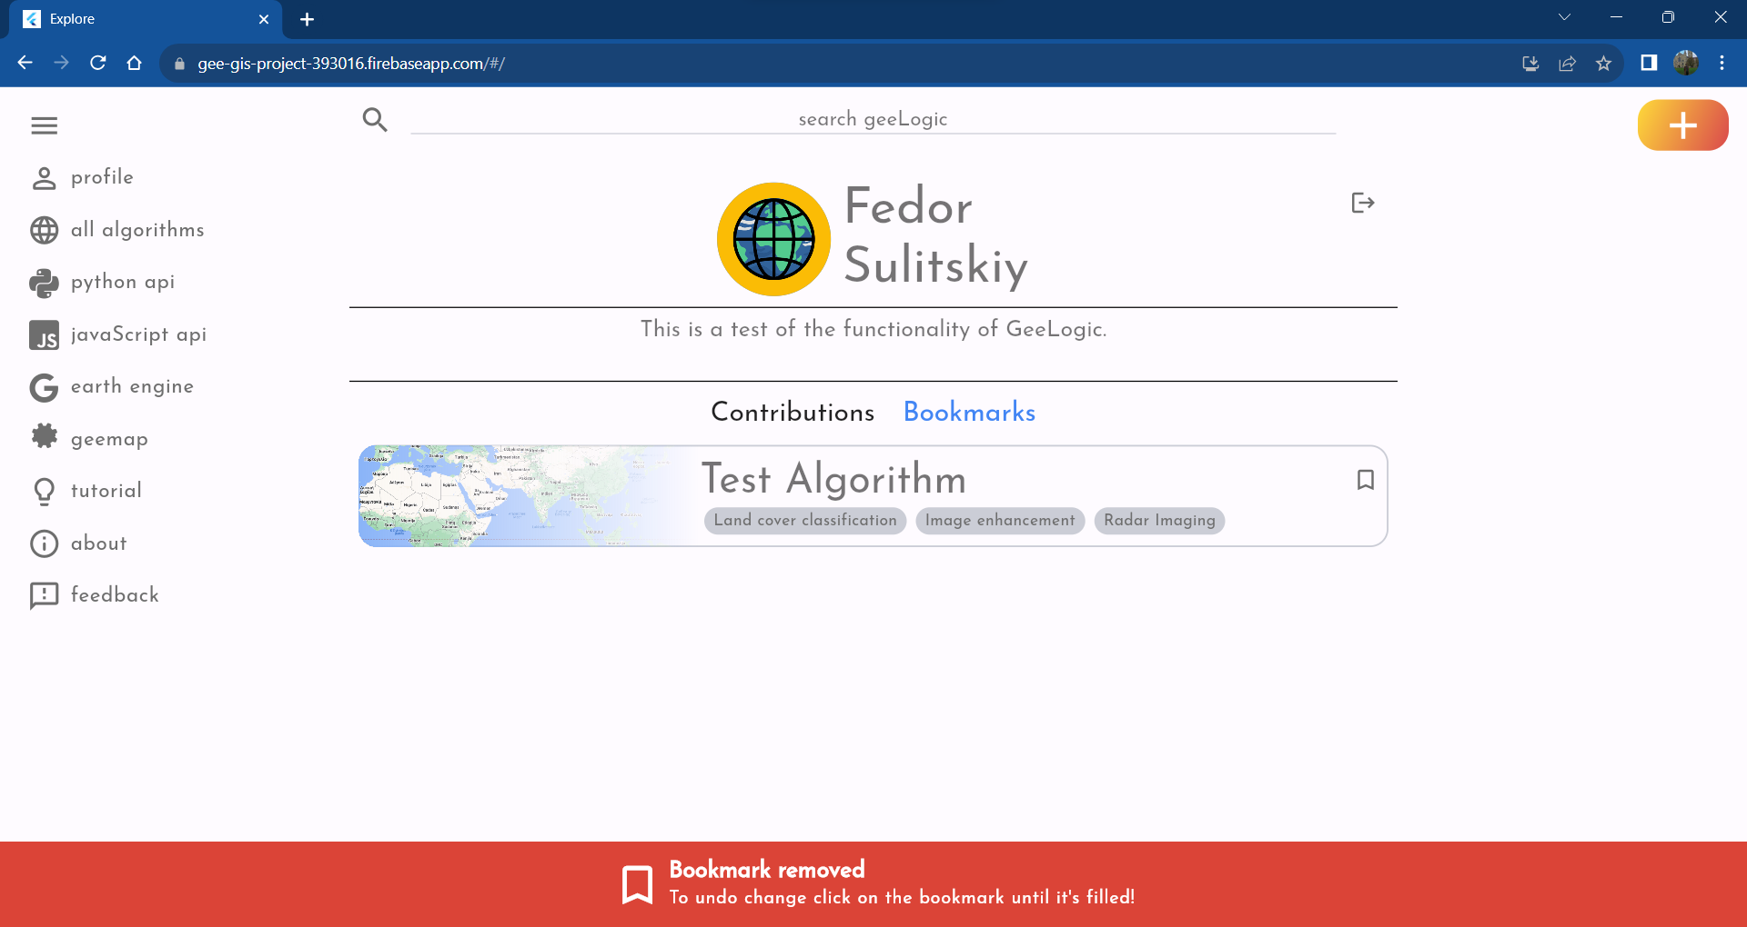

Figure 34 Screenshot of the User Screen bookmarks, with the bookmark now removed. The bottom pop up warns the user they can undo the change in case they accidentally did it.

1. Edit the newly submitted algorithm.

User may navigate to the “Contributions” tab where the only algorithm contributed is present. At the top right corner of a window very similar to that of the bookmarked algorithm there are two icons: edit and delete icons.

Upon pressing the edit icon, the user will be redirected to the Edit Screen, which is of the same format as the Input Screen, however with all the data about the algorithm already input into the fields. The code is already verified since it was verified upon initial submission meaning there is no need to re-verify it unless it is changed.

To test the capabilities of the edit feature every field will be altered.

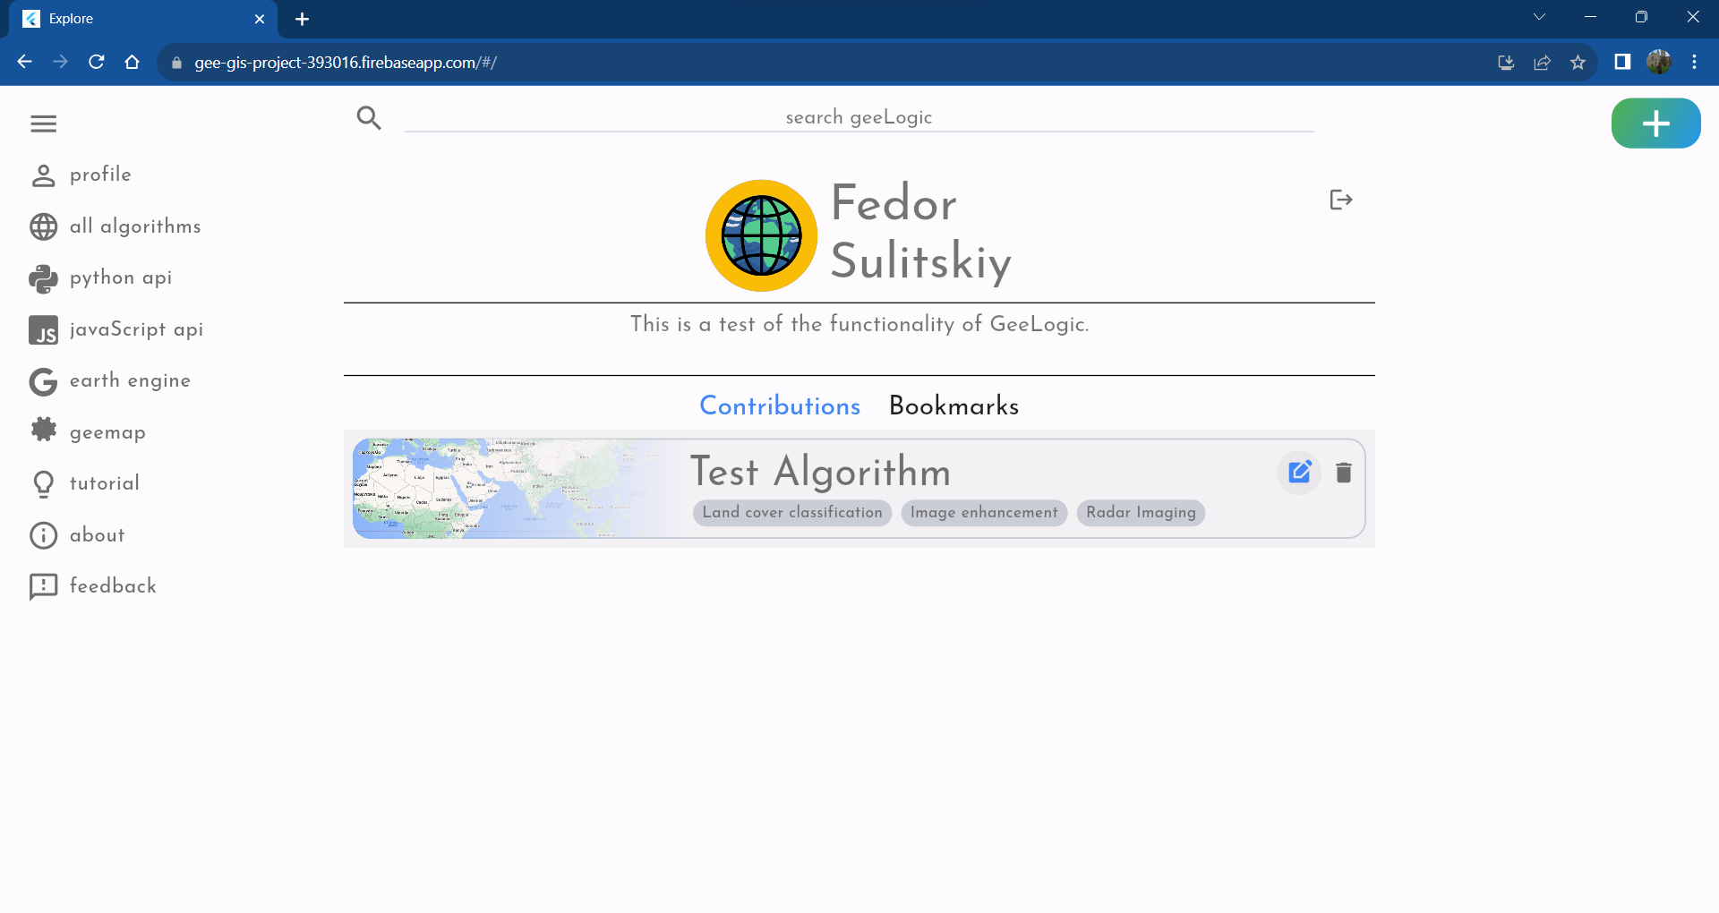

Figure 35 Screenshot of the User Screen with "Contributions" tab selected.

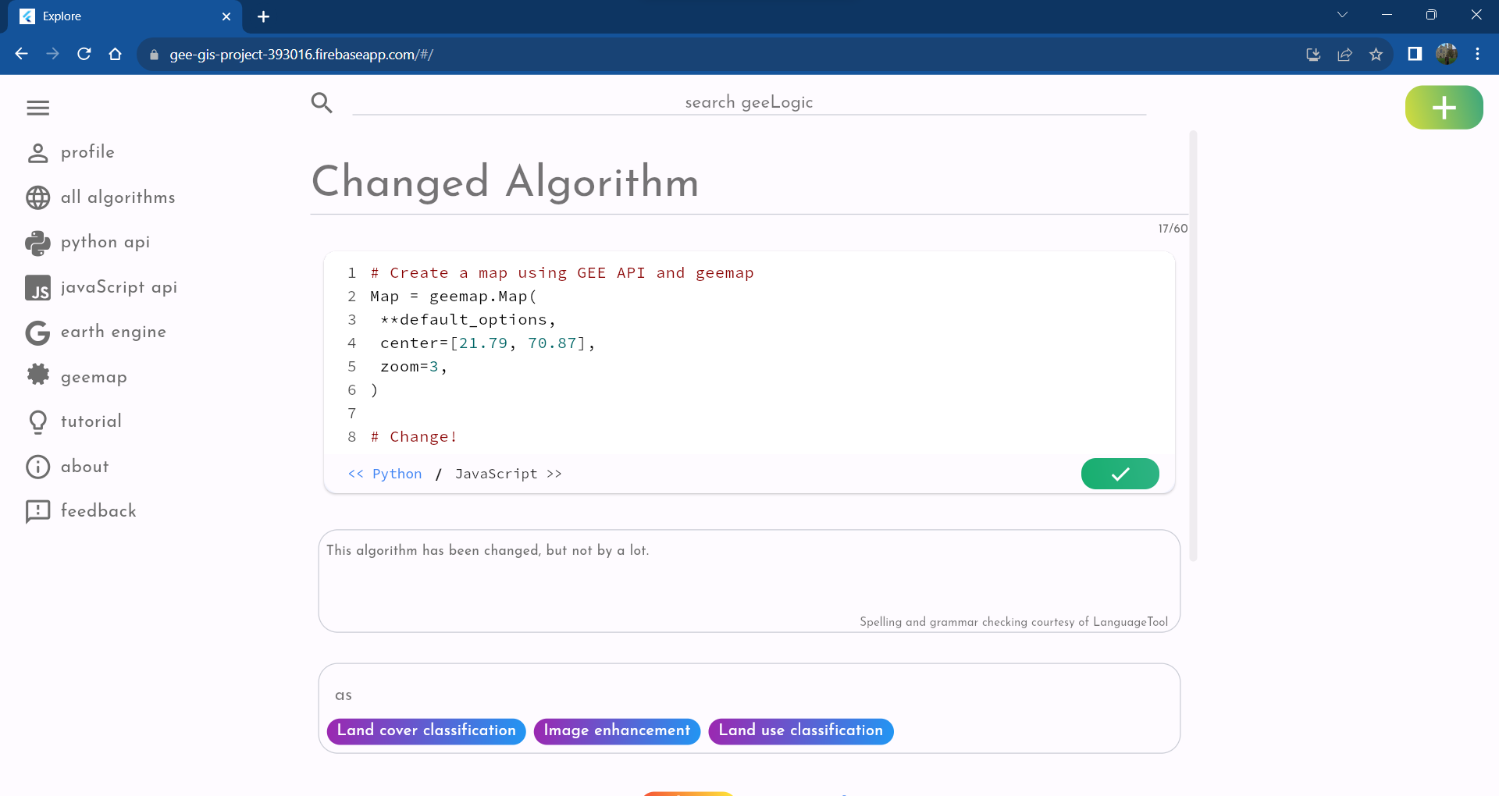

Figure 36 Screenshot of the Edit Screen, where every field has been altered, including adding a comment to the code, requiring reverification, and changing "Radio Imaging" to "Land use classification" in the tags.

1. Observe changes.

When the newly changed “Changed Algorithm” is located at the Catalogue Page, one can verify that, indeed, the editing was successful.

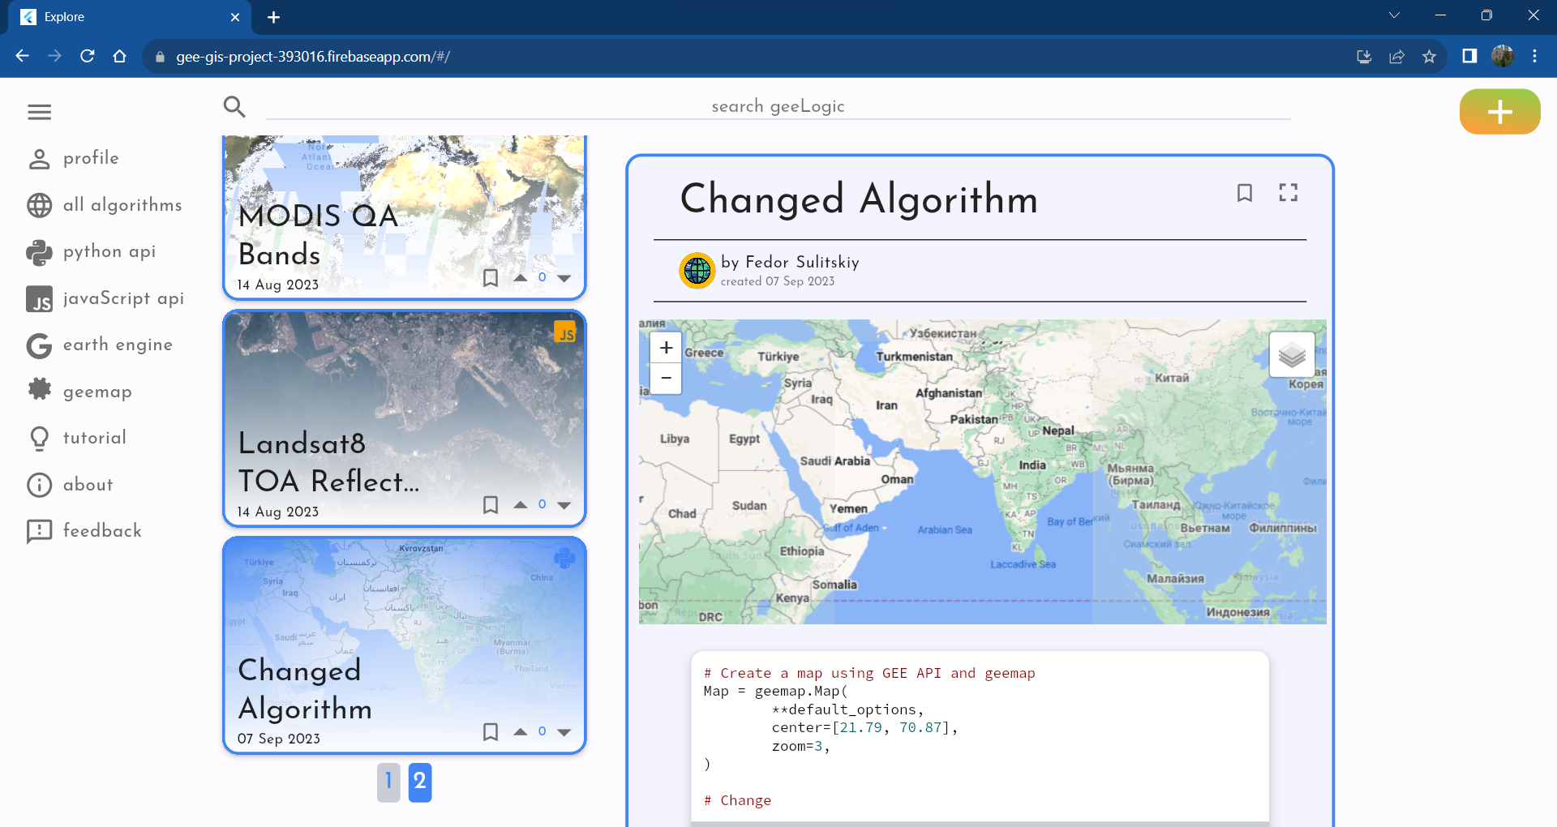

Figure 37 Screenshot of the Catalogue Screen demonstrating that changing the new algorithm was a success.

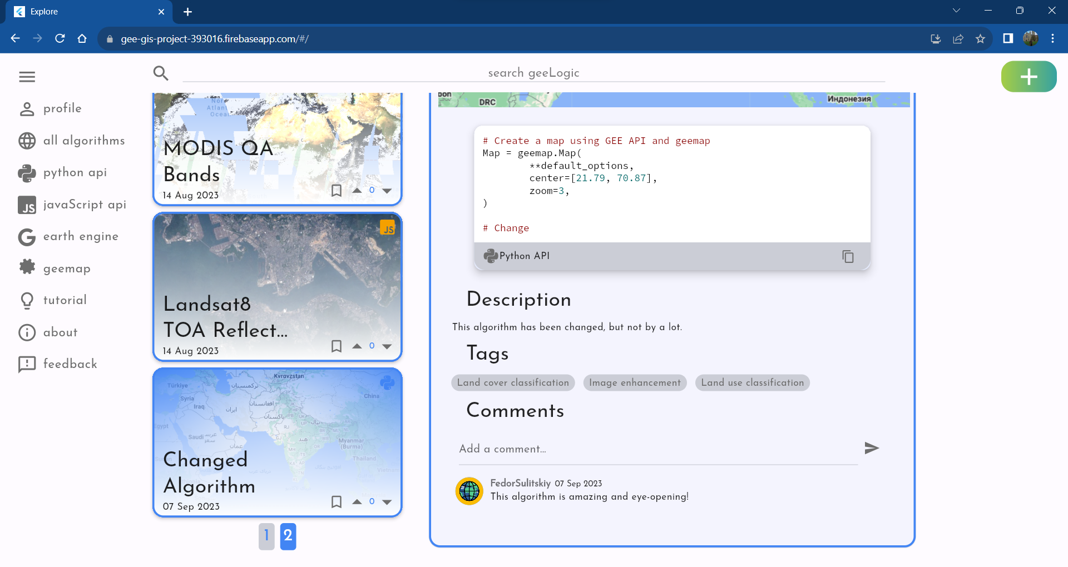

Figure 38 Screenshot demonstrating the bottom part of the details card of the new "Changed Algorithm", further demonstrating that all the changes were introduced.

1. Delete the newly edited algorithm to leave the state of the website the same.

To delete one’s algorithm the user must head back to the User Screen where they will be able to find the delete icon to the right of the edit icon. Upon pressing this icon, they will be asked to verify if they wish to delete the algorithm, to prevent accidental deletion when button is pressed unintentionally.

If the user presses “Yes” a bottom pop-up will give the user one last chance to undo a deletion, in case they decide to change their mind last second. However, if the “undo” button is not pressed the page will update and the algorithm will be deleted forever. Indeed, the algorithm was successfully deleted, and entirely removed from the UI upon reloading the page.

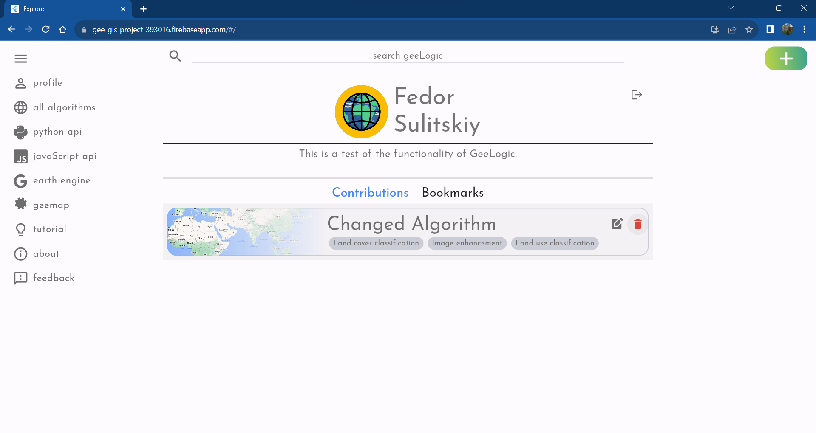

Figure 39 Screenshot of the User Screen with the delete icon being highlighted.

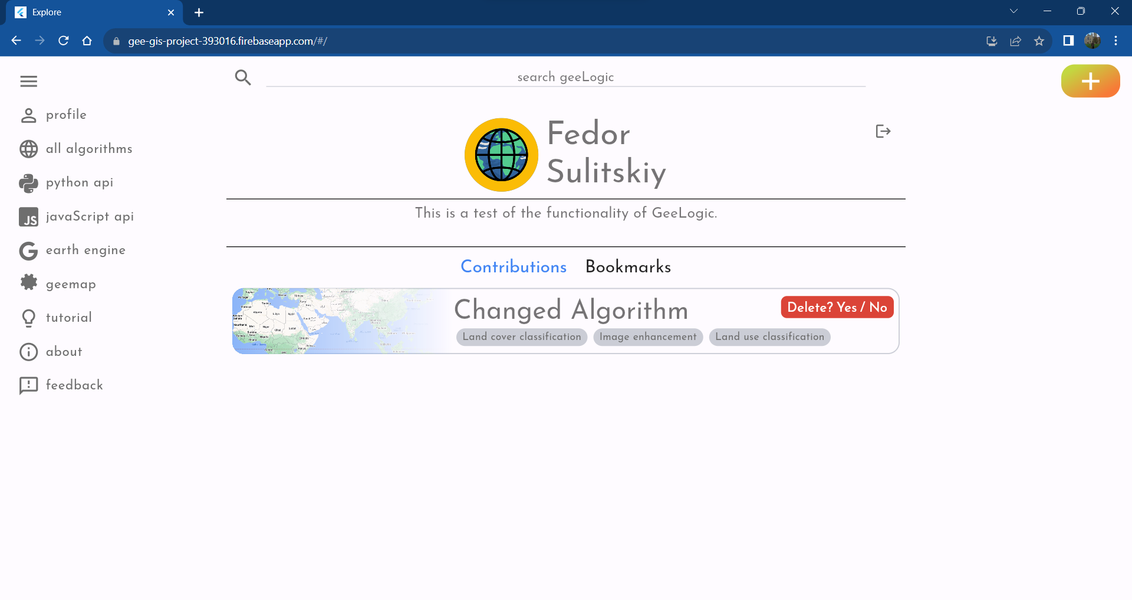

Figure 40 Screenshot showing the pop up when the delete icon is pressed.

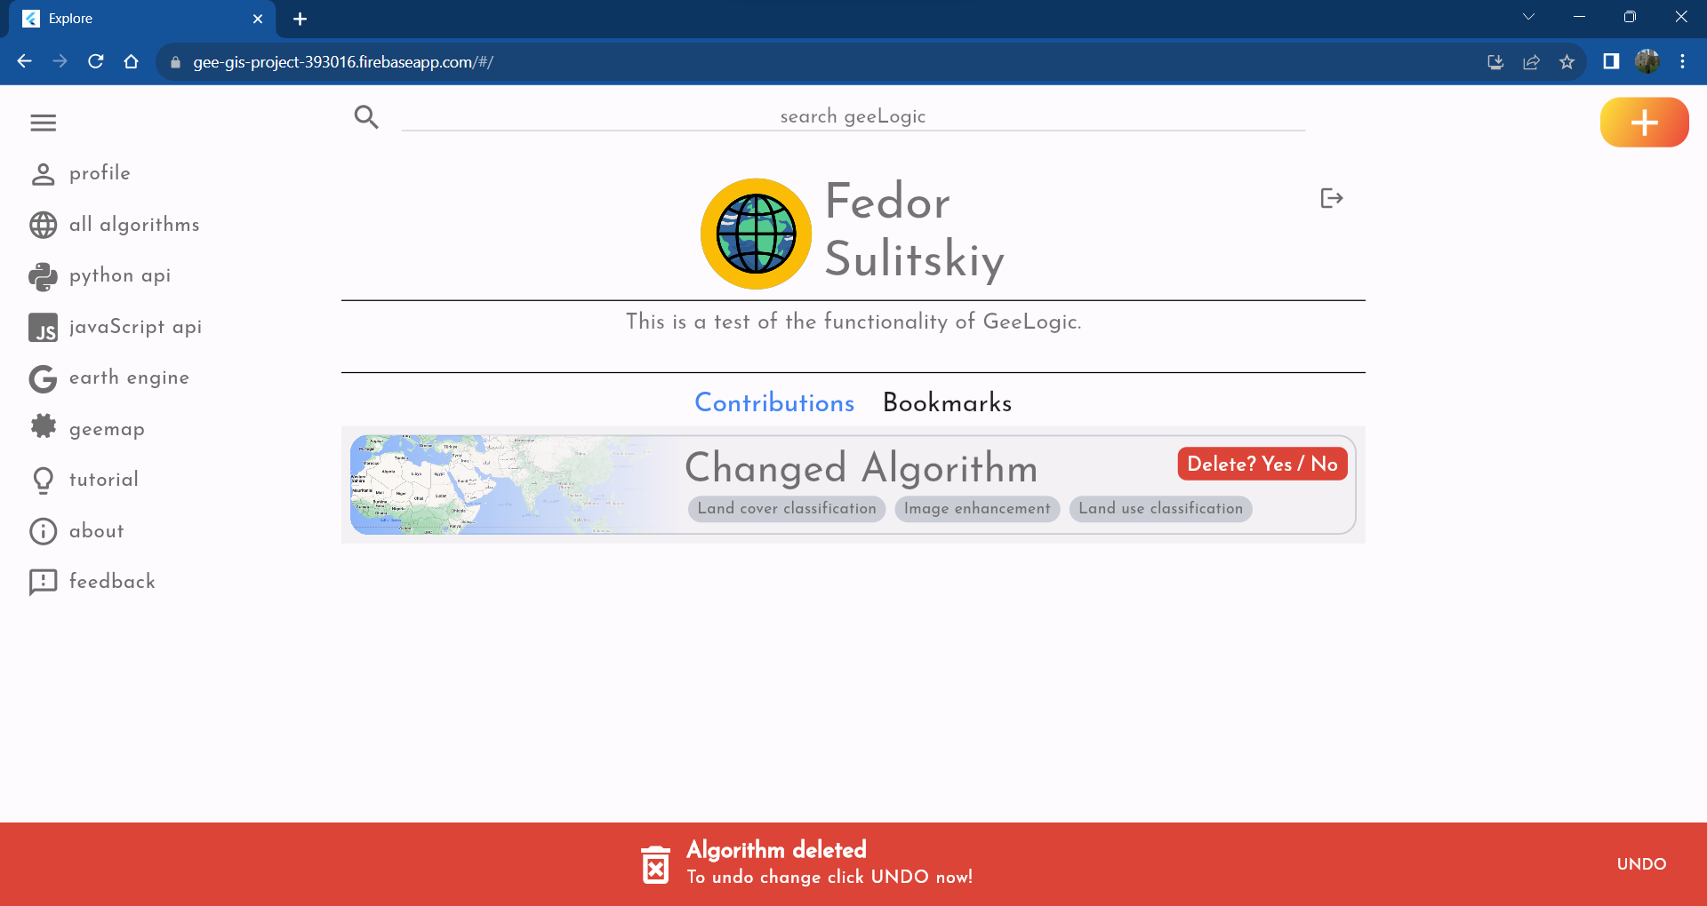

Figure 41 Screenshot showing the final warning, which gives the user the last change to undo the deletion process.

## Miscellaneous Testing

These tests did not fit in the general flow of the previous sub-section, but they are no less important. They are best characterised as alternative choices a user may take, to those taken up above.

### Test is one can choose a custom image upon registration

For this test the user must be logged out and reauthenticate with a different Google account, to access the Signup Screen. It cannot be accessed unless an entirely new user joins the platform.

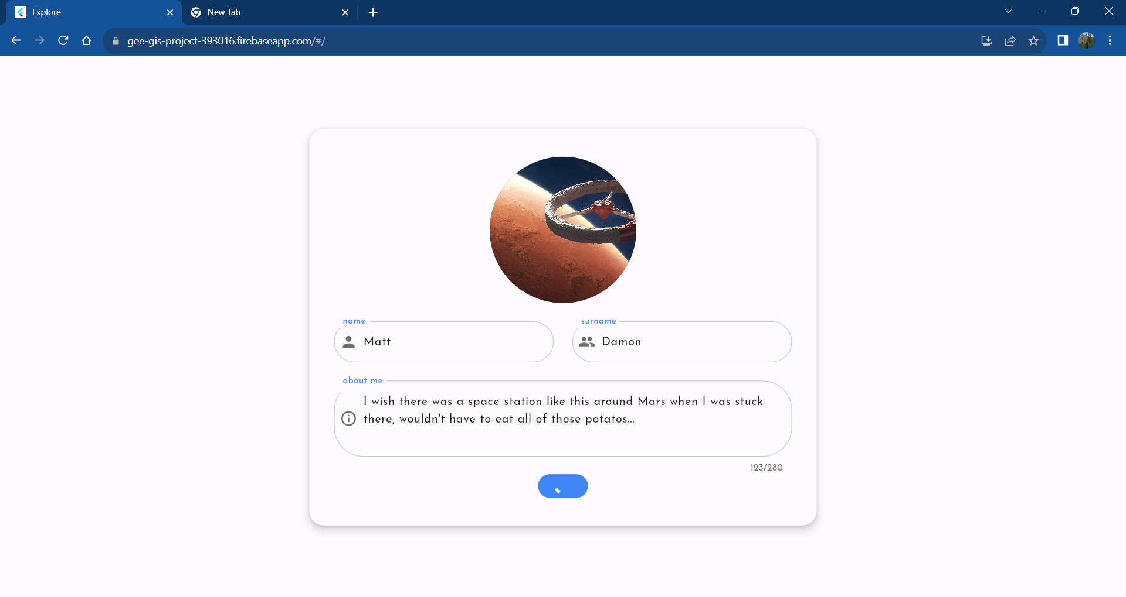

Figure 42 Another user (with a sense of humour) signs up for the account at GeeLogic, this time choosing an image of a space station in orbit around Mars as their profile image.



Figure 43 Partial screenshot of the User Screen, showing the profile of the new user and this time their avatar is an awesome space station!

Indeed, as Figure *42* Another user (with a sense of humour) signs up for the account at GeeLogic, this time choosing an image of a space station in orbit around Mars as their profile image.Figure 42 and Figure 43 demonstrate the new test user has successfully managed to sign up using a custom image to use as their profile avatar.

### Testing if the Feedback Screen is functional

One must sign in and have access to Catalogue Screen of GeeLogic. In the side menu one must select the “feedback” option and fill in all the input fields. Upon successful sending of the message, user will be informed by the bottom pop up.

Finally, as Figure 46 shows the message sent was successfully received by the dedicated mailbox created for this project.

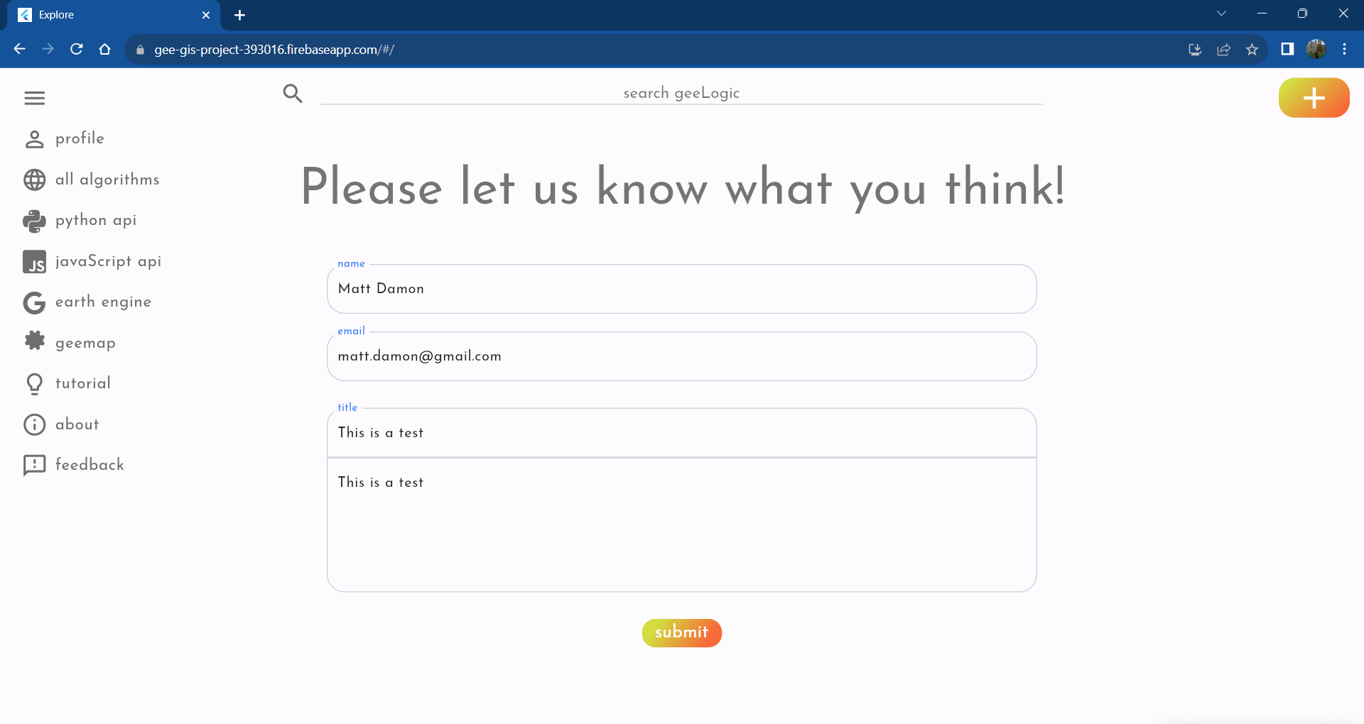

Figure 44 Screenshot of the Feedback Screen with input fields filled in with test information.

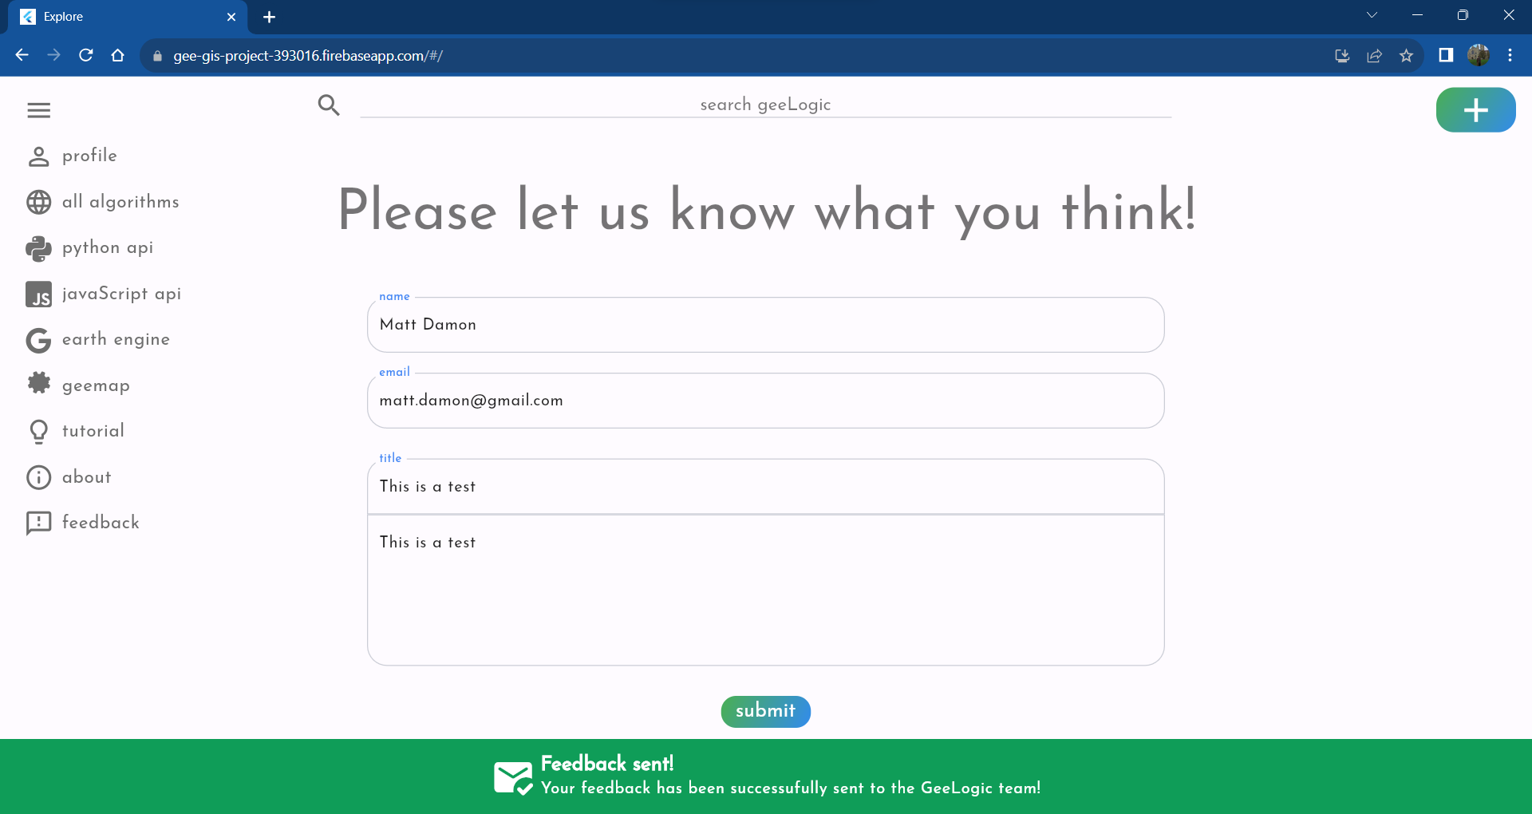

Figure 45 Screenshot demonstrating the bottom pop-up indicating that the message was successfully sent.

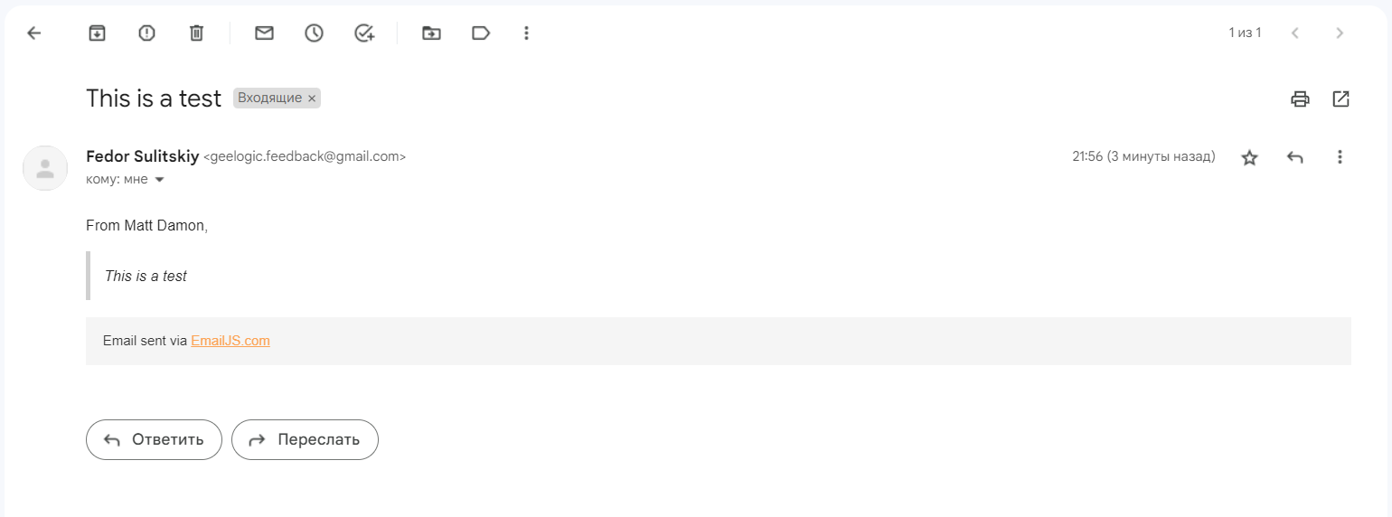

Figure 46 Screenshot of the newly received test email from test Matt Damon.

### Create new algorithm using JavaScript API

Not every GEE-valid JavaScript API based code is valid on GeeLogic due to the reliance on converting the input string of JavaScript to Python using geemap. Geemap is imperfect at this job, and consequently so is GeeLogic.

Hence, to ensure that a successful test yields a predictable result, a working JavaScript code was chosen; copied from one of the algorithms already submitted. The code is for one of the most popular vegetation indices, Normalised Difference Vegetation Index (NDVI)[3].

Submission took around 50 seconds, but it was successful, and the newly added algorithm could be found in the main catalogue upon a reload of the page.

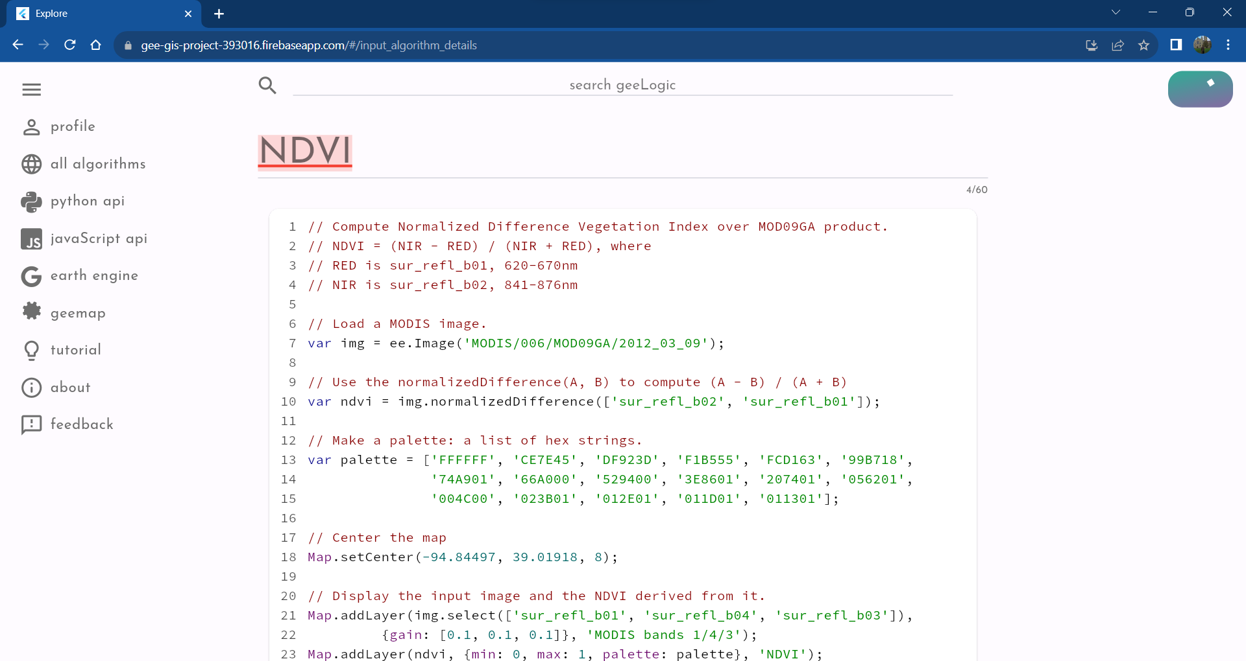

Figure 47 Screenshot of the Input Page where the new algorithm being submitted is NDVI, using JavaScript API. Top half.

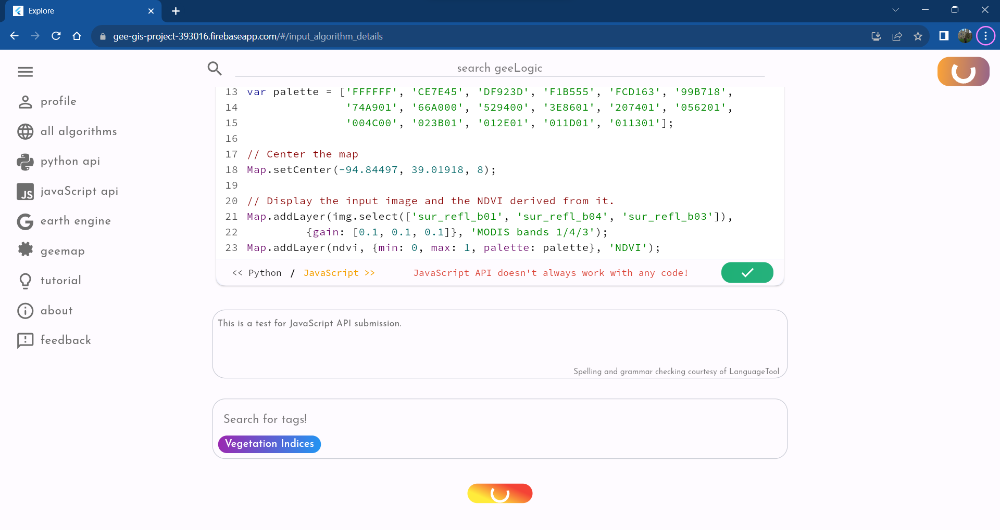

Figure 48 Screenshot of the Input Page where the new algorithm being submitted is NDVI using JavaScript API. Bottom half.

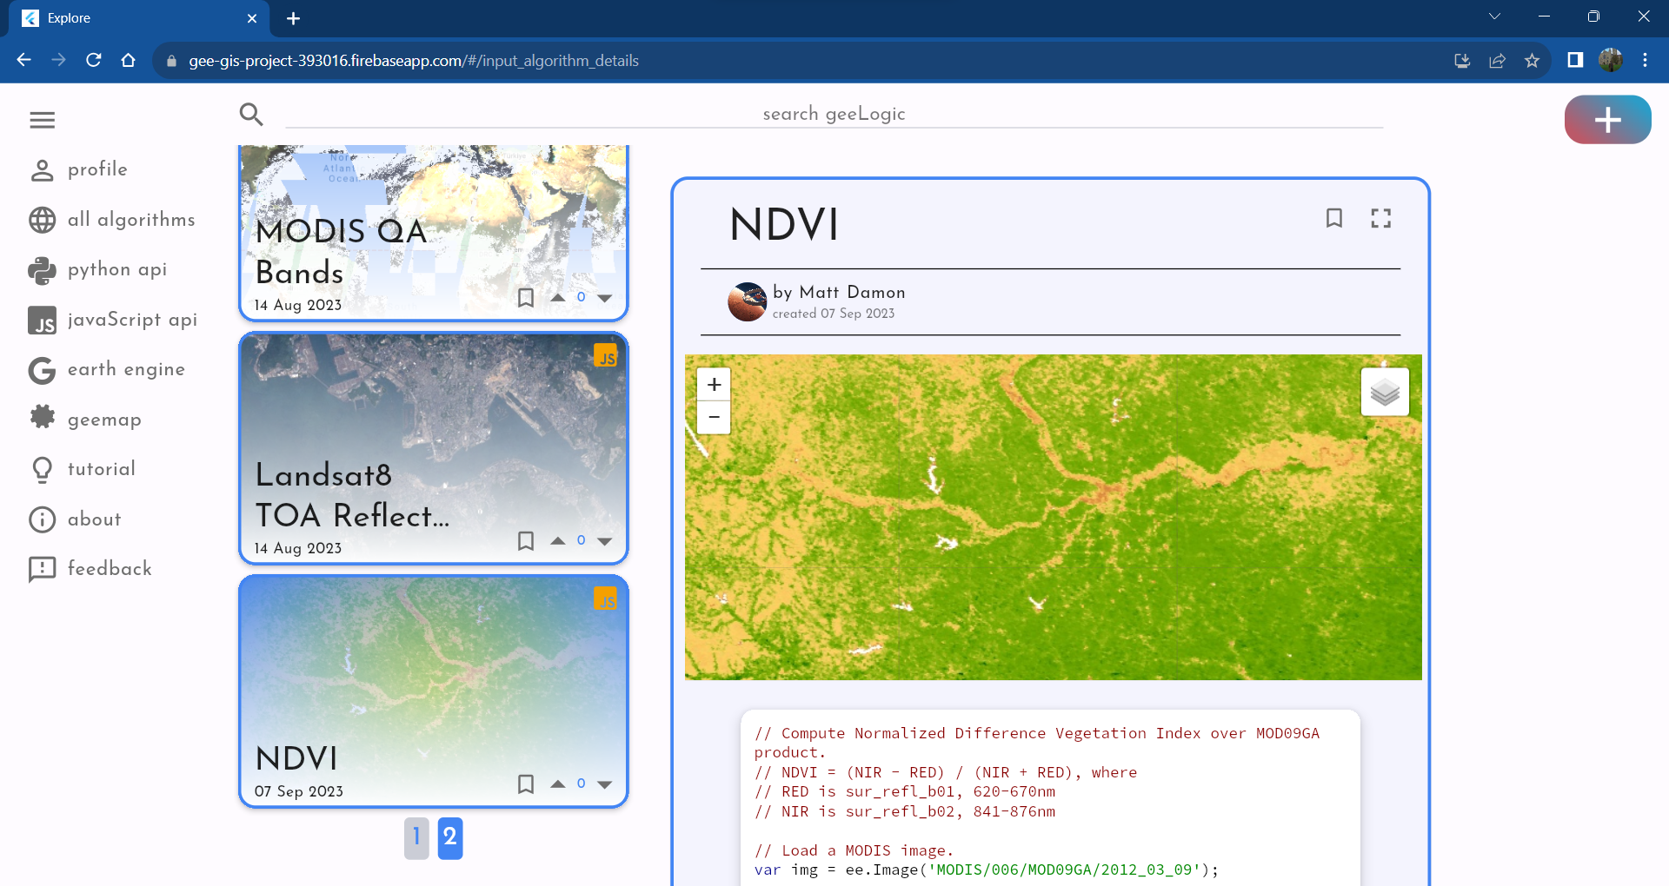

Figure 49 Screenshot of the Catalogue Screen with the newly submitted algorithm being successfully displayed for the users to see.

### Cumulative votes and votes visibility

The purpose of this test is to see if other users can see each other’s votes on different algorithms. Furthermore, it is to test if the current user can add their vote or subtract it from the total.

Another account was used to add a vote to the SRTM algorithm which can be observed on the left screenshot of Figure 50, making the first part of the test a success. Once the current user votes up or down, their arrow gets highlighter accordingly and their votes get added to the total displayed on the thumbnail card of the algorithm. This indicates that both tests yield positive results, indicating voting features works as intended.

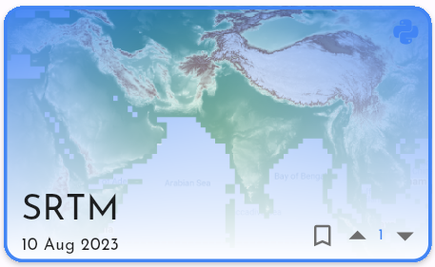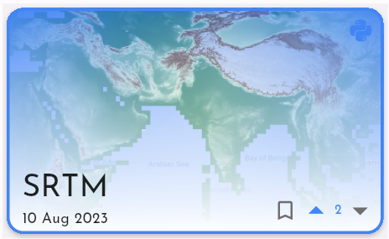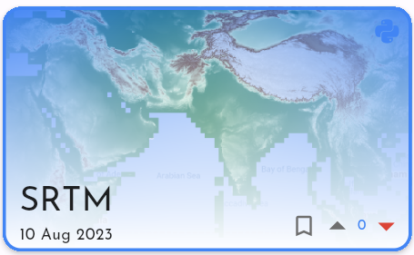

Figure 50 Three versions of the SRTM's thumbnail window. The left one shows it in its initial state before the user voted. The central shows the user upvoted the algorithm, which is indicated by the arrow turning blue and the total score of votes increasing by one. The right one shows the user downvoting the algorithm which is indicated by the red arrow and the subtraction of one from the total score of voting.

### Undoing deletion of the algorithm

It is necessary to test if it is possible to undo the deletion of an algorithm, when given the chance, since deletion is a critical step as it cannot be undone once it is done. Users must have a fair chance to change their mind last second or it will lead to bad experience.

To test this problem one must head to the User Screen and locate the delete button on the algorithm of interest. The deletion button is highlighted on Figure 39, for reference. Once pressed and confirmed that the user wishes to delete the algorithm, the “UNDO” button must be pressed on the bottom pop up.

The test was a success since upon clicking the “UNDO” button the pop up was removed and the algorithm was not deleted, as expected.

The main features of the project were manually tested, and the testing sequences were meticulously described in this section along-side the results under normal operations with average internet speeds. Every query on the API was tested consequently through these tests making separate testing of these queries obsolete since if they can work within the frontend framework, they would easily work by themselves too. Nonetheless it is possible to manually test any API query since they are prepared in Postman, and their documentation is available publicly.

To conclude, the tests showed success in GeeLogic ability to handle its key requirement functions.

# Discussion and Conclusion

From the point of view of the original aims of the project a lot has been learnt regarding the creation of a GEE-based web application using Flutter Web. Indeed, this framework proved to be very capable and resulted in a fast, responsive, and smooth user interface. The speed of iterating through ideas, offered by Flutter, proved to be pivotal in being able to finish this project on time, with the result looking the way it does. Overall, it is safe to say that Flutter Web was a good choice for frontend framework, with great potential and clear path to further improve and perfect this project.

However, experimentation showed that the current system of APIs is flawed. It creates inefficiencies which cause the time of receiving a response unacceptably high. If scaled the service would become paralysed. However, a promising solution is embedding a Solara based widget directly into the frontend without the use of a REST API. Solara is a python-based library which can also leverage geemap and was one of the options discovered during development. However, it was ultimately discarded due to ambiguity in how to embed a Python widget directly into Flutter.

Using Firebase was also an optimal decision. Such an integrated set of services offers great support, analytics, and versatility, unmatched by self-made solution. Potentially it should be considered to migrate the MySQL database to Firebase which will also make Node API redundant. This would greatly simplify the system as a whole, however if GeeLogic were to scale Firebase may become too expensive to use sustainably. Hence, further research is required into the cost effectiveness of this solution. From technological point of view, it is certainly beneficial.

From the point of view of functional requirements GeeLogic has achieved all its must-have and should-have requirements along with some of its could-have ones, making it a successful experiment. GeeLogic’s primary aim was exploration of technologies and integrating GEE API with Flutter Web, both of which were achieved. Despite its shortfalls, the key requirements were fulfilled:

* F-M1: Host various information relevant to the various geospatial observation algorithms, including title, description, and code.
* F-M2: Use Google Earth Engine API to have an interactive access to the algorithms.
* F-M3: Allow users to create details page about their algorithms.
* F-M6: Contain feedback page connected to the developer’s mailbox.
* F-S4: Allow users to leave comments.
* F-S5: Allow users to upvote and downvote algorithms.

These requirements are identified to be the most important since their combination defines the deliverables identified in the Aims and Goals section at the beginning of the report. This creates a strong foundation for future work since GeeLogic was always developed with developing a more sophisticated system sometime in the future, in mind. It is ready to have another developer join the development team, due to the extra effort put into documenting each widget and function with a plethora of comments and docstrings, as exemplified by the code of algo_info_provider.dart file.

Furthermore, existing work has opportunities for immediate improvement since certain features were developed with a vision in mind, which was not realised. For example, the response in sub-section 4.3.4 Database contains a list of tag json objects. The json object from the list includes a tag description, but this field was not exploited on the frontend, due to its low priority and time constraints. Nevertheless, it remains there; to facilitate future improvement and expansion of GeeLogic!

## Summary of Achievements

Overall, out of functional and non-functional requirement every must have requirement has fulfilled, along with every should have requirement. Furthermore, several could have requirements were fulfilled, namely F-C1, F-C4, F-C7 and F-C8. These concerned creating accessible links to geemap documentation and GEE website, as well as creating more sophisticated tutorial page and filling in some initial data for the service to not be empty. Said data was taken from the example’s selection provided by GEE for new users to get familiar with the platform.

Technically this makes the project a success, however less quantifiable tasks were also achieved, namely: gaining valuable insight into developing with Flutter Web, experience in working with geemap and GEE APIs and experience in hosting and deploying an entirely new project.

To conclude, both the aims and goals of the projects as outlined at the beginning of the report have been achieved.

## Future Work

GeeLogic offers a lot of potential for growth. It has the potential to become an independent niche social network or integrate closer with Google ecosystem if worked on seriously for a long period of time. However, if six more months were allocated for development the following major vectors of progression would be pursued:

* Improve layout’s responsiveness to allow use of the service on all screens including smartphones.
* Improve the navigation system, optimising it for browser use, employing Flutter Navigator 2.0.
* Find a way to integrate Flutter directly with GEE API, without using Python API, or drastically improve the speed of Python API and rendering of the map widget by removing inefficiencies.
* Dismantle Thumbnail API and find better solution for solving this problem.

Furthermore, GeeLogic needs minor improvement to optimise user experience and bring it up to a standard that would be expected of a social platform including:

* Allow use without authentication.
* Allow users to edit their profiles.
* Add comprehensive filtering and sorting features.
* Expand the social feature by allowing replies, viewing other people’s profiles and introducing direct messaging.
* Allow users to add attachments such as images or embedded videos into the description of the algorithms.
* The Could have requirements of this project.

GeeLogic is a project set up for future development and certainly has its development roadmap pre-determined. GeeLogic is also already a functional web service which satisfied every key functional and non-function requirement. Therefore, this report concludes the result of this project to be a success!

# References

Chui, M., Issler, M., Roberts, R., & Yee, L. (2023). *Technology Trends Outlook 2023.* McKinsey Global Publishing.

*Copernicus*. (n.d.). Retrieved from European Space Agency: https://www.esa.int/Applications/Observing_the_Earth/Copernicus

Copernicus. (2023, September). *Surface air temperature for August 2023*. Retrieved from Copernicus Climate: https://climate.copernicus.eu/surface-air-temperature-august-2023#:~:text=August%202023%20is%20the%20warmest,previous%20warmest%20August%20in%202016.

Erwin, S. (2023, February 2). *Hydrosat wins Air Force contract for thermal infrared data analytics*. Retrieved from SpaceNews: https://spacenews.com/hydrosat-wins-air-force-contract-for-thermal-infrared-data-analytics/#:~:text=Hydrosat%20developed%20an%20analytics%20platform,climate%20change%20or%20natural%20disasters.

Google. (n.d.). *Case Studies*. Retrieved from Google Earth Engine: https://earthengine.google.com/case_studies/

Google Earth Engine. (n.d.). *Platform.* Retrieved from Google Earth Engine: https://earthengine.google.com/platform/

Gorelick, N., Hancher, M., Dixon, M., Ilyushchenko, S., Thau, D., & Moore, R. (2017). Google Earth Engine: Planetary-scale geospatial analysis for everyone. *Remote Sensing of Environment*, 18-27.

Primož Rome. (2022, January 18). *Every Satellite Orbiting Earth and Who Owns Them*. Retrieved from DEWESoft: https://dewesoft.com/blog/every-satellite-orbiting-earth-and-who-owns-them

Satellite Vue. (2023). *Better data for sustainable buildings and cities: Enhanced resolution. Enhanced decision making.* Retrieved from www.satellitevu.com: https://www.satellitevu.com/built-environment

Satellite Vue. (2023, June 13). *The ‘World’s Thermometer’ reaches orbit - SatVu's Revolutionary "HOTSAT-1" successfully launches*. Retrieved from www.satellitevu.com: https://www.satellitevu.com/press/worlds-thermometer-reaches-orbit-hotsat-1-successfully-launches

Surrey Satellite Technology Ltd. (2019). *Applications of Earth Observation.* UK Space.

*Vanguard 2*. (n.d.). Retrieved from NASA: https://nssdc.gsfc.nasa.gov/nmc/spacecraft/display.action?id=1959-001A

*Vegetation manager for rail: Limit downtime by managing vegetation around tracks*. (n.d.). Retrieved from Hitachi Energy: https://www.hitachienergy.com/uk-ie/en/markets/transportation/rail/vegetation-manager-rail

Werner, D. (2023, June 8). *Hydrosat acquires IrriWatch*. Retrieved from SpaceNews: https://spacenews.com/hydrosat-acquires-irriwatch/

# Appendix

1. User Manual
2. Login Screen and Signup Screen

First thing user will see is the Login Screen (Figure 51). This screen greets the user with an array of helpful cards which outline what can be done in GeeLogic, to help them get started with the website. These are shown on Figure 52 and Figure 53.

It is not possible to use the application without being authenticated, hence user will have to click on the big G button to launch authorisation sequence. If they are already registered on the platform they will be logged in and be redirected to the Catalogue Screen. If they are not registered yet, they will be sent to the Signup Screen (Figure 54).

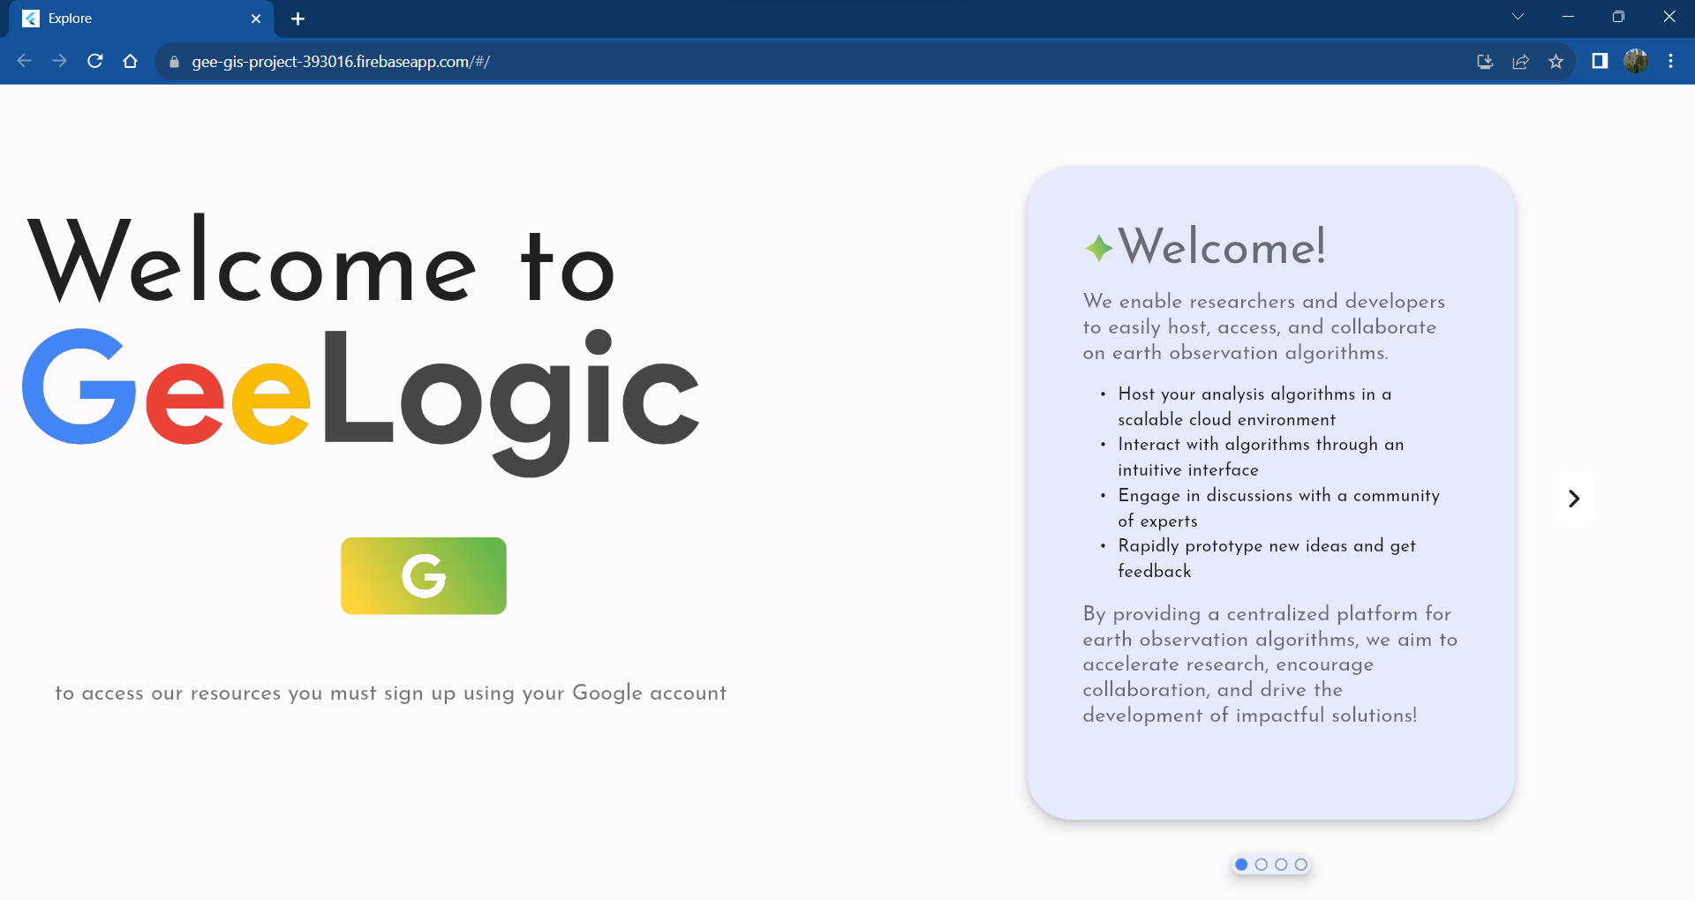

Figure 51 Login Screen

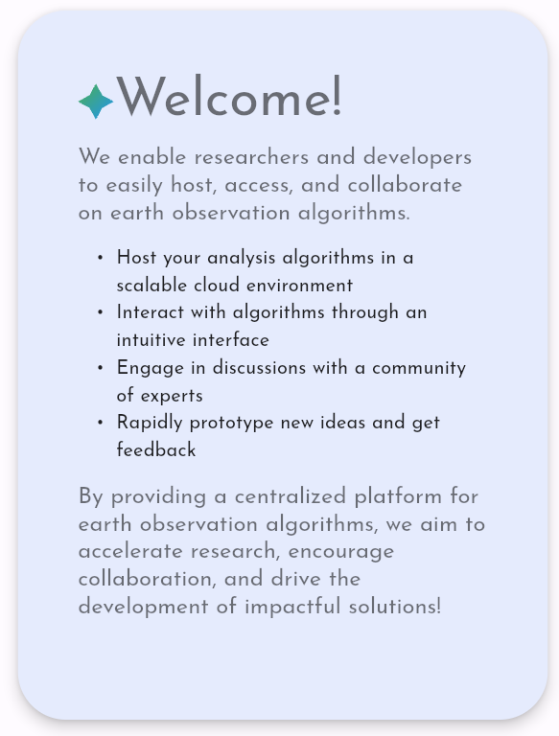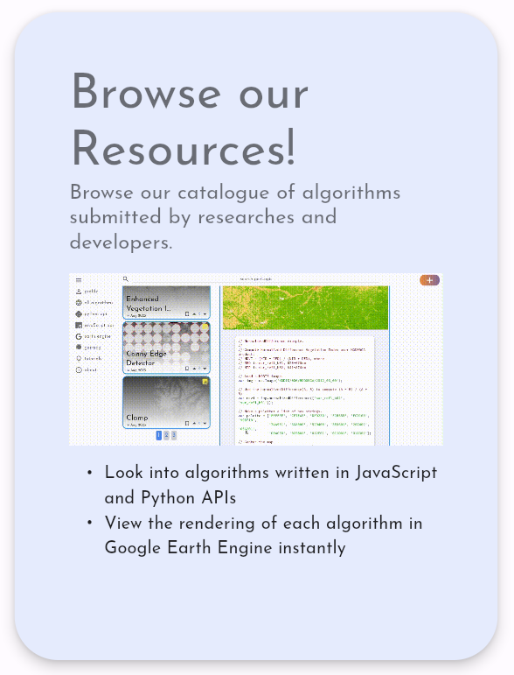

Figure 52 First and second tutorial cards from Login Screen

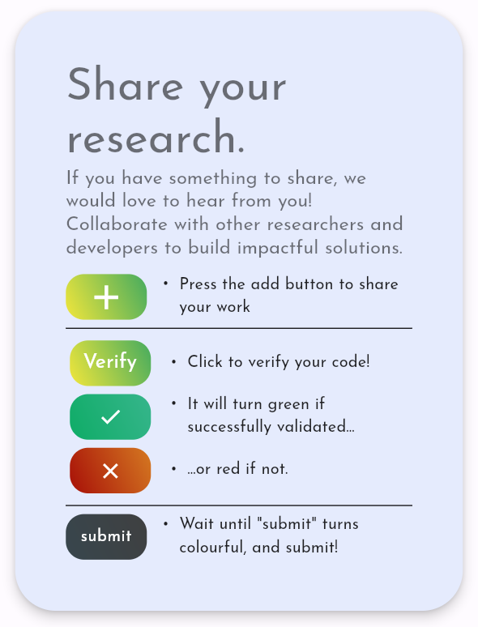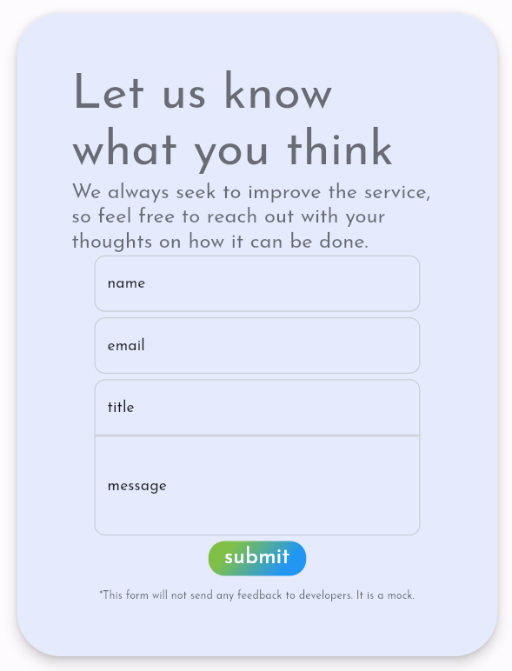

Figure 53 Third and fourth tutorial cards from Login Screen

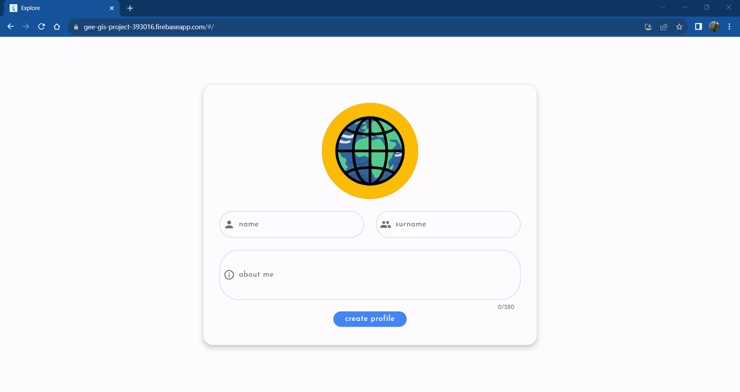

Figure 54 Signup Screen

1. Catalogue Screen

Upon finishing registration user will be redirected to the main screen, the Catalogue Screen. This screen by default contains all algorithms on the service, ordered in chronological succession with the first algorithm being the earliest to have been added.

There are three variations of this screen accessible to the user, as dictated by requirement F-S1 (Have multiple sections in the webapp corresponding to different major categories). These major categories are the API in which the submitted code was written; Python or JavaScript or both. By default, both APIs are showed, however on the side menu one can select to view only algorithms written in Python or JavaScript APIs by clicking on the corresponding language’s logo.

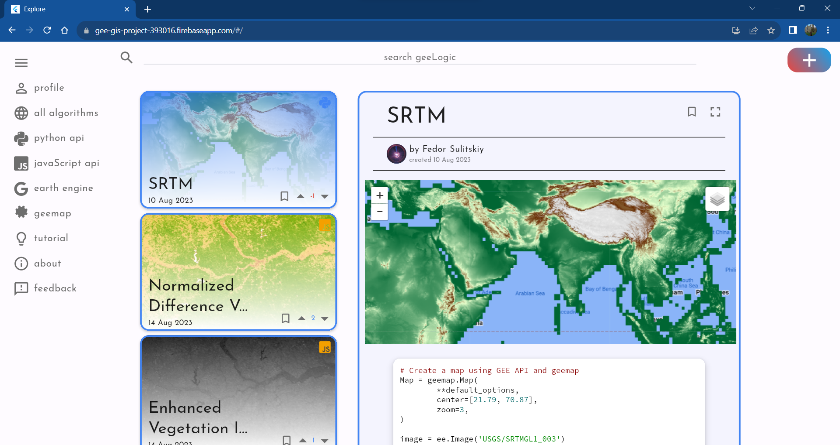

Figure 55 Catalogue Screen

Furthermore, Catalogue Screen contains a number of important features which need to be discussed. These are defined in 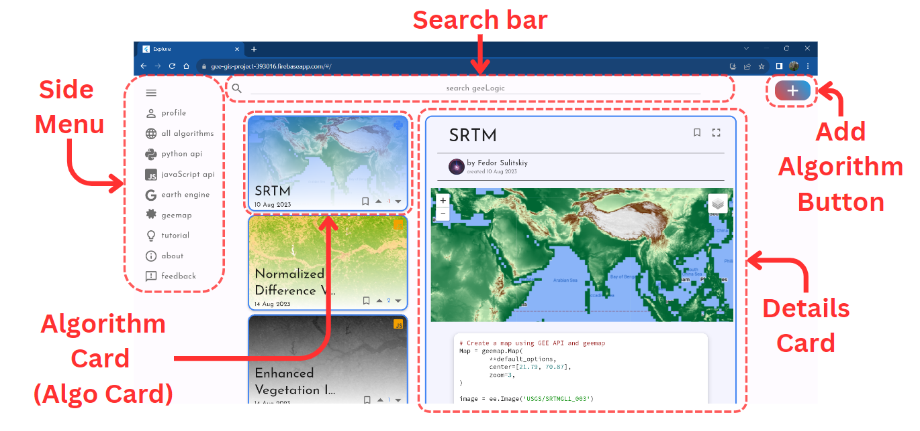Figure *56*. Additionally the Algorithm Card, or Algo Card when shortened, as well as Details Card have some unique details that are further explored on Figure 57, Figure 58and Figure 59.

Other elements, including the Side Menu, Search Bar and Add Algorithm Button are part of the persistent UI, common to the rest of the screens. Side Menu allows for site navigation, Search Bar permits users to search GeeLogic for particular algorithms and Add Algorithm Button redirects users to Input Screen, Figure 63, so they can contribute their own algorithms.

Figure 56 Catalogue Screen dissected

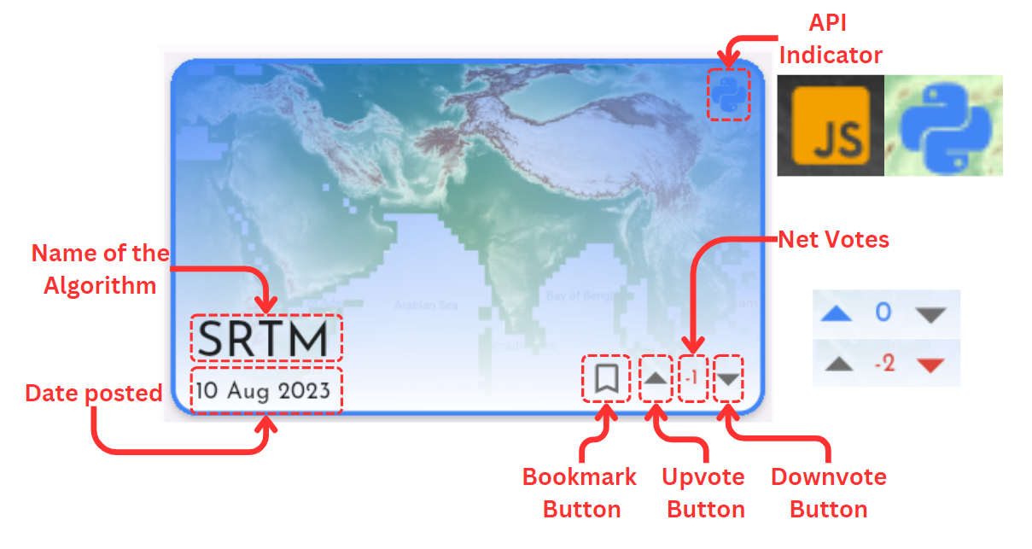

Figure 57 Algo Card dissected. This figure shows two different labels one can expect to spot on each Algo Card indicating what kind of API this algorithm uses. As well as it shows the different options of how the voting UI looks when voted. If user hasn’t votes then both arrows are grey, however if they did they will turn blue (upvote) or red (downvote). If the overall vote for the algorithm is positive the net number will be blue, however if it is negative, it will turn red.

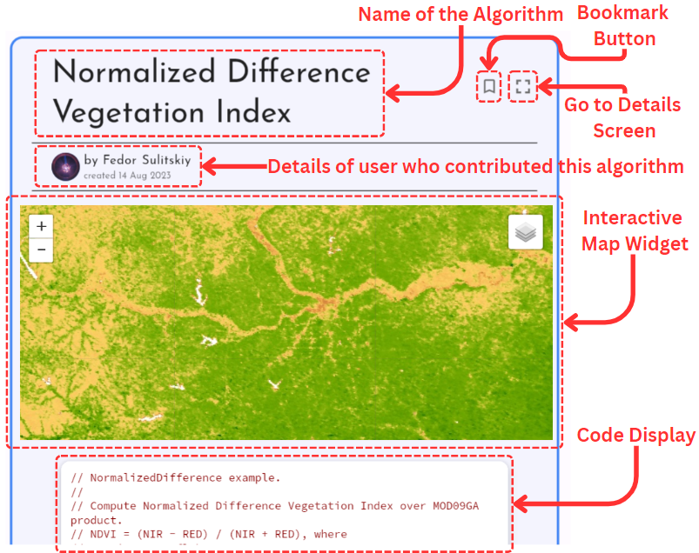

Figure 58 Details Card dissected. This figure shows major elements of the top half of the Details Card.

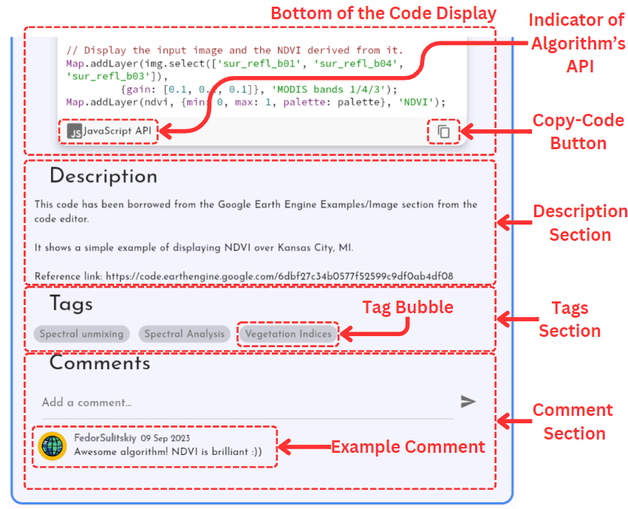

Figure 59 Details Card dissected. This is the bottom half of the Details Card where Figure 58 shows the top half.

1. Details Screen

In the top right corner of Figure 58 one can find an icon that looks like a frame; this icon directs the user to the Details Screen. Details Screen is very similar to Details Card, in fact it reuses many of the same elements, however the key differences are that it is solely dedicated to the algorithm without an array of Algo Cards as a distraction and it has a larger Map Widget to allow the user to focus on it.

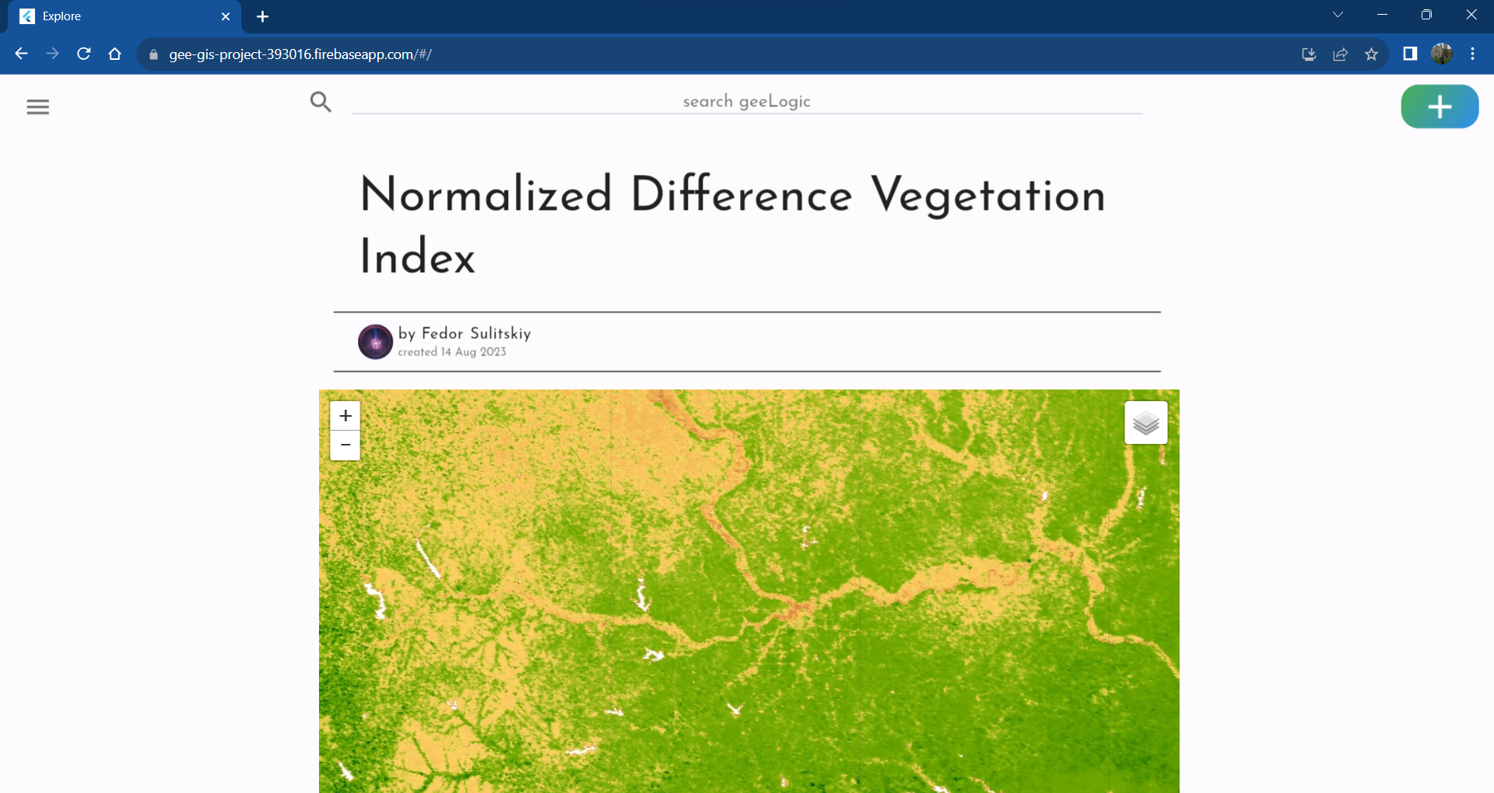

Figure 60 Top of the Details Screen.

1. User Screen

In case the user wishes to overview their public details, which includes the data submitted on the Signup Screen, or overview their contributed algorithms or overview their bookmarked algorithms, they can navigate to the User Screen. The User Screen has the user’s details at the top and two tabs; Contributions (selected by default) and Bookmarks, which show corresponding algorithms in a list.

Figure 61 shows the User Screen when a user with large contribution history clicks on the profile icon in the Side Menu. Below Figure 62 shows the User Algorithm widget dissected, for the Contributions tabs and Bookmarks tab.

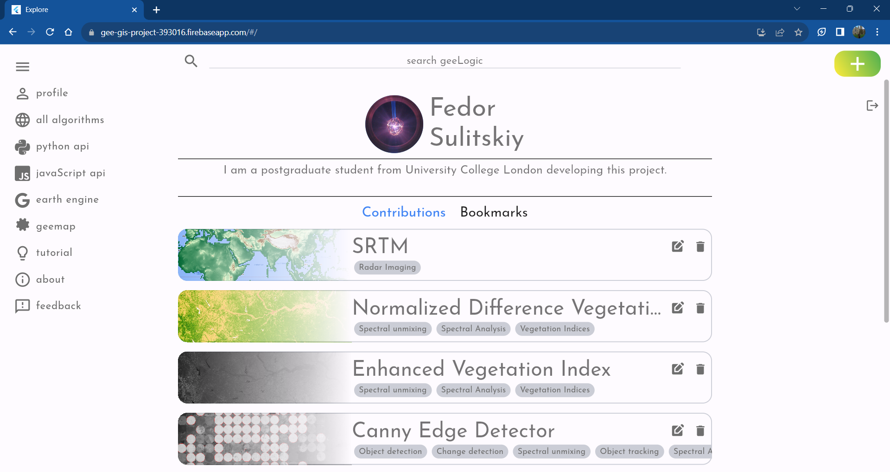

Figure 61 User Screen

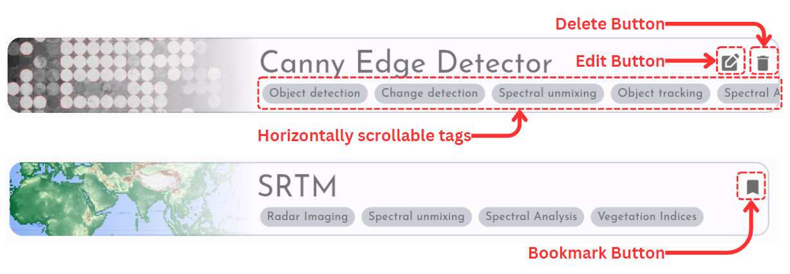

Figure 62 User Algorithms for the Contributions tab (top) and Bookmarked tab (bottom) dissected.

1. Input Screen

When the user clicks on the Add Algorithm Button in the top right corner of any screen, they will be redirected to the Input Screen. There, they will find four input fields; for title, for code associated with an algorithm, for the description of the algorithm and for the tags. Every field must be filled in, and the user will be informed and disallowed to submit the algorithm unless each field has new information in it.

Once every field has been filled in the code must be verified. The verification involves the backend checking if the submitted code can be understood by the geemap library and if a functional map widget be generated using it. When choosing the Python API, the Map geemap object is already created which guides the user into using a syntax understandable by the backend. For code submitted in JavaScript the initial input field is blank since context restrictions are less severe, however geemap is also used to convert the JavaScript code into Python code which is then executed in the backend. This occasionally doesn’t work perfectly rendering some valid code impossible to post on GeeLogic. When selecting the JavaScript API at the bottom of the code input the user will be informed about this problem.

When verified successfully the Verify button should turn green and gain a tick icon instead of the word “Verify”, similarly when verification was unsuccessful the Verify button will turn red and have a cross as its icon.

It is notable that each input field has an embedded autocorrect, helping users with their grammar and spelling. It is powered by the Language Tool open-source service. The original Flutter package which integrated Language Tool with the text input field was further modified specifically for this project to enable greater customisation so as to match the rest of the aesthetics.

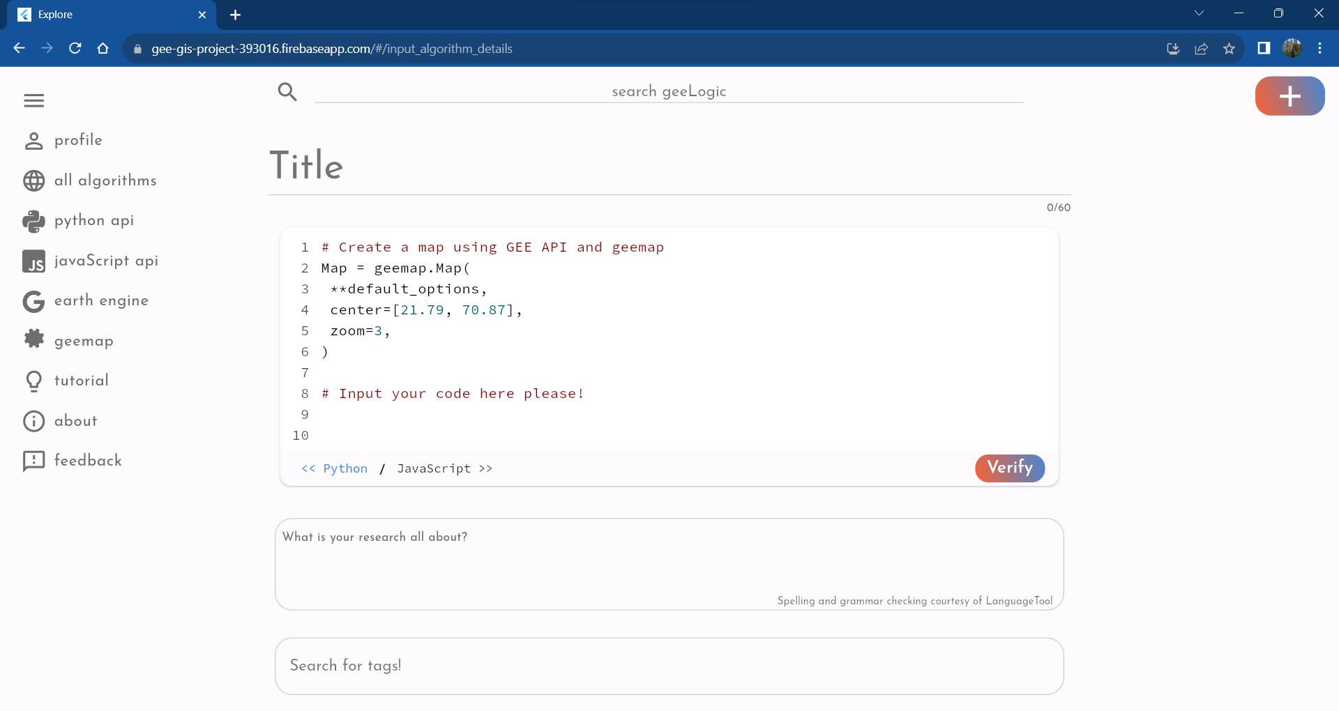

Figure 63 Input Screen

1. Edit Screen and Delete

To edit or delete an algorithm user will have to return to the User Screen and look at the button in the top right corner of the User Algorithm under Contributions tab as highlighted on Figure 62. When pressing the edit icon the user will be redirected to the Edit Screen, Figure 64, which is very similar to the Input Screen, except it already has existing data filled in and the code doesn’t need to be verified again unless it is changed. However, the difference in user flow is the user will not be redirected to the Catalogue Screen when updating the algorithm.

The deletion mechanism has been described in detail in Step 11 of the testing procedure in sub section 5.1 Main Testing Sequence.

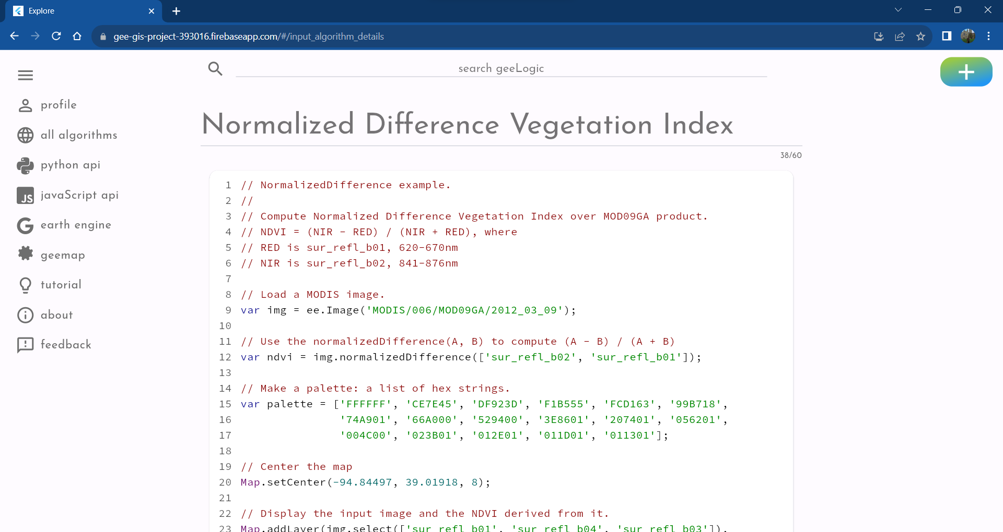

Figure 64 Edit Screen, top.

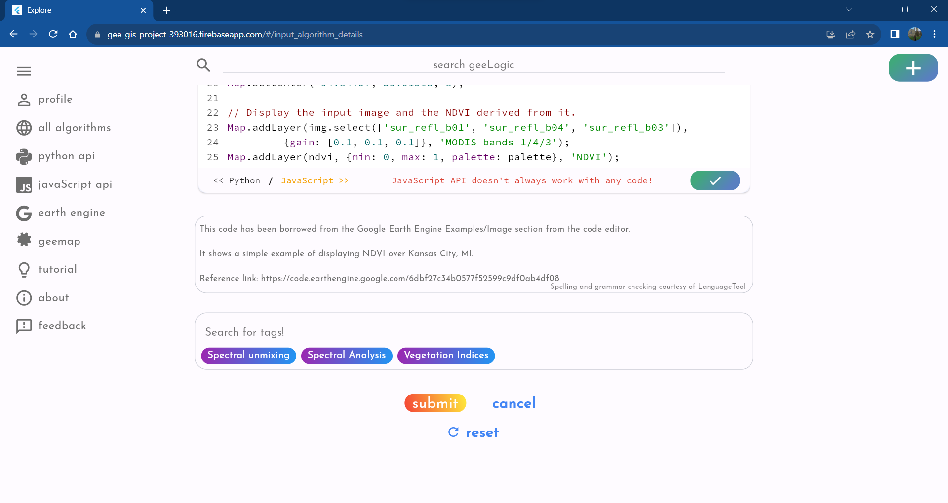

Figure 65 Edit Screen, bottom. Notice the three buttons at the end. Submit button submits changes to the database, cancel returns the user to the User Screen and reset will reset all the changes to the initial state. Furthermore, since this algorithm uses JavaScript API, it can be seen that the user is indeed informed that it does not always accept valid inputs.

1. About Screen

About Screen contains the first few opening paragraphs of this report. This page aims to quickly describe to the user what is the purpose and vision behind GeeLogic. It’s screenshot can be seen on Figure 66.

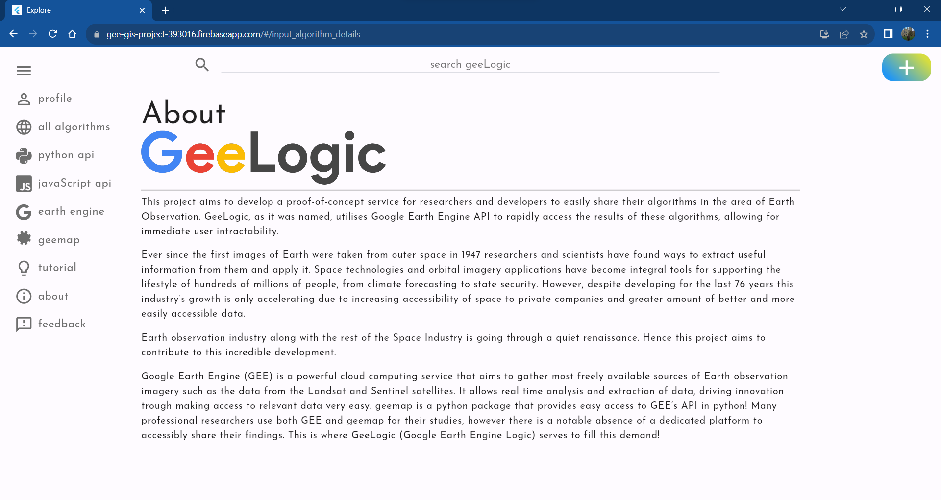

Figure 66 About Screen

1. Tutorial Screen

Tutorial Screen, Figure 67, hosts a very brief tutorial encompassing the most complicated mechanic of using GeeLogic: the submission procedure. Given that simple browsing is fairly similar to most other websites and its intricacies can be easily understood through usage, it was determined that only the contribution of a new algorithm must be taught on the Tutorial Screen.

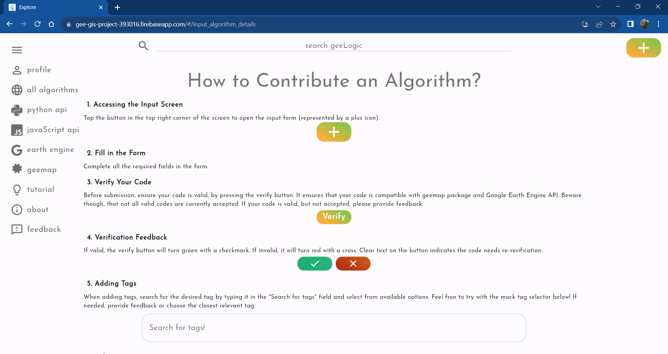

Figure 67 Tutorial Screen. It is notable that the tags input is interactable and behaves in a similar way to that of the Input Screen and Edit Screen.

1. Feedback Screen

GeeLogic aims to improve and grow, hence it is essential for the developer to receive feedback from its users on what can be improved. Therefore it is necessary to establish a reliable means of communication; Feedback Screen serves this purpose. Any user can submit their details and send their query directly to the dedicated mailbox created for this project.

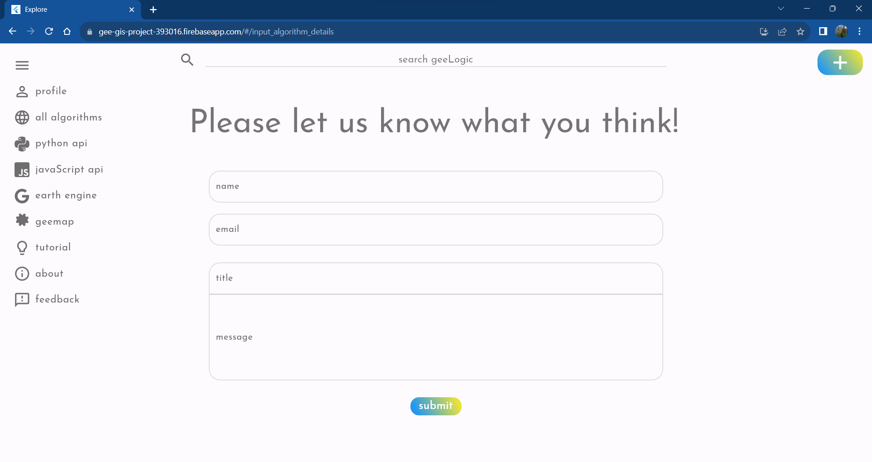

Figure 68 Feedback Screen

1. Additional Side Menu Buttons

Alongside the navigation buttons for the different screens of GeeLogic there are also two buttons that do not lead anywhere within GeeLogic: “earth engine” and “geemap”. These buttons will redirect the user to the website of Google Earth Engine and geemap Python library’s documentation. The former was included to allow users of the service to quickly go to GEE’s website and prototype their ideas while the latter is included to be able to quickly access geemap’s documentation which should assist with submitting correct code using Python API.

1. API Documentation

The three APIs used by GeeLogic were documented using Postman. The advantage of using Postman for documentation is that its free to use, its helps format it very accessibly and beautifully and it allows for manual and automatic tests on its platform.

The documents are too long for pasting directly into this report, (22-pages, half of which is due to html example code for Thumbnail API’s input taking 11 pages) however they are available through the following hyperlinks, and an example of some of the Node API’s queries is also shown below:

* [Node API](https://documenter.getpostman.com/view/25451165/2s9Y5R372Q)
* [Python API](https://documenter.getpostman.com/view/25451165/2s9YC1Wa7J)
* [Thumbnail API](https://documenter.getpostman.com/view/25451165/2s9YC1WtuM)

The online documentation includes http method, uri, description, example body of the request, along with headers, and example successful return of each request.

Furthermore, a lot of effort was put into comprehensively documenting each API in code. Below is an example service part of an API mechanism along with its documentation for search_tags Node API endpoint.



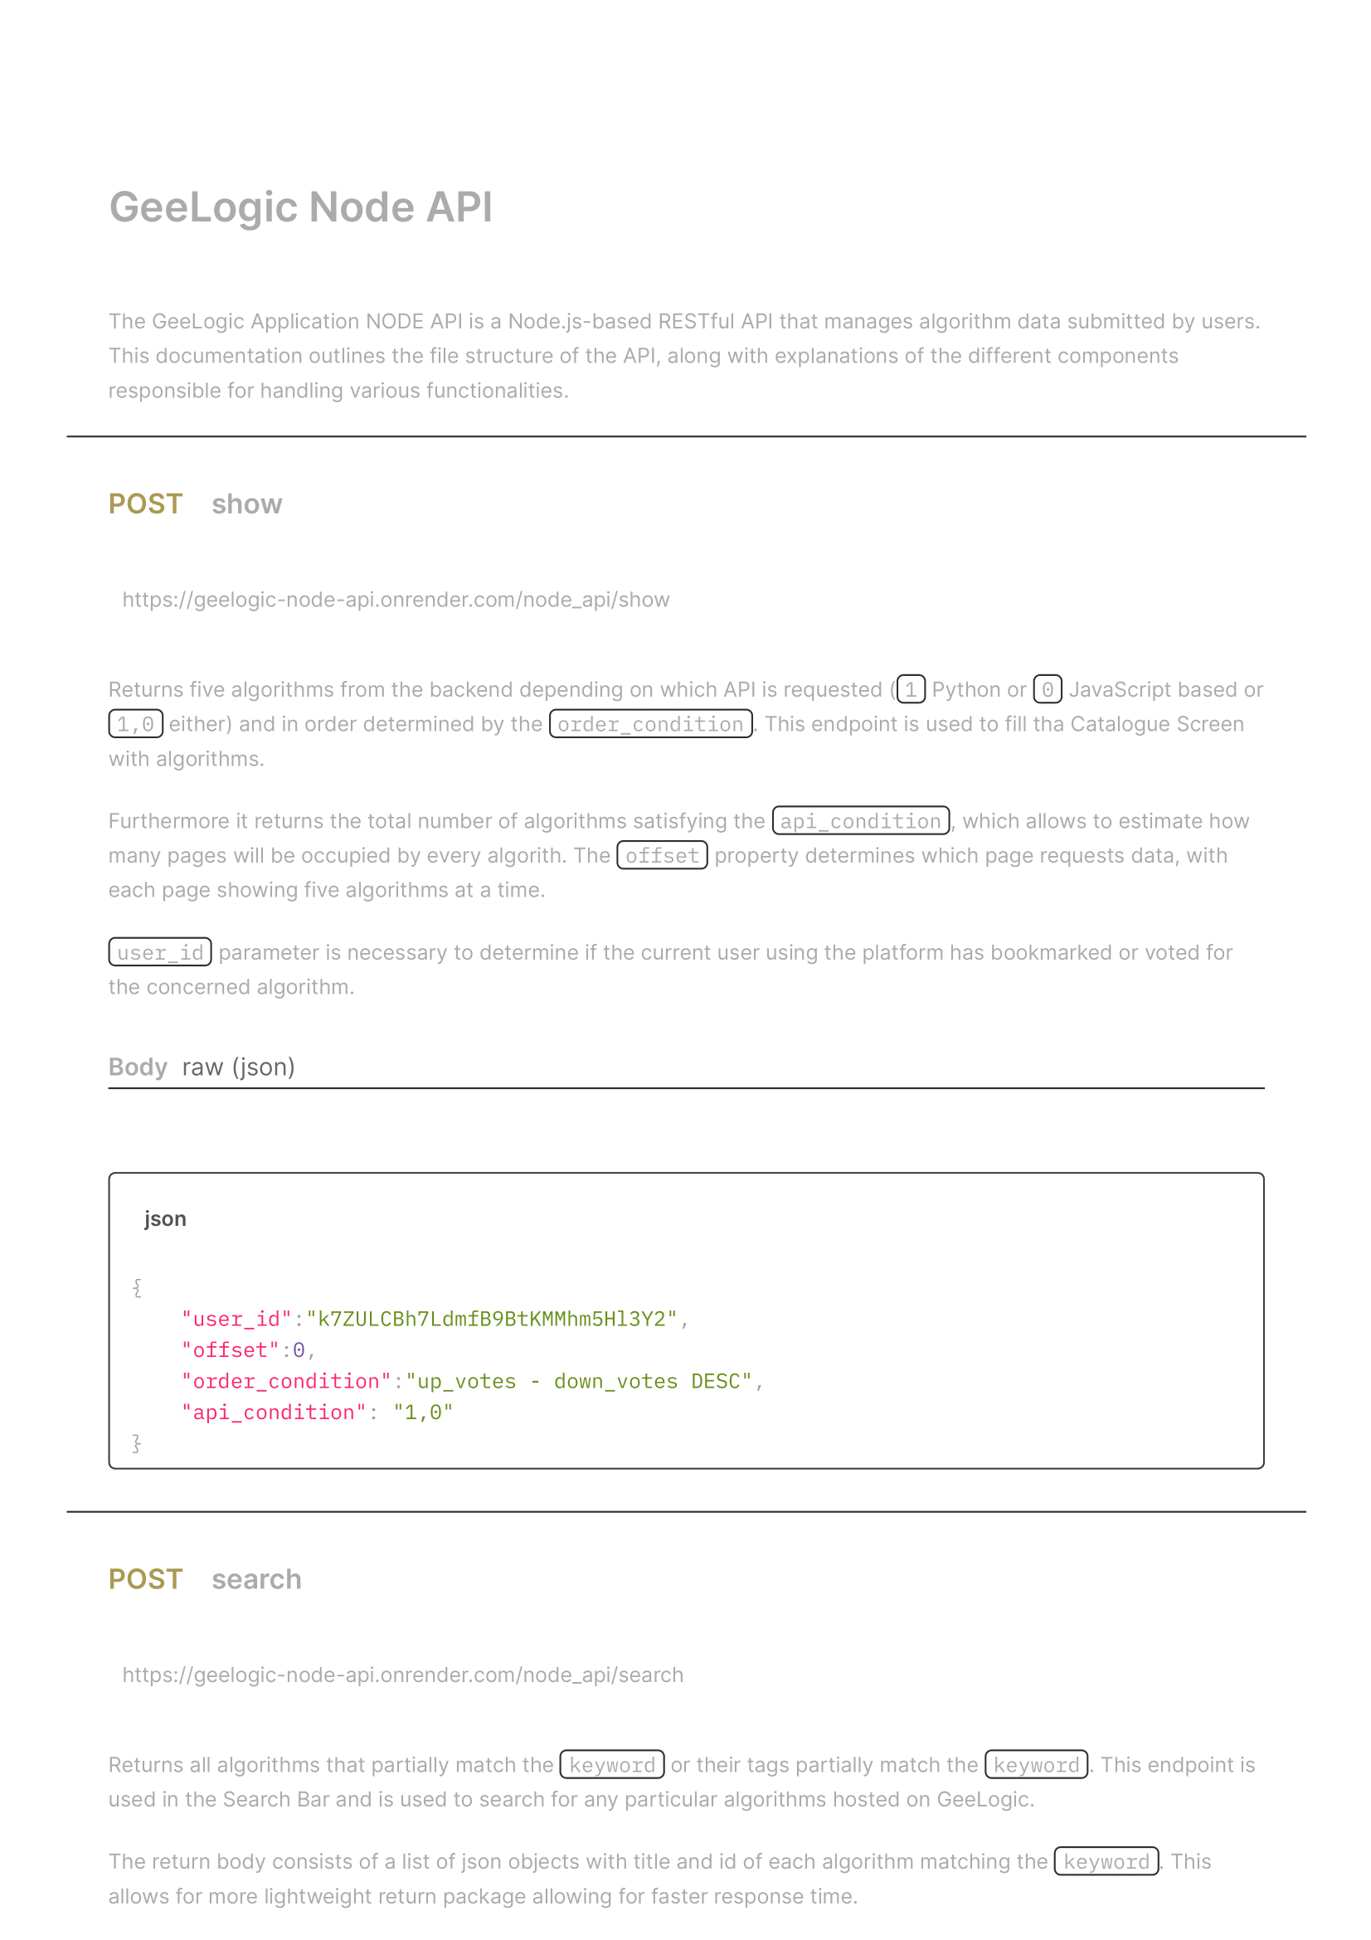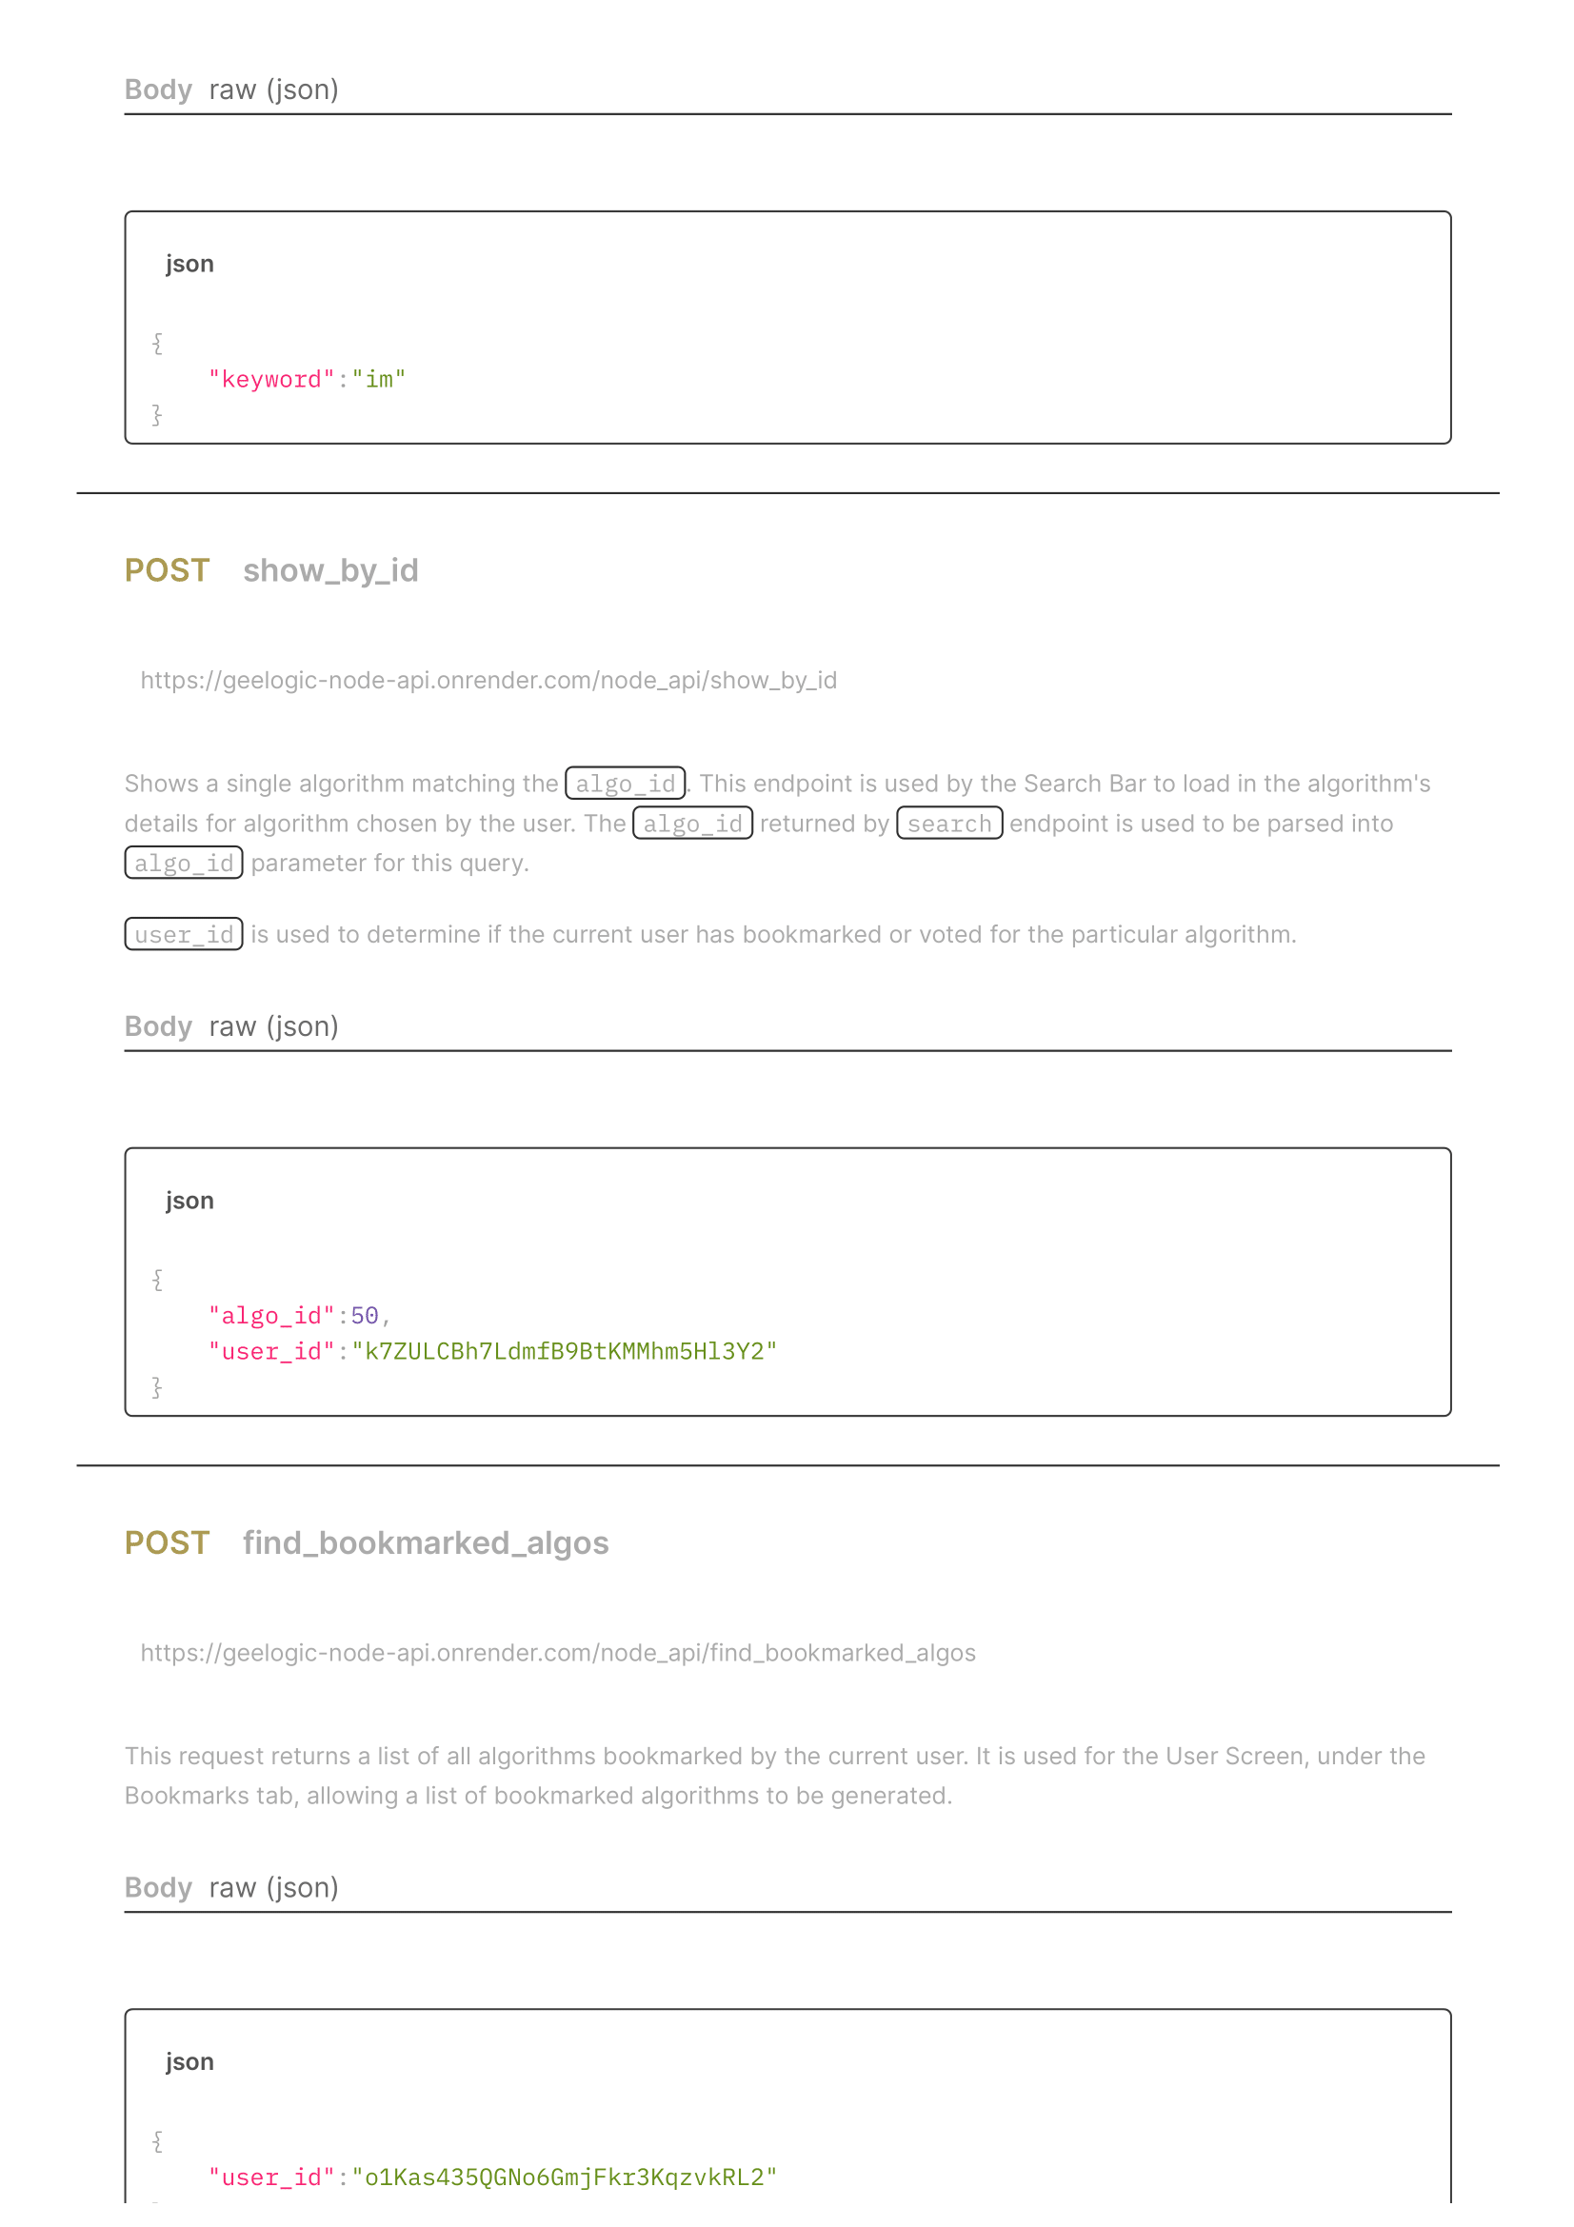

1. Google. (n.d.). *Case Studies*. Retrieved from Google Earth Engine: https://earthengine.google.com/case_studies/
2. Under normal operations, when GEE is used in a private jupyter notebook it will ask the user to reauthorise every week, which is undesirable for GeeLogic since this authorisation is impossible from Docker container and is very inconvenient otherwise. The way around this is using Service Account credentials for authorisation. Hence GeeLogic application has its own Google Cloud account that is authorised to use GEE, and its credentials are used to activate GEE. All authentication details are stored in secret files and environment variables.
3. It is widely popular as it highlights organic vegetation on an image, allowing one to judge where there is live plants, and where there isn’t, and even be able to differentiate between healthy and unhealthy plants. (Landsat Missions, n.d.)